COMBINED WEAPONS PRICE LIST

MELEE WEAPONS – combined tables
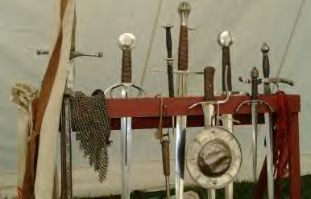

AXE/MACE
(DX-5, Flail-4, other Axe/Mace-3 or Two-Handed Axe/Mace-3)
May not attack and parry in the same turn.
 | Damage
Weapon | Type | Amt | Reach | Cost | Wt. | Min ST | Special Notes
Axe | cut | sw+2 | 1 | 50 | 4lbs | 12
Hatchet | cut | sw | 1 | 15 | 2lbs | 7 | May be thrown
Heavy club | cr | sw+2 | 1 | 20 | 2lbs | 7 | May be thrown
Mace | cr | sw+3 | 1 | 50 | 5lbs | 12 | May be thrown
Pick | imp | sw+1 | 1 | 70 | 3lbs | 11
Small/Light mace | cr | sw+2 | 1 | 35 | 3lbs | 11 | May be thrown
Throwing axe | cut | sw+1 | 1 | 60 | 4lbs | 12 | May be thrown
BRAWLING
(DX-4)
 | Damage
Weapon | Type | Amt | Reach | Cost | Wt. | Min ST | Special Notes
Blackjack | cr | thr | C | 20 | 1lbs | 7 | May not parry.
Boots | cr | thr+1 | C,1 | Var. | Var. | -
Brass knuckles | cr | thr | C | Var. | Var. | - | Effect given by various items.
BROADSWORD
(DX-5, Rapier-4, Sidesword-2, Shortsword-2 or Two-Handed sword-4)
 | Damage
Weapon | Type | Amt | Reach | Cost | Wt. | Min ST | Special Notes
Basket Hilt |  |  |  | +25%* | 1lb |  | *based on list price, no change in cost for blade quality.
Broadsword | cut | sw+1 | 1 | 300 | 3lbs | 10
 | imp | thr+2 | 1
Falchion | cut | sw+2 | 1 | 300 | 5lbs | 10
 | cr | thr | 1
Light club/stave | cr | sw+1 | 1 | <10 | 3lbs | 11
Longsword | cut | sw+1 | 1,2¹ | 350 | 5lbs | 11
 | imp | thr+1 | 2
FENCING WEAPONS
Each weapon uses a separate skill (listed below).
See B(4th)208 for fencing rules.
 | Damage
Weapon | Type | Amt | Reach | Cost | Wt. | Min ST | Special Notes
Basket Hilt |  |  |  | +25%* | 1lb |  | *based on list price, no change in cost for blade quality.
MAIN GAUCHE (DX-5, Broadsword–4, Knife-4, Rapier-3, Sabre-3 or Smallsword-3)
Main-gauche | imp | thr | C | 50 | 1¼lbs | - | No parry penalty for either off-hand,
 | cut | sw-3 | C,1 |  |  |  | nor for parrying with a knife.
RAPIER (DX-5, Broadsword–4, Main gauche-3, Sabre-3, Shortsword-4, Smallsword-3)
Rapier | imp | thr+1 | 1,2 | 500 | 2½lbs | 7
SABRE (DX-5, Broadsword–4, Main gauche-3, Rapier-3, Shortsword-4, Smallsword-3)
Sidesword | cut | sw+1 | 1 | 400 | 2¾lbs | 10
 | imp | thr+1 | 1,2
SMALLSWORD (DX-5, Main gauche-3, Rapier-3, Sabre-3 or Shortsword-4)
Smallsword | imp | thr+1 | 1 | 400 | 1½lbs | -
FLAIL
(DX-6, Axe/Mace-4, or Two-Handed Flail-3)
May not attack and parry in the same turn.
 | Damage
Weapon | Type | Amt | Reach | Cost | Wt. | Min ST | Special Notes
Morning-star flail | cr | sw+1 | 1 | 400 | 2¾lbs | 10
KNIFE
(DX-4, Main gauche-3, or Shortsword-3)
–1 to parry with a knife.
 | Damage
Weapon | Type | Amt | Reach | Cost | Wt. | Min ST | Special Notes
Dagger | imp | thr-1 | C | 30 | ½lb | - | Stilettos have armour divisor (2).
Large knife | cut | sw-2 | C, 1 | 40 | 1lbs | -
 | imp | thr | C
Small knife | cut | sw-3 | C, 1 | 20 | ½lb | -
 | imp | thr-1 | C
LANCE
(DX-5 or Spear-3)
Must have at least one point in Riding skill. Must have saddle and stirrups to use a couched lance.
 | Damage
Weapon | Type | Amt | Reach | Cost | Wt. | Min ST | Special Notes
Lance | imp | thr+3² | 4 | 60 | 6lbs | 12 | May not parry. See B(4th)397.
Tourney Lance | cr | thr+3² | 4 |  |  |  | May not parry. See B(4th)397.
POLEARM
(DX-5, Spear-4, Staff-4, or Two-Handed Axe/Mace-4)
All polearms require two hands. All except pollaxe become unready after an attack, but not after a parry.
 | Damage
Weapon | Type | Amt | Reach | Cost | Wt. | Min ST | Special Notes
Glaive | cut | sw+3 | 2, 3¹ | 100 | 8lbs | 11
 | imp | thr+3 | 1-3¹
Halberd | cut | sw+5 | 2, 3¹ | 150 | 12lbs | 13
 | imp | sw+4 | 2, 3¹ |  |  |  | May get stuck, see B(4th)405.
 | imp | thr+3 | 1-3¹
Lucerne hammer | cr | sw+4 | 2, 3¹ | 120 | 10lbs | 12
 | imp | sw+4 | 2, 3¹ |  |  |  | May get stuck, see B(4th)405.
 | imp | thr+3 | 1-3¹
Pollaxe | cut | sw+3 | 1, 2¹ | 120 | 8lbs | 12 | Balanced weapon; does not
 | cr | sw+3 | 1, 2¹ |  |  |  | become Unready after attacking.
 | imp | thr+2 | 1-2¹
SHORTSWORD
(DX-5, Broadsword-2, Knife-4, Sabre-4 or Smallsword-4)
 | Damage
Weapon | Type | Amt | Reach | Cost | Wt. | Min ST | Special Notes
Falchion | cut | sw+1 | 1 | 200 | 3lbs | 7
 | cr | thr-1 | 1
Baton | cr | sw | 1 | 10 | 1lb | 7
 | cr | thr | 1
SPEAR
(DX-5, Polearm-4 or Staff-2)
 | Damage
Weapon | Type | Amt | Reach | Cost | Wt. | Min ST | Special Notes
Boar spear | imp | thr+2 | 1 | 30 | 3lbs | 9 | Used 1 handed. Cannot be thrown.
 | imp | thr+3 | 1, 2¹ |  |  |  | Used 2 handed.
Javelin | imp | thr+1 | 1 | 5 | 2lbs | - | Primarily for throwing.
Long Spear | imp | thr+2 | 1 | 30 | 5lbs | 10 | Used 1 handed. Throwable (just).
 | imp | thr+3 | 1, 2¹ |  |  |  | Used 2 handed. Throwable (just).
Pike | imp | thr+3 | 4-6¹ | 180 | 3lbs/yd | 12 | Only used 2 handed. Cannot parry.
 | cr | sw | 4-6 |  |  |  | Haft damage when inside point.
Spear | imp | thr+2 | 1 | 20 | 4lbs | 9 | Used 1 handed. Throwable.
 | imp | th+3 | 1, 2¹ |  |  |  | Used 2 handed. Throwable.
STAFF
(DX-5, Polearm-4 or Spear-2)
Requires two hands. Parry is +2.
 | Damage
Weapon | Type | Amt | Reach | Cost | Wt. | Min ST | Special Notes
Quarterstaff | cr | sw+2 | 1, 2 | 5 | 4lbs | 6
 | cr | thr+2 | 1, 2
Walking staff | cr | sw+1 | 1, 2 | 1 | 2lbs | -
 | cr | th+1 | 1, 2
TWO-HANDED AXE/MACE
(DX-5, Axe/Mace-3, Polearm –4 or Two-Handed Flail -4)
Require two hands. Cannot attack and parry in the same turn. Becomes unready after attack or parry (unless 1.5x min ST).
 | Damage
Weapon | Type | Amt | Reach | Cost | Wt. | Min ST | Special Notes
Great axe | cut | sw+3 | 1, 2¹ | 50 | 8lbs | 13
 | cut | sw+3 | 1, 2¹ | 100 | 15lbs | 15 | Double-headed great axe. Remains ready to attack each turn.
Great hammer | cr | sw+4 | 1, 2¹ | 60 | 7lbs | 13
 | imp | sw+3 | 1, 2¹ |  |  |  | May get stuck B(4th)405
Maul | cr | sw+4 | 1, 2¹ | 40 | 12lbs | 14
Scythe | cut | sw+2 | 1 |  |  | 12
 | imp | sw | 1 | 8 | 5lbs | 6 | -2 to hit when impaling.
TWO-HANDED FLAIL
(DX-6, Flail –3, or Two-Handed Axe/Mace-4)
May not attack and parry in the same turn. Requires two hands unless 1.5x Min ST.
 | Damage
Weapon | Type | Amt | Reach | Cost | Wt. | Min ST | Special Notes
Flail | cr | sw+4 | 1,2 | 50 | 8lbs | 13
TWO-HANDED SWORD
(DX-5, Broadsword-4)
Requires two hands unless 15x Min ST.
 | Damage
Weapon | Type | Amt | Reach | Cost | Wt. | Min ST | Special Notes
Estoc | imp | thr+2 | 1 | 650 | 5lbs | 10 | Armour divisor (2)
 | cr | sw+1 | 2 |  |  |  | 1 turn to ready after swing.
Falchion | cut | sw+4 | 1, 2¹ | 800 | 10lbs | 12 | Counts +1 quality for breakage.
 | cr | thr+1 | 2
Flammard | cut | sw+3 | 1, 2¹ | 2000 | 8lbs | 12
 | imp | thr+3 | 2
Greatsword | cut | sw+3 | 1, 2¹ | 800 | 7lbs | 12
 | imp | thr+3 | 2
Longsword | cut | sw+2 | 1,2¹ | 350 | 5lbs | 11
 | imp | thr+3 | 2
WHIP
(No default)
 | Damage
Weapon | Type | Amt | Reach | Cost | Wt. | Min ST | Special Notes
Whip | cr | sw-2 | 1-7 | 10/yd | 2lbs/yd | 10 | Armour divisor (0.5). See B(4th)406.
¹ Must be readied for one turn to change effective reach.
² Damage is based on horse’s ST and velocity.
- Work out collision damage between mount and target: (Mount ST) x (Distance moved last turn) /100 dice of damage, rounded down.
- Add lance thrust/impaling bonus of +3.
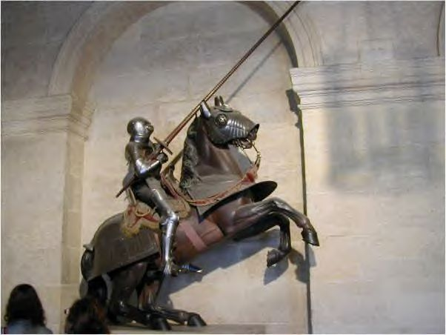

MISSILE WEAPONS – combined tables
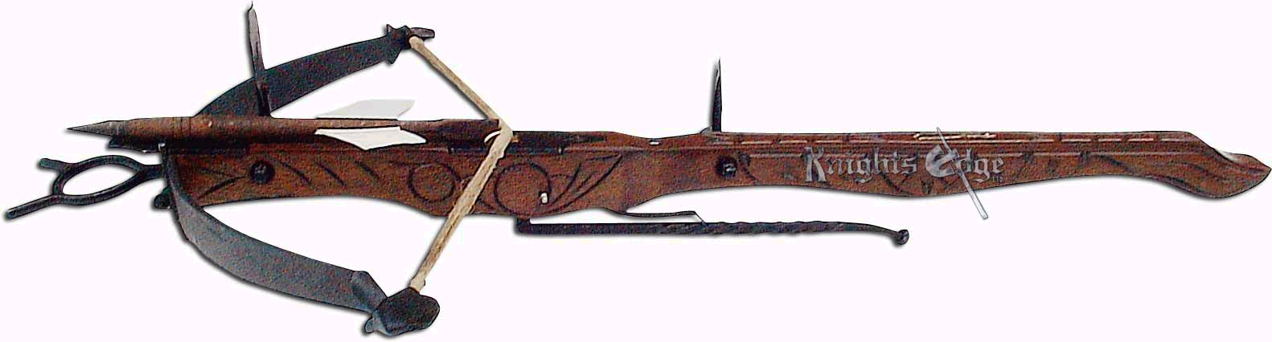

BOW
(DX-5)
2 hands to fire, 2 turns to ready (1 with Fast Draw-Arrow).
 |  | Damage |  |  |  | Ranges
Weapon |  | Type | Amt |  | Acc | ½ Dam | Max |  | Wt. |  | Cost | Min ST |  | Bulk | Special Notes
Short bow |  |  | thr |  | 1 | x10 | x15 |  | 2lbs |  | 50 | 7 |  | -6
Regular bow |  |  | thr+1 |  | 2 | x15 | x20 |  | 2lbs |  | 100 | 10 |  | -7
Longbow |  |  | thr+2 |  | 3 | x15 | x25 |  | 3lbs |  | 200 | 11 |  | -8
Composite bow |  |  | thr+3 |  | 3 | x20 | x25 |  | 4lbs |  | 900 | 10 |  | -7
Arrow, Barbed |  | imp |  |  |  |  |  |  | 2oz |  | 3 |  |  |  | Damage by bow
Arrow, Broad |  | imp |  |  |  |  |  |  | 2oz |  | 2 |  |  |  | Damage by bow
Arrow, Blunt |  | cr |  |  |  |  |  |  | 2oz |  | 2 |  |  |  | Damage by bow
Arrow, Bodkin |  | pi | (2) |  |  |  |  |  | 2oz |  | 2 |  |  |  | Damage by bow
Arrow, Forked |  | cut | (0.5) |  |  |  |  |  | 3oz |  | 2 |  |  |  | Damage by bow
Bow case |  |  |  |  |  |  |  |  | 1lb |  | 10
Bowstring |  |  |  |  |  |  |  |  | neg. |  | 5
Bracer |  |  |  |  |  |  |  |  | 5oz |  | 8
Quiver |  |  |  |  |  |  |  |  | 0.5lb |  | 3 |  |  |  | Holds 10 arrows
 | Increased Draw Bows
 | Min ST |  |  | Damage bonus |  |  |  | Range increase |  | Price increase
 | +2 |  |  | +1 |  |  |  | +10% |  | +10%
 | +4 |  |  | +2 |  |  |  | +25% |  | +25%
 | +6 |  |  | +3 |  |  |  | +40% |  | +40%
 | +8 |  |  | +4 |  |  |  | +60% |  | +60%
 | +11 |  |  | +5 |  |  |  | +75% |  | +75%
 | +15 |  |  | +6 |  |  |  | +90% |  | +90%

CROSSBOW
(DX-4)
2 hands to fire (except pistol crossbow).
 | Damage |  |  | Ranges
Weapon | Type | Amt | Acc | ½ Dam | Max | Wt. |  | Cost | Min ST | Bulk | Special Notes
Crossbow |  | thr+2 | 4 | x15 | x20 | 7lbs |  | 750 | 7 | -6
Pistol crossbow |  | thr+2 | 1 | x15 | x20 | 4lbs |  | 150 | 7 | -4
Bolt, Barbed | imp |  |  |  |  | 2oz |  | 3 |  |  | Damage by bow
Bolt, Broad | imp |  |  |  |  | 2oz |  | 2 |  |  | Damage by bow
Bolt, Blunt | cr |  |  |  |  | 2oz |  | 2 |  |  | Damage by bow
Bolt, Bodkin | pi | (2) |  |  |  | 2oz |  | 2 |  |  | Damage by bow
Bolt, Forked | cut | (0.5) |  |  |  | 3oz |  | 2 |  |  | Damage by bow
Prodd |  | thr+1 | 2 | x15 | x20 | 6lbs |  | 150 | 7 | -6
Lead bullet | cr |  |  |  |  | 1oz |  | 5cp |  |  | Prodd only
Goat’s-foot lever |  |  |  |  |  | 2lbs |  | 20 | 7 |  | Mechanical aid
Winch |  |  |  |  |  | 5lbs |  | 50 | 7 |  | Mechanical aid
Bowstring |  |  |  |  |  | neg. |  | 5
Quiver |  |  |  |  |  | 0.5lb |  | 3 |  |  | Holds 10 bolts
NET
(Cloak-5)
See B(4th)411 for full rules on nets.
 | Damage |  |  | Ranges
Weapon | Type | Amt | Acc | Max |  | Wt. |  | Cost | Min ST | Bulk | Special Notes
Large net | spe |  | 1 | ST/2 + skill/5 |  | 20lb |  | 25 | 11 | -6
Small net | spe |  | 1 | ST + skill/5 |  | 5lb |  | 5 | 8 | -4
THROWN AXE
(DX-4)
 | Damage |  |  | Ranges
Weapon | Type | Amt | Acc | ½ Dam | Max | Wt. |  | Cost | Min ST | Bulk | Special Notes
Hatchet | cut | sw | 1 | x1.5 | x2.5 | 2lb |  | 15 | 7 | -2
Throwing axe | cut | sw+1 | 2 | x1 | x1.5 | 4lb |  | 60 | 11 | -3
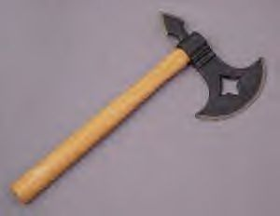
THROWN KNIFE
(DX-4)
-2 attack unless specifically made to be thrown.
 | Damage |  |  | Ranges
Weapon | Type | Amt | Acc | ½ Dam | Max | Wt. |  | Cost | Min ST | Bulk | Special Notes
Large knife | imp | thr | 0 | x0.8 | x1.5 | 1lb |  | 40 | 6 | -2
Small knife | imp | thr-1 | 0 | x0.5 | x1 | 0.5lb |  | 20 | 5 | -1
Dagger | imp | thr-1 | 0 | x0.5 | x1 | 0.5lb |  | 30 | 5 | -1
Throwing dagger | imp | thr-1 | 0 | x0.8 | x1.5 | 0.25lb |  | 40 | 5 | -1
THROWN SPEAR
(DX-4)
 | Damage |  |  | Ranges
Weapon | Type | Amt | Acc | ½ Dam | Max | Wt. |  | Cost | Min ST | Bulk | Special Notes
Javelin | imp | thr+1 | 3 | x1.5 | x2.5 | 2lb |  | 30 | 7 | -4
Long Spear | imp | thr+3 | 2 | X0.8 | x1 | 5lb |  | 60 | 10 | -8 | -2 attack
Spear | imp | thr+3 | 2 | x1 | x1.5 | 4lb |  | 40 | 9 | -6
THROWING
(DX-3)
 | Damage |  |  | Ranges
Weapon | Type | Amt | Acc | ½ Dam | Max | Wt. |  | Cost | Min ST | Bulk | Special Notes
Rock | cr | thr-1 | 0 | x2 | x3.5 | 1lb |  | - | - | 0
Flask | spe | spe | 0 |  | x3.5 | 1.5 lb |  | 1 | - | -1 | See B(4th) 411

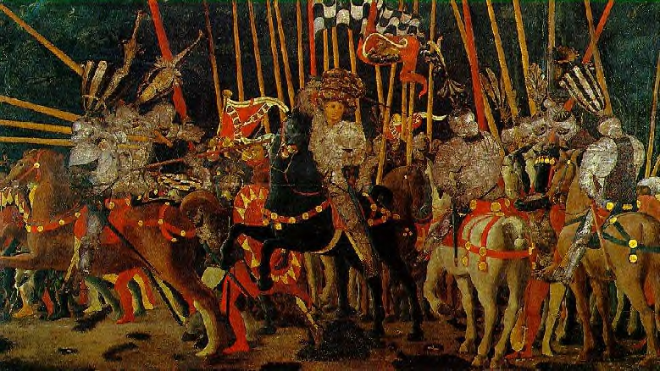

COMBINED ARMOUR PRICE LIST
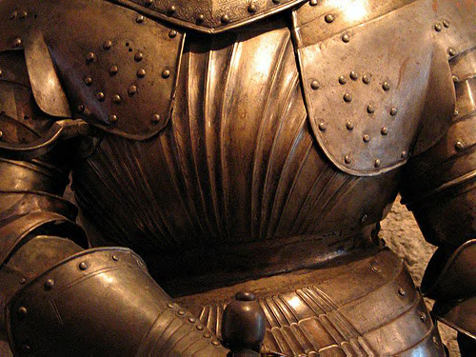

SHIELDS – combined table
SHIELDS
Description | Material | DB | DR | Hits | Weight | Cost | Notes
Buckler | Uncovered wood | 1 | 2 | 10 | 2lbs | 5
Buckler | Covered wood | 1 | 3 | 15 | 2lbs | 12
Buckler | Metal & wood | 1 | 3 | 20 | 2lbs | 25
Buckler | Steel | 1 | 6 | 40 | 4lbs | 100
Small | Uncovered wood | 2 | 2 | 15 | 8lbs | 8
Small | Covered wood | 2 | 3 | 25 | 8lbs | 20
Small | Metal & wood | 2 | 3 | 30 | 8lbs | 40
Small | Steel | 2 | 6 | 60 | 16lbs | 160
Medium | Uncovered wood | 3 | 2 | 20 | 15lbs | 12
Medium | Covered wood | 3 | 3 | 35 | 15lbs | 30
Medium | Metal & wood | 3 | 3 | 40 | 15lbs | 60
Medium | Steel | 3 | 6 | 80 | 30lbs | 240
Large | Uncovered wood | 4 | 2 | 30 | 25lbs | 18
Large | Covered wood | 4 | 3 | 50 | 25lbs | 45
Large | Metal & wood | 4 | 3 | 60 | 25lbs | 90
Large (pavisse) | Covered wood | 4 | 3 | 50 | 30lbs | 120
Shield spike | Steel | - | - | - | +5lbs | +20

ARMOUR – combined tables
Description | Material | Covers | DR | Weight | Cost |  | Notes
CLOTHING
Winter clothing | Padded cloth | Arms, torso, groin, legs | 1 | 3lbs | x2
Winter coat | Thick cloth | Arms, torso, groin, legs | 1 | 10lbs | x2
Hat | Leather | Head | 1 | 1lb | x2
Sleeveless doublet | Leather | Torso | 1 | 2lbs | x2
Doublet (tunic) | Leather | Arms, torso | 1 | 4lbs | x2
Long coat | Leather | Arms, torso, groin | 1 | 8lbs | x2
Leggings | Leather | Legs | 1 | 2lbs | x2
Gloves | Leather | Hands | 1 | neg. | x2
Shoes | Leather | Feet | 1 | 2lbs | x1
LIGHT LEATHER, FUR AND PADDING
Vest | Light leather | Torso | 1 | 2lbs | 15
Jacket | Light leather | Torso | 1 | 4lbs | 25
Chausses | Light leather | Legs, groin | 1 | 2lb | 10
Gloves | Light leather | Hands | 1 | neg. | 8
Waistcoat | Fur | Torso | 1 | 2lbs | <10
Cloak | Fur | Torso, legs (rear) | 1 | 3lbs | <20 | Better quality fur costs more
Sleeveless aketon | Padded cloth | Torso | 1 | 6lbs | 30
Aketon | Padded cloth | Arms, torso, arms | 1 | 8lbs | 50
Padded cuisses | Padded cloth | Legs, groin | 1 | 2lbs | 20
Full aketon | Padded cloth | Arms, torso, groin, legs | 1 | 10lbs | 70
HEAVY LEATHER
Jack | Thick leather | Torso | 2¹ | 8lbs | 65
Jacket | Thick leather | Arms, torso | 2¹ | 10lbs | 100
Coat | Thick leather | Arms, torso, groin | 2¹ | 12lbs | 140
Cuisse | Thick leather | Groin, legs | 2¹ | 3lbs. | 40
Cavalry boots | Thick leather | Legs, feet | 2¹ | 5lbs | 100
Jack | Reinforced leather | Torso | 2 | 10lbs | 100
Jacket | Reinforced leather | Arms, torso | 2 | 12bs | 150
Coat | Reinforced leather | Arms, torso, groin | 2 | 14lbs | 210
Cuisse | Reinforced leather | Groin, legs | 2 | 4lbs. | 60
Gloves | Reinforced leather | Hands | 2 | 1lb | 30
Infantry boots | Reinforced leather | Feet | 2 | 3lbs | 80
RIGID LEATHER
Cuirass | Cuirbouilli | Torso | 3 | 10lbs | 100
Vambraces | Cuirbouilli | Arms | 3 | 2lbs | 50
Cuisse | Cuirbouilli | Groin, legs | 3 | 3lbs | 60
Greaves | Cuirbouilli | Legs | 3 | 3lbs | 60
MAIL AND BRIGANDINE (mail includes padding)
Jack | Brigandine | Torso | 4 | 35lbs | 420
Surcoat | Brigandine | Torso, groin, legs | 4 | 56lbs | 630
Byrnie | Mail | Torso | 4/2² | 25lbs | 230
Haubergeon | Mail | Torso, groin, arms | 4/2² | 34lbs. | 300
Haubergeon | Mail | Torso, groin, arms, hands | 4/2² | 36lbs | 350 | As above, but with mufflers (gloves)
Hauberk | Mail | Torso, groin, legs, arms, hands | 4/2² | 48lbs | 460
Chausses | Mail | Legs, feet | 4/2² | 15lbs | 110
Vest/Byrnie | Fine mesh mail | Torso | 4/1² | 15bs | 690 | Concealable
Shirt/Haubergeon | Fine mesh mail | Torso, arms | 4/1² | 20lb | 900 | Concealable
PLATE (plate includes padding) Full suits do not include helmet
Breastplate | Plate | Torso (front) | 6 | 18lbs | 600
Cuirass/corselet | Plate | Torso | 6 | 30lbs | 1 300
Pauldrons & gardebras. | Plate | Arms | 6 | 10lbs | 1 000
Cuisses and greaves. | Plate | Legs and groin | 6 | 18lbs. | 1 100
Sabatons/sollerets | Plate | Feet | 4 | 4lbs | 200
Gauntlets | Plate | Hands | 4 | 2lbs | 200
Full suit | Plate | All but head and neck | 6 | 64lbs | 3 800 | DR4 on hands and feet
Breastplate | Field plate | Torso (front) | 7 | 18lbs | 1 000
Cuirass/corselet | Field plate | Torso | 7 | 36lbs | 2 300
Pauldrons & gardebras. | Field plate | Arms | 7 | 12lbs | 1 500
Cuisses and greaves. | Field plate | Legs and groin | 7 | 22lbs. | 1 600
Full suit | Field plate | All but head and neck | 7 | 76lbs | 5 800 | DR4 on hands and feet
Breastplate | Hardened plate | Torso (front) | 7 | 18lbs | 3 000
Cuirass/corselet | Hardened plate | Torso | 7 | 30lbs | 6 900
Pauldrons & gardebras. | Hardened plate | Arms | 7 | 10lbs | 4 500
Cuisses and greaves. | Hardened plate | Legs and groin | 7 | 18lbs. | 4 800
Sabatons/sollerets | Hardened plate | Feet | 5 | 4lbs | 1 000
Gauntlets | Hardened plate | Hands | 5 | 2lbs | 1 000
Full suit | Hardened plate | All but head and neck | 7 | 64lbs | 21 200 | DR5 on hands and feet
Full suit | Maximillian plate | All but head and neck | 7³ | 64lbs | x2⁴ | DR5 on hands and feet
Full suit | Jousting plate | All but head and neck | 9 | 86.4lbs⁵ | x5⁶ | DR6 on hands and feet
HELMETS. All metal helmets and coifs come with an arming cap.
Arming cap | Padded | Head | 1 | neg. | 2
Coif | Padded | Head | 1 | neg. | 5
Coif | Lt Leather | Head | 1 | 1lb | 6
Coif | Mail | Head | 4/2² | 4lbs | 55 | Includes padding
Kettle hat | Plate | Head | 5 | 4lbs | 100
Skull cap | Plate | Head | 4 | 2lbs | 20
Bascinet | Plate | Head | 6 | 8lbs | 250
Visored bascinet | Plate | Head, face | 6 | 10lbs | 340
Barbute, open | Plate | Head | 6 | 7lbs | 300
Barbute, close | Plate | Head, face | 6 | 7lbs | 325
Sallet | Plate | Head, face | 6 | 6lbs | 350
Visored sallet | Plate | Head, face | 6 | 7lbs | 400
Armet | Plate | Head, face, neck | 6 | 7lbs | 420
Armet | Field plate | Head, face, neck | 7 | 9lbs | 600
Armet | Hardened plate | Head, face, neck | 7 | 7lbs | 1 800
Close helmet | Plate | Head, face, neck | 7 | 6lbs | 500
Close helmet | Field plate | Head, face, neck | 7 | 8lbs | 750
Close helmet | Hardened plate | Head, face, neck | 7 | 6lbs | 2 250
Close helmet | Maximillian plate | Head, face, neck | 7 | 6lbs | 4 500
Great helm | Jousting plate | Head, face, neck | 9 | 12lbs | 1 500 | Includes padding and a skull cap.
Aventail/camail | Mail | Neck | 4/2² | 2lbs. | 30 | Includes padding
Bevor | Plate | Face, neck | 5 | 2lbs | 50 | Aimed attacks against the face can bypass the bevor by taking an additional -2 to hit
Face mask | Steel | Face | 4 | 4lbs | 100
Gorget | Plate | Neck | 6 | 2lbs | 50
Plumes/device | Various | - | - | 0.5lb+ | 10+
1. DR2 against cutting, piercing and impaling attacks, DR1 against crushing attacks.
2. DR4 against cutting, impaling and piercing attacks; lower DR against crushing attacks. Halve this DR if worn without any padding.
3. Maximillian plate gives a +1 Defence Bonus due to the deflecting flutes.
4. The cost of Maximillian plate is double that of the equivalent piece of Hardened Plate.
5. For the weight of each piece of Jousting plate, add 35% to the weight of equivalent plate.
6. The cost of Jousting plate is five times that of equivalent plate.

