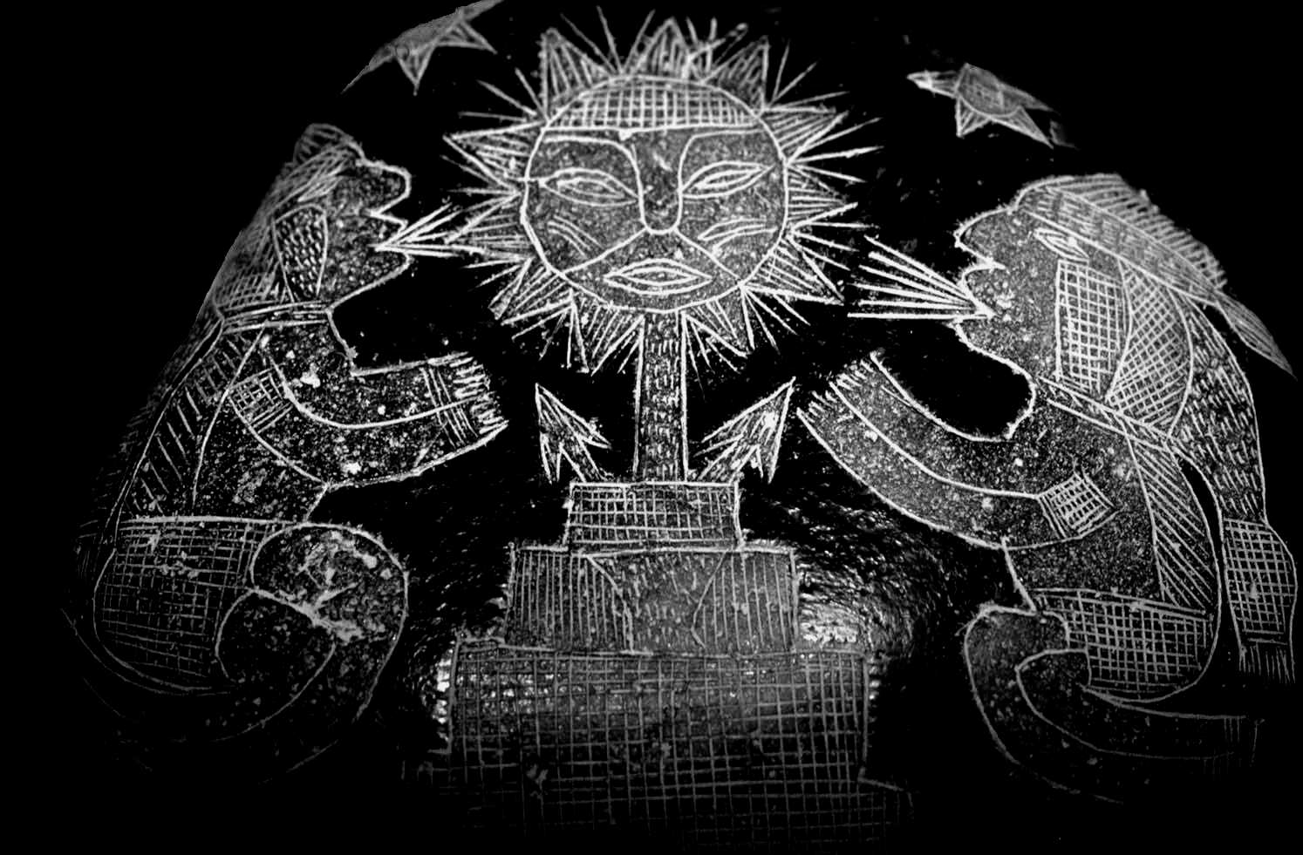

Sadurian Religions

Contents
Page | Topic | Page | Topic
1 | Contents page | 10 | Avatars
2 | General information | 10 | Ancient Ones
3 | Gods listed alphabetically | 11 | The world – lesser deities
4 | Gods listed by aspect | 11 | Spirit races
5 | Relationships | 11 | Sub-cults
5 | Sanctity and sacred spaces | 11 | Lesser deities
5 | The pantheons | 12 | Worshippers
6 | Devils | 12 | Relationship
6 | Ancient Ones and demons | 13 | Priest powers
7 | History of the gods | 15 | Ritual Magic – Path of the gods
7 | Origins of the world | 19 | The Old Gods
8 | The Nature gods | 20 | Priests of the Old Gods
8 | The Aagarhik gods | 73 | The New Gods
8 | The Human gods | 74 | Priests of the New Gods
8 | The Ancient Ones and Demons | 87 | The Nature Gods
9 | The Devils | 88 | Priests of the Nature Gods
9 | Schism of the Human gods | 98 | The Aagarhik Gods
10 | Gods and other spirits | 99 | Priests of the Aagarhik Gods
10 | The spirit realms

The nature of Gods

General Information
A lot of the information here is based on the 3e books, GURPS Spirits and GURPS Religion.
Clerics and Priests
While some game systems may make a distinction between the two, I use the terms ‘priest’ and ‘cleric’ interchangeably as a term for a recognised follower of a god with the Clerical Investment advantage.
However, while ‘priest’ is a generic term, a ‘Priest’ (capitalised) is a specific title, usually of a priest or cleric of Religious Rank 1. Hopefully, it will be obvious to which I am referring in each case.
Spirit Types
GURPS Spirits is recommended to fully follow the information on spirits.
Gods are spirits who attract worship.
Personification spirits are spirits associated with a particular concept or thing (known as its aspect), usually valued enough by worshippers that the spirit is worshipped to protect or promote that aspect.
Divine spirits are simple spirits that do not have enough Life Energy to do any more than maintain a precarious existence. They are so weak that the only way that they can communicate with the mortal realm is through the dreams of the weak or vulnerable.
Worship
Most gods (and some other spirits) require worship to provide them with Fatigue (known as Life Energy). The more Life Energy a spirit receives, the more powerful it may become.
This worship may take many forms, and need not be a formal ritual (though it usually is). Evil gods, in particular, may gain Life Energy simply from mortals’ suffering.
There are inner spirit realms that overlay the mortal world and may occasionally interact with it through magic. Certain spirits of these spirit realms may materialise in the mortal realm. The spirit realms are filled with all manner of spirits, including:
- The wandering and restless spirits of the dead of mortal races, those who have not passed into their religion’s afterlife for whatever reason.
- Spirit races such as demons, faeries and goblins (who are also frequently found in the mortal realm as they find it easy to materialise there).
- Gods and devils.
- Other divine spirits
Most gods are Personification spirits (representing a particular philosophical concept) but there are exceptions; the Nature Gods, for example, have many subservient demigods who are Spirits of Place or Animals.
Far more widely worshipped and therefore far stronger and more numerous than other spirits, the gods may be of any disposition or morality but even the most depraved of them is less evil than the devils and more conventional and sane than the malevolent and mysterious Ancient Ones. The devils were also gods, and share many of their characteristics, but were imprisoned behind a Great Seal after a failed rebellion (see below, History of the Gods).
Pantheons are “families” of gods who share certain common values. The gods may work against each other occasionally, but they will unite against outside opponents (just like a mortal family). Some of the more powerful gods have managed to gain popularity in different regions and pantheons (usually under different names), but generally each is worshipped only within a limited geographical area. The pantheons of the Sadurian Empire are:

The Old Gods. The most popular pantheon in Saduria, the Old Gods are Personification spirits representing earthly and very familiar aspects.

The New Gods. Becoming increasingly popular, the New Gods are also Personification spirits but represent more abstract and philosophical ideas.

The Nature Gods. The oldest of the current Sadurian pantheons, the Nature Gods are Personification spirits with aspects of natural concepts and things.

The Aagarhik Gods. Second in age only to the Nature Gods, the Aagarhik Gods are Personification spirits covering primitive aspects popular with both orcs and a few degenerate humans. Their worship is almost exclusively confined to the orc lands and Badlands region of northern Saduria).
Other pantheons exist in other countries; these will be covered (in less detail than the Sadurian gods) in the entries for the lands in question.
The Gods; listed Alphabetically
Name of God | Pantheon | Page |  | Name of God | Pantheon | Page
Andriesia | Old Gods |  |  | Kalisis | New Gods
Anguran | Old Gods |  |  | Keelut | Nature Gods
Apsu | Nature Gods |  |  | Lihan | New Gods
Bachue | Old Gods |  |  | Linmeth | Old Gods
Barchat | Nature Gods |  |  | Marerewana | Aagarhik Gods
Belhella | New Gods |  |  | Nakki | Old Gods
Brionelle | New Gods |  |  | Nyamia | Aagarhik Gods
Byel | Nature Gods |  |  | Pandour | Old Gods
Chauro | Old Gods |  |  | Peletri | Old Gods
Chernog | Nature Gods |  |  | Persera | New Gods
Damona | Nature Gods |  |  | Ramman | Nature Gods
Druantia | Nature Gods |  |  | Sakarabru | Aagarhik Gods
Elendic | Old Gods |  |  | Samas | Old Gods
Evua | Aagarhik Gods |  |  | Sharu | Old Gods
Flidais | Nature Gods |  |  | Sigu | Old Gods
Guruhi | Aagarhik Gods |  |  | Skoal | Old Gods
Habren | Old Gods |  |  | Tanith | Old Gods
Halfour | Old Gods |  |  | Tantric | New Gods
Hashin | Old Gods |  |  | Tathbeth | Old Gods
Kake-guia | Aagarhik Gods |  |  | Viktor | Old Gods

The Gods; listed by Aspect
Aspect/Area of Influence | Old Gods | New Gods | Nature Gods | Aagarhik Gods
Animals (wild) | - | - | Flidais | -
Charity/Generosity | - | Persera | - | -
Death | Anguran | Kalisis | - | Kake-gura
Elementalism | - | Tantric | - | -
Femininity | Tanith | Kalisis | - | -
Fertility | Habren | Persera | - | -
Fire | Samas | - | - | Evua
Forests – dark forests | - | - | Chernog | -
Forests – woodland |  |  | Druantia
Harvest | Bachue | - | - | Nyamia
Healing | Linmeth | Persera | - | Sakarabru
House and Hearth | Chauro | - | - | -
Hunting | - | - | Flidais | -
Justice and Judgement | Sharu | Lihan | - | Sakarabru
Knowledge and Wisdom | - | Belhella | - | -
Livestock and Farming | Sigu | - | Damona | Nyamia
Love (sensual) | Andriesia | - | - | -
Love (spiritual) | - | Brionelle | - | -
Magic and Spirits | Tathbeth | - | - | -
Masculinity | - | Lihan | - | -
Mercy | Peletri | - | - | -
Moon | Tanith | Kalisis | - | -
Murder | Hashin | - | - | Guruhi
Music | Elendic | - | - | -
Nature | - | Tantric | - | -
Night and Darkness | - | - | - | Sakarabru
Predators | - | - | Keelut | -
Retribution and Punishment | Pandour | - | - | Guruhi
Sea | Skoal | Tantric | Apsu | Marerewana
Sky | - | - | - | Nyamia
Storms | Halfour | Tantric | Ramman | Nyamia
Strength | - | Lihan | - | -
Sun | Samas | - | Barchat | Evua
War | Viktor | - | - | Guruhi
Water | Nakki | - | Apsu | -
Weather | - | Tantric | Ramman | -
Wilderness | - | - | Byel | -

Relationships

In general, the priests of a church can buy worshippers of allied churches as Allies and those of enemy churches as Enemies, but this is certainly not a requirement. Usually, this should be considered only if the priest is planning on seeking out his allies or enemies on a regular basis.
Sanctity and Sacred Spaces
As well as indicating how worshippers of the different religions are expected to act towards each other, the relationship between the religions also determines how priests of one religion will interact with one another’s areas of sanctity (for Clerical Magic).
Churches are: Effect on Bonuses and Penalties for sanctity.
Allied. Treat as if it were of the priest’s own church.
Friends. Treat as one level less.
Neutral. No effect.
Enemy. Treat all bonuses as penalties (but not vice versa).
All Ritual Magic users treat sacred spaces as the same for churches within the same pantheon, but treats sacred spaces of the same tradition but different pantheons as being one level less, and any bonuses for other Ritual Magic traditions as penalties
For Example: A sacred grove dedicated to the Nature Gods and giving their worshippers a +3 will give priests of the New Gods a +2. A stone altar sacred to Demonologists (using Ritual Magic – Demonology) to the +2 level will inflict a –2 penalty for priests using Ritual Magic – Divine.
The Pantheons
The gods of the Sadurian pantheons (Old Gods, New Gods, Nature Gods and Aagarhik Gods) have been established for many years and, whilst not all can be called friendly towards each other, neither are they overtly hostile. The large number of worshippers that each god attracts is sufficient to maintain the gods’ power to a level that they are satisfied with, especially as no one pantheon is considerably more powerful than another. Naturally, there are gods more in favour than others, but the nature of the pantheon means that a strong god within that pantheon usually balances out a weaker one.
The pantheons are careful to maintain the status quo, for none wishes to be the loser in a conflict, and any internal fighting will inevitably open the way for outside deities to encroach on their worshipper base. However, should a pantheon or god begin to lose power through a lack of worshippers, the other gods are unlikely to leap to their aid! As a means to maintain stability, the gods have certain informal “rules” that they exist by, mainly detailing what is acceptable and what is not. Staying within these guidelines avoids costly conflict and wasting Life Energy on infighting.

No god in a pantheon will make a personal effort to convert a worshipper of another pantheon, but they will certainly instruct their priests to attempt to do so on their behalf. This is considered “fair” by the other pantheons, and is the only legitimate way the gods are allowed to attack each other’s power base.
Very occasionally, a god may spend their energy on manifesting a miracle to gain worshippers. This is seen as stretching the “rules” and will generally only be tolerated on a small or discrete scale, in extreme situations and on behalf of exceptionally devoted worshippers.
The pantheon gods are the sworn enemies of devils, demons and the Ancient Ones. They are friendly (or sometimes allied – as noted in the individual church’s descriptions) to others within their pantheon, and usually neutral to the other pantheons. Note that there may be times when a particular god may either become temporarily hostile or allied to another god, but this is generally short-lived and has no effect on the relationship chart detailed above.
Devils

Devils are the “renegade” gods who are imprisoned behind the Great Seal (see below in the section on “The History of the Gods”). They are Personification spirits associated with negative and “evil” aspects. They have far less worshippers and therefore more limited power than the pantheon gods, but are not bound by the “rules” that the others live by.
Devils are prepared to accept Life Energy from whichever source they can find, including human sacrifice and suffering. They fight against the pantheons whenever they can, but cannot achieve much by themselves because of their imprisonment. Instead, the devils act through their priests and worshippers to discredit and attack the other religions.
Unlike the gods, the devils are more than happy to fight against each other, but also see the benefits of occasional short-lived co-operation.
Devils are the enemy of the gods, demons and the Ancient Ones. They are usually warily neutral towards each other, but can be hostile even towards other devils. These are noted in the description of the individual church.
Ancient Ones and Demons

The Ancient Ones are Ultraterrestrial spirits approaching the power of the gods, and may be as powerful as some of the devils. It is believed that they gain most of their power from sources other than mortal worshippers, as they do not seem particularly concerned with recruiting followers and have a distressing habit of casually destroying their own priests. They can directly affect neither the spirit realm nor the mortal realm but may cast their malign influence into either.

Demons, although attracting the odd (mad) worshipper, and therefore technically classing as gods, are actually members of a powerful spirit race and are far less powerful than the “true” gods. They class as Demon spirits under GURPS Spirits, and are individual and varied, appearing in almost any physical form. It is thought that they may be the servants or spawn of Ancient Ones as superficially many demons share the latter’s’ physical appearance, and are not dependent on worship from mortals for their Life Energy.
Anyone worshipping either demons or Ancient Ones is insanely hostile to all around them, and the Ancient Ones and demons themselves are as hostile to the gods and devils as they are to everything else. Ancient Ones and demons are considered the enemies of everyone, including each other!

History of the Gods

Origins of the World

The origin of the world is a fundamental concept for most religions. The Sadurian religions are no exception, and many centuries of research and divine inspiration have gone into discovering how the world began. Of course, the religions of other countries have a different idea of How It All Began, but this is down to ignorance and worshipping false gods….

Before the world began the universe was filled with free divine spirits. Their Life Energy (Fatigue) came from all around them as it was in abundant supply. Then, from somewhere else, came the Ancient Ones, powerful and belligerent Ultraterrestrial spirits who began draining the Life Energy at a far greater rate than the others. With the Ancient Ones using up the Life Energy, it soon began to run out and the spirits knew that they had to create a new source that the Ancient Ones could not access. Much thought was put into how to make a source of Life Energy, and eventually the spirits pooled their powers to create the world. This was incredibly expensive and many spirits were permanently weakened; the Ancient Ones took advantage and attacked some of the weaker spirits and drained what was left of their Life Energy, causing their victims to fade into non-existence.
Upon this new world the spirits used much of their remaining power to create life. What were needed were life forms that could sustain and proliferate themselves, while producing Life Energy that could be used by the spirits but not the Ancient Ones. It was here that the spirits came into conflict amongst themselves, for they all had different ideas as to the best means to both create and tap the Life Energy so generated.
Various camps of spirits with similar ideas grouped themselves together. The camps fought against each other to have their ideas accepted, but all that this achieved was a further weakening of the spirits. Unknown to the spirits, their conflict had once more attracted the attentions of the Ancient Ones, always on the lookout for easily gained Life Energy. These powerful and malign spirits were content to watch the others fight, though they scavenged the last Life Energy of any casualties.
At last, the spirit groups agreed that further conflict was pointless and they decided to create and nurture their own life forms, planning that all the life forms would live in harmony with each other. So were created plants, animals and the mortal races.
The Nature Gods
The first to create their life forms was a large group that became the pantheon of the Nature Gods and their associated lesser spirits. The Nature Gods made plants and wild animals, forming bodies of water and weather to support their new charges, and tying themselves irrevocably to their new creations. Some of the minor spirits submitted themselves to locally administer the Nature Gods’ life forms; they became the Animal Spirits and Spirits of Place who were to gain much of their Life Energy through their more powerful patrons. The very weakest of these minor spirits became the race of faeries, who are not dependent on worship, but have extremely limited power.
The Aagarhik Gods
The other spirits saw the success of the Nature Gods’ creations and used them as templates to make their own life forms. The Aagarhik Gods made the next creations. They formed orcs and other crude creatures to inhabit the world and interact with the new forms made by the Nature Gods. Sadly, the Aagarhik Gods had little creativity or imagination, and their creations, though fast breeding and hardy, were slow-witted and unsophisticated, with limited capacity to learn. Minor spirits in the Aagarhik camp followed the example of the minor Nature spirits and became goblins, a crude and twisted faerie-like race that draws Life Energy from suffering.
The Human Gods
The remaining, and largest, group of spirits saw the orcs of the Aagarhik Gods and realised that they could create far better life forms along the same lines. With great care, the spirits that became the Human Gods modelled and rejected ideas until they eventually made humans. Human imagination presented great opportunities for these spirits to secure areas of worship based on Personification of aspects, and they set about dividing these human philosophical values amongst themselves and so became the Human Gods.
The Ancient Ones and Demons
All was well, and the world settled into a time of peace and prosperity where all life flourished and multiplied. The great quantity of Life Energy generated allowed many spirits to become gods, dependent on worship for their power but receiving enough to greatly grow in power. Sadly, such concentrations of Life Energy once again attracted the attention of the malevolent Ancient Ones (sometimes known as the Old Ones) who had been patiently watching for some time. These Ultraterrestrial spirits wanted only to drain the Life Energy of the world, caring little about nurturing the new life forms that generated it. In the past, they had easily overcome the defences of those divine spirits that now maintained the world, and so they came expecting to drain the world at their leisure. Now, however, the world’s spirits were powerful gods, their power boosted by the worship of their new followers. They managed to repulse the Ancient Ones, though not without great cost.
Soon, all that remained of the presence of the Ancient Ones in the world were the demons that they left behind, hidden and waiting. Whether servants or spawn of the Ancient Ones is still not known, but demons are also mindless devourers of Life Energy and are the enemy of all living things. It is possible that demons are simply manifestations of all that is chaotic in the world, as they appear in a bewildering variety of guises and forms.
Devils
Following the expulsion of the Ancient Ones, the gods were severely weakened. Some who had long thought that they were being overlooked and sidelined by the others in the various pantheons, made a bid for dominance. They fought the other weakened gods, destroying many in the process, and used all manner of techniques to steal worship from the mortal races on the world. Some of their methods were destructive, but generated large amounts of Life Energy. The gods fought back, and eventually managed to imprison the renegades behind a Great Seal. These renegades were branded the devils. The devils are still trapped, unable to break out of the Great Seal by their own power. They exist in the prison until they can somehow find a way to dismantle the Great Seal from the other side. Although the gods ban their worship, it still continues, as the promises the devils make are attractive to weak-willed mortals. Through destructive but potent methods of gaining Life Energy, the devils are able to receive enough to maintain themselves, though they are unable to grow in power.
Following this latest conflict, the few remaining gods agreed an informal set of rules that they would live by to ensure the continuance of all. Part of this agreement was that no gods would fight each other directly, or physically interfere in the world. The depredations of the Ancient Ones and the devils had demonstrated how fragile the world was to the gods’ powers. The only way to settle disputes was now through their mortal worshippers, even subservient spirits were considered bound by the “rules”.
The Schism of the Human Gods – The Old and New Gods
Much later, a sub-group of the Human Gods, later known as the New Gods, became dissatisfied with the progress of their mortal worshippers. They realised that many worshippers were becoming less inclined to show proper worship to the gods and were taking the gods for granted. Mages had managed to tap into the world’s Life Energy, and were utilising it to empower themselves to almost the same status as the gods themselves. The very intelligence and imagination that had made humans excellent sources of Life Energy was making them less dependent on their gods.
Not wishing to start a new conflict and still bound by the “rules”, the New Gods formed a new pantheon devoted to more spiritual ideals, and, in accordance with the “rules” began to gain worship through the preaching of their mortal priests. Slowly, the priests gained more followers, and the New Gods grew in stature. Despite having smaller number of worshippers, the more spiritual and focused nature of those worshippers means that the Life Energy gained is out of all proportion to their numbers. The New Gods are therefore now approaching the power of the Old Gods that they broke away from.

Gods and other Spirits

The Spirit Realms

The spirit realms are where the gods and other spirits exist. The gods themselves are mainly Personification spirits, protecting and promoting their own aspect in order to monopolise on a mortal value. They are dependant on worship for their Life Energy, and therefore seek mortal followers. Only the Nature Gods have managed to tap into the Life Energy of non-sapient life forms, gaining a large proportion of their Life Energy from animals and plants but being consequently heavily dependant on the natural environment.
Avatars
The gods find materialisation hugely expensive (in terms of Fatigue), and are anyway dissuaded from doing so by the ‘rules’ agreed amongst themselves. Just occasionally, however, they see a good reason to have a physical presence on the world; whether to support their priesthood or to play at being mortal for a short while. Rather than materialise at full power, therefore, the gods may use an avatar. Avatars have a fraction of the power of the god, but are nonetheless enormously powerful when compared to mortals. In the world, only demons approach their power.
Despite being such a small part of the god’s full power, avatars are still expensive to create, and most gods refrain from using them. In any case, using avatars to directly influence or recruit mortals is not allowed under the code of rules the gods exist by.
Ancient Ones
Part of neither the spirit realms nor the mortal realms, Ancient Ones are Ultraterrestrial spirits hovering on the edge of the mortal world but unable to directly drain its Life Energy. They are attracted by sources of Life Energy, and devour it greedily and destructively. They are not dependent on worship, but are drawn to powerful sources of Life Energy like moths to a flame. One source of Life Energy that consistently attracts them is the use of sorcery. Sorcerous magic uses the mage’s own Fatigue, but a great deal of wasted Life Energy is also drawn from the world and is thrown out with the casting. It is this wasted energy that attracts the Ancient Ones. This is one reason that many priests, especially those of the New Gods, oppose sorcery.
The World – Lesser Deities
Not all worship-dependent divine spirits are as powerful as the gods proper. Animal Spirits, Ascended Spirits and Spirits of Place all require and attract worship, but are dependent on their patron gods for the majority of their Life Energy. Though they are technically gods, they are not in the same league as the gods proper, and are therefore classed as demigods.
Animal spirits are subservient to the Nature Gods, and are responsible to the Nature Gods for their own species of animal. They may attract worship in their own right, and hunters may call upon the spirit of their chosen prey to call for their aid in the hunt.
Ascended spirits are also known as demigods; former mortals who have managed to attain deification. To gain this rarefied status the demigod must have impressed enough mortals with his divine potential that his patron god feels that his following is large enough to warrant divine status. The new demigod is a convenient go-between from the god’s inner spirit world to the mortal realm. As well as advising on how mortals think and act, the demigod should find it easier to manifest an avatar in the world, as they are less bound by the “rules”.
Spirits of Place usually serve the Nature Gods. They most commonly manifest as nymphs; dryads, naiads and nereids, but are also known to appear in animal or monstrous form. The Nature Gods most commonly use their Spirit of Place servants to guard particularly sacred sites.
Spirit Races
Below even the lesser deities are the spirit races. The most common ones are faeries and goblins, though demons are also in this category. The major difference between spirit races and lesser deities is that the spirit races are not dependant on worship, though this is at the expense of power.
The spirit races find manifesting in the mortal realm relatively easy, and are by far the most commonly found spirits using physical form.
Sub-cults

Lesser Deities
Most gods have a large number of servitor spirits. These serve a patron god (or devil) in return for a small portion of the more powerful god’s Life Energy. Obviously, the success of their patron god is important for the servitor spirit’s own power, though many will also attract their own worshippers and therefore class as gods in their own right. These worshipped lesser spirits are referred to as lesser deities.
Many lesser deities are demigods or Ascended Spirits, the spirits of mortals who have sufficiently impressed their patron god in their lifetime that they are deified after death. These demigods tend to be given responsibility for a part of the patron god’s aspect, usually one that they personified as a mortal.
Other lesser deities include Animal Spirits or Spirits of Place. These spirits were too weak following the struggle against the Ancient Ones and the devils to claim equal place amongst the gods. Instead, they chose to ally themselves with a major god, serving them in return for regular donations of Life Energy. They associate with a given animal species or place, gaining a small number of worshippers (and thereby achieving god status) who view that species or place as important.
It is possible that particularly powerful lesser deities will have servitor deities of their own.
Worshippers
Worshippers of lesser deities form sub-cults. The sub-cult attracts those who prefer a single and narrower part of the patron god’s wider aspect. By worshipping a deity who serves a greater god, the worshippers provide Life Energy to both the lesser deity and its patron.
Priests of these sub-cults are able to attain Religious Rank 2, which effectively places them at the head of that sub-cult. They gain powers as though part of the patron god’s church, but usually limited to those which directly concern the narrower aspect of the sub-cult.
Few lesser deities are powerful enough to grant either spells or the Blessed Advantage.
Relationship
Lesser deities are always classed as being allied to their patron god, as they have effectively chosen (or been given) a small portion of the church to have responsibility for.
They share their patron god’s own relationship with other gods.

PRIEST POWERS
Despite each god and pantheon being different, there are some powers that are universal for all Sadurian priests. These required powers are:

Required

SKILLS
Religious Ritual. The most common function of priests in the mundane world is to perform the regular rituals associated with their church. Most priests specialise with their own church.
Theology. Priests are expected to know about their own church! Most will specialise with their own church, but it can be useful to have a grasp of comparative religion.
ADVANTAGES
Clerical Investment. Every church in every pantheon requires its priests have Clerical Investment. Without Clerical Investment, the “priest” is simply the leader of a cult.
Legal Immunity (may include “diplomatic pouch”). Most Sadurian priests of legal and recognised religions are allowed to be tried by their own church. High-ranking priests have more freedom from prosecution and may also use seals of office to pass secret messages.
Religious Rank (at 5 points per level). This covers the priest’s rank within the church hierarchy, and may dictate what other powers are available.
Status. Priests are valued and important members of the community, and their social status reflects this. High-ranking priests may gain status approaching or equalling that of the nobility.
Reputation. Most churches attract a neutral reputation, but some are considered particularly benevolent or evil.
DISADVANTAGES
Disciplines of Faith. Many churches have a set of guidelines that they expect their priests (and, to a lesser degree, their followers) to live by.
Recommended

SKILLS
Exorcism. More relevant to some churches than others.
Languages. As well as their native and possibly a classical language, priests of the Old and New Gods can learn the “secret” languages of their pantheon. This takes the form of codewords, gestures and secret signs, and includes literacy in that language. The pantheon of the Old Gods teaches Orrinate, and the New Gods teach Jerrin.
Ritual Magic (Divine). All priests can be taught a group of rituals in order to cast ritual magic. This is in addition to any Clerical Magic they may be granted. The ritual path for each pantheon differs slightly, and the Path for each religion is listed in the section on Ritual Magic under the pantheon’s description. Ritual Magic will be the only form of magic open to the priests of some pantheons, and is the only magic available to Devil worshippers, Demonologists, and cult leaders (worshippers of lesser Divine Spirits).
ADVANTAGES
Blessed. By no means either limited to, or a requirement of, priests. Note that each god will Bless their follower in a different way (giving different powers). Followers of the same church react at +1/10 points spent on the Blessing.
Clerical Magic. Some gods offer their priests magical powers. These powers are usually limited to a list of spells that mirror the god’s aspect. Refer to the individual entry for the god in question. In general, only priests (not lay worshippers) are granted clerical magic.
Contacts – own church. Temples and priests of your own religion throughout the Empire can provide help and shelter.
Mystic Symbol (10 points/level). Your religious symbol grants +1/level to all rolls made for Ritual Magic, and also aids all resistance rolls, adding +1/level to rolls made to resist possession, hostile rituals or any Will-based resistance roll. It acts for as long as the priest wears or carries it.
Tenure. This is a common (but by no means required) advantage.
True Faith. Sadly, not all priests qualify for this.
Ritual Aptitude – single Path (2 points). Without this advantage, all Ritual Magic rolls are at –5 and no Path can have a skill higher than 12. This is aptitude with only one church’s Path (usually your own!).
Patron. The church is usually willing to support their priest when they are furthering the church’s interests.

Power Investiture. The clerical magic equivalent of Magery, most gods have a different requirement of the priest before they grant this power. It is usually linked to priest’s Religious Rank.

DISADVANTAGES

Duty. Some churches may require some of their priests to perform arduous and/or dangerous missions.

Enemies. Not all priests take enemies, but occasionally a church will have foes that may hunt the priest.

Intolerance. Some priests cannot see that other religions may also be valid.

Odious Personal Habits. This could cover priests who insist on high-handed lecturing and preaching at every opportunity.

Sense of Duty. A sense of duty towards followers of your church.
RITUAL MAGIC – The Path of the Gods
Ritual Magic is taught to all priests who wish it, though not all are as able to learn as well as others. Ritual Magic is slower and less “flashy” than Clerical Magic (or, indeed, Sorcery) but has the advantage of being available to anyone to learn, regardless of magical aptitude. It does not require the use of Fatigue to power the ritual, which is handy for less physical priests, who are usually happier conserving their energy.
The rules for Ritual Magic will obviously be required to use these rituals. They can be found in GURPS Spirits and GURPS Voodoo, and are replicated in a Sadurian-specific form in their own book, Sadurian Ritual Magic.
If these are not available then ignore Ritual Magic and assume that all priests have access to the relevant Clerical Magic spells from GURPS Religion instead.
If you do not have access to GURPS Religion either, then you may be better off substituting a few appropriate standard magic spells instead.

Ritual Magic is connected with tapping the power of spirits, and the power behind religious Ritual Magic is the god’s own influence, or that of their spiritual servants.
Most of these rituals are almost direct conversions of the equivalent Clerical Magic spells to Ritual Magic rituals.
Note that each church’s tradition (in respect to Ritual Magic) is considered different from that of another. How they interact depends on how each church views the other (see Relationships, p4).
In addition, the clerical tradition of Ritual Magic is quite different to that practiced by witches, and practitioners of witchcraft get no bonuses relating to a church’s sacred spaces and vice-versa, though the rituals will work against each other as normal.
Bless Defaults to Path of the Gods – 2
The subject has +1 to any die roll whilst following the tenets of the church. This is commonly placed in a magic item, usually a Charm or Fetish, and may be combined with a Mystic Symbol.
May be used to counter a Curse and vice-versa.

Consecrate Defaults to Path of the Gods – 2
May only be cast in areas of High Sanctity (equivalent to a +3 Sacred Space), unless being used to newly Consecrate an area, in which case it should be performed in that area.
Consecration is used in the creation of Ritual Magic Items (Charms, Symbols and Fetishes), and is a prerequisite for the construction of such an item. It may also be used to restore lost sanctity to an area following a Desecration. For every month that the ritual is performed at least once per week, the sanctity level of that area is restored by one level.
To improve the sanctity of a new area, (i.e. create a new Sacred Space), the Consecrate ritual must be performed at least once a week for the period indicated on the Ritual Modifiers table (1 week for a standard sacred space). This does not have to have been consecutive, but the area will lose a “level” of sacred space bonus for every period of time equal to the time of the next level down that the rituals are not performed. For example, if an area is a traditional worship site (counting as high sanctity) and is abandoned for 20 years (the time required for an old mystic area, the next level down), the level will drop to that of the old mystic area (still high sanctity but with a lower Ritual Magic bonus).
Consecrate works to improve the bonus for the consecrating priest’s god only, usually classing one level down for other members of the same pantheon. Other pantheons apply or ignore the bonus depending on their relationship to the church, as detailed in Relationships, p4.
Curse Defaults to Path of the Gods – 3
The subject has –1 to any die rolls for the duration.
May be used to counter a Bless and vice-versa.
Desecrate Defaults to Path of the Gods – 1
Effectively, this is the opposite of Consecrate. There is a 10% chance that a Desecration will destroy an object so Desecrated, but otherwise the Desecration effects last until the area or item is Consecrated again. Desecration is quicker than Consecration, and the ritual only need be repeated weekly for one month to decrease the sacred space bonus (and possibly the sanctity) of an area by one level. It must be performed in the area to be Desecrated. Remember that, if Desecrating an area, the area’s starting sanctity bonus may be applied as a penalty to the ritual if the area is sacred to an enemy church. There may also be an additional –5 for having no sacred space sympathetic to the priest’s own church!
Note that this ritual is classed as being hostile. Any backfiring will affect the caster’s own magic items.

Excommunication Defaults to Path of the Gods – 6
A successful ritual roll indicates that the god approves of the excommunication. There is a penalty to the ritual roll of -2 for each Religious Rank under 5 held by the casting priest. The priest receives a sign that it is successful or not. Followers of that pantheon react at –3 to the excommunicated person, and the excommunicated person cannot benefit from that pantheon’s clerical spells or rituals. Revocation can only be done with a successful Divine Intervention. Upon death, the excommunicated person’s spirit will be barred from the pantheon’s afterlife and will be forced to wander the spirit realm.
Excommunication is most often used as a punishment for religious criminals, and is considered almost as bad as execution.
This is considered a hostile spell, and most priests are understandably loath to chance a backfire without ensuring a large ritual bonus first.
Final Rest Defaults to Path of the Gods
If this ritual is successfully performed over the spirit of a dead person, that person’s soul cannot be used for any summoning, animation or resurrection. It is more difficult to persuade a spirit to depart the longer it has been “free”; use the Ritual Magic duration modifiers as a penalty, with the time since the person died as the “duration”. Only one attempt is allowed per subject.
Lead Service Defaults to Path of the Gods
To use this ritual, the priest must directly lead a group of worshippers in prayer or worship. The worshippers may add a bonus to any ritual being attempted by the priest.
If successfully cast, any ritual being performed simultaneously (i.e. a combined ritual) may add half the Multiple Target penalty as a bonus, using the size of the congregation as the size of group.
Oath Defaults to Path of the Gods – 4
An Oath may only be performed on a willing subject (no resistance roll and therefore no chance of a backfire). The person giving their consent need only be willing at the time of the ritual; if he changes his mind later it is too late. Although it may not be magically influenced, this consent may be given under duress (including torture), or even be tricked from the subject!
Once performed over someone, any actions furthering the terms of the Oath gain +1. Consciously breaking an Oath, or acting in a manner that works against the aims of the Oath, however, is a serious thing. Once the Oath is broken the person begins to suffer from Night Terrors (as in the ritual Path of Dreams). He suffers nightmares every night for 1d minutes per night. Attempting to wake up before the dream is over requires a Will roll at –6. At the end of the nightmare the subject must make a Fright Check at –2 per point the caster made the Oath roll by. The theme of the nightmares is connected to the broken oath and the subject should be in no doubt that the two are connected. The nightmares will generally preclude the subject gaining a restful night’s sleep, and may also result in them crying out or screaming in their sleep, something that may have serious consequences if adventuring.
If the subject continues to disregard the aims of the Oath, the nightmares continue and get worse, -1 to the Fright Check per week that the requirements of the oath are not followed.

The only way to safely renege on an Oath is by a Divine Intervention.

THE OLD GODS

Nature of the Old Gods
The term “Old Gods” is a little misleading, as they are not the oldest gods popularly worshipped in Saduria. They are, however, by far the older of the two “respectable” human pantheons (the other being the New Gods).
Part of the appeal of the Old Gods is their worldliness. Each god or goddess is seen as having very human characteristics, including human failings and weaknesses. The pantheon as a whole is treated very much like a human family, with all the internal conflicts and alliances that families contain. Many worshippers who have begun to acknowledge other religions still turn to the Old Gods in times of stress.
The Old Gods are losing worship to the more politically acceptable New Gods in the south of Saduria. They are, however, still by far the most popular pantheon within the empire.

Death and Funeral Arrangements
Followers of the Old Gods believe that, at death, the body and spirit have departed. The spirit will wander freely in the spirit realm, and may appear in the mortal realm as a ghost unless the correct rituals are observed, even a few appropriate words for the dead spirit are enough to attract the attention of Anguran, the god of Death. Once Anguran is aware of the dead mortal, his servants appear to take the spirit to Anguran’s realm. If the spirit is allowed to wander far enough from the dead body, it will require a priest to perform the Final Rest ritual to return the spirit to Anguran’s embrace.
Once presented by Anguran’s servants, the dead are judged by Sharu, with intercessions by his children, Pandour and Peletri, and are sent to whichever place Sharu deems they deserve. The realm of Anguran has many places, the dead hope to be sent to a part of the Halls where they live out eternity as they are deemed worthy; a devout peasant could therefore potentially end up spending his afterlife as a privileged nobleman (possibly with his former landlord as his servant…) and vice-versa.
Those who have sinned badly in life are sent to one of Pandour’s Hells for eternal torture and suffering.
The dead body is recognised as being just the lifeless remains. Funeral arrangements vary according to local tradition and conditions, but most commonly means burial. Although a priest (preferably of Anguran) is usually asked to perform the religious ceremony to call Anguran’s servants to collect the dead person’s soul, it is sometimes left to a lay worshipper to do so.

Priests of the Old Gods

Requirements
In general, the Old Gods are remarkably easy about who becomes a priest. As long as the minimum skill levels are attained, most of the gods in the pantheon are happy accept anybody as their cleric.
Where a particular god has requirements that differ from the norm these are noted under their description, for example Tanith only accepts females. The normal requirements for each rank are:
Requirement | Novice | Priest | High Priest | Patriarch | Supreme Patriarch
Clerical Investment | 5 points | 5 points | 5 points | 5 points | 5 points
Religious Rank  (at 5 points per level) | Level 0 | Level 1 | Level 2 | Level 3 | Level 4
Status* | Level 0 | Level 1 | Level 3 | Level 5 | Level 7
Disciplines of Faith | Var. | Var. | Var. | Var. | Var.
Legal Immunity | 5 pt. | 10 pt.** | 10 pt.** | 15 pt.** | 20 pt.**
Religious Ritual† | 12- | 14- | 16- | 18- | 20-
Reputation | Var. | Var. | Var. | Var. | Var.
Theology† | 12- | 14- | 16- | 18- | 20-
* In those areas where the New Gods have a strong hold the social status of priests of the Old Gods is effectively reduced by one point because the Old Gods are viewed as a socially backward. This presently only includes Sadur City and its immediate surrounds. No points are recovered for this, unless the campaign is likely to be set primarily in the capital.
**Includes “diplomatic pouch”.
†These skill levels are usually taken with a specialism in the priest’s preferred god, although this is not necessary.
Each god (church) has only one Patriarch, who is the direct representative and favourite of that god.
There is only one Supreme Patriarch in the Old Gods pantheon. A single priest, who is the pantheon’s direct representative in the mortal world, holds the post. He holds influence and rank almost equal to that of the Emperor himself. The Supreme Patriarch is expected to leave behind his dedication to a single god, and devote himself to the pantheon as a whole. He retains any powers from his previous god (aside from any mundane Social Regard), and may buy powers freely from any god within his pantheon.

Andriesia Goddess of Love
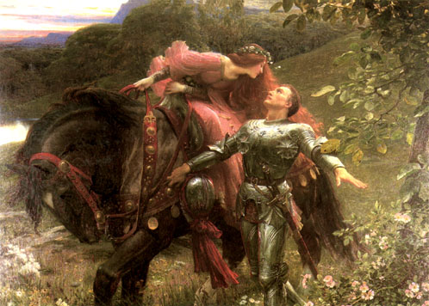
Nature
Andriesia is the popular goddess of sensual, earthly, love. Notoriously fickle with her favours, Andriesia is not overly concerned who enjoys them for she gains Life Energy from the carnal pleasure that her worshippers are enjoying, no matter who they are. She is known as both a generous and jealous goddess, depending on the worshipper’s personal experiences.
Depiction and Symbols
As befits her area of influence, Andriesia is depicted as a divinely attractive and overtly sensual woman. Her age depends on who is depicting her and for whom it the image intended. In public areas she is shown with flimsy clothing, but in temples and many private homes she is shown defiantly naked.
Symbols of Andriesia include a broken chain (representing losing inhibitions), caves (representing the womb and heart), and red flowers (representing passion).
Worshippers
Anyone wishing to find or keep love may pray to Andriesia, from illicit lovers to married couples. Even slighted lovers may worship Andriesia in the hope that she may once again bestow her favour upon them.
Andriesia is, as might be expected, a popular goddess with prostitutes and most have her image in whichever room they call their place of “work”.
Priest and priestesses of Andriesia usually have a reputation for being fairly liberal and open to suggestions of a sexual nature. This might not be true of every individual, but it is certainly accurate when describing the church as a whole. Where such open sexuality is publicly frowned upon, especially where the New Gods hold sway, priests of Andriesia may attract a negative reputation.
Blessed
Those lucky few who are Blessed by Andriesia have either an uncanny knack of getting people to fall in love with them or the ability to divine the future of love affairs. The most favoured may even have both.
- Sex Appeal Skill Bonus; 1point/+2 to skill (to max +10).
- Lithomancy; Divination using gemstones for 10 points, with a compulsory speciality to divine the future of love affairs.

Magic
Andriesia may endow her priests with Power Investiture at a maximum level of (their Religious Rank–1).
Upon reaching the Priesthood (Religious Rank 1), Andriesia allows her priests to learn from the following spells in addition to the common priest rituals:
Spell | College | Page
Alter Visage | Body Control | M41
Alter Voice | Body Control | M41
Aura | Knowledge | M101
Bravery | Mind Control | M134
Charm | Mind Control | M139
Clean | Making and Breaking | M116
Emotion Control | Mind Control | M137
Enslave | Mind Control | M141
False Memory | Mind Control | M139
Foolishness | Mind Control | M134
Forgetfulness | Mind Control | M135
Glib Tongue | Mind Control | M141
Hide Emotion | Communication and Empathy | M45
Hide Thoughts | Communication and Empathy | M46
Hush | Sound | M172
Lesser Geas | Mind Control | M140
Loyalty | Mind Control | M136
Mass Suggestion | Mind Control | M141
Peaceful Sleep | Mind Control | M138
Perfume | Body Control | M35
Permanent Forgetfulness | Mind Control | M138
Persuasion | Communication and Empathy | M45
Presence | Communication and Empathy | M49
Resist Disease | Healing | M90
Resist Pain | Body Control | M38
Sense Emotion | Communication and Empathy | M45
Sleep | Mind Control | M135
Soilproof | Making and Breaking | M116
Strike Barren | Body Control | M41
Suggestion | Mind Control | M140
Touch | Body Control | M35
Vigil | Mind Control | M138
Vigor | Body Control | M37
Weaken Will | Mind Control | M136
Ritual and Ceremony
All Andriesia’s rituals involve appeals from the heart, or from rather lower bodily regions. Emotional and physical passion, especially sexual, is promoted and often ritualised with symbolism. Sometimes the symbolism may be rather more real than symbolic! Andriesia gains much of her Life Energy from the pleasure her worshippers gain from acts of love and sex, and is therefore very keen to encourage it in all its earthly forms!
Ceremonies to Andriesia can often involve the burning of expensive incense, or the use of rare unguents. They have a reputation for being rather thinly veiled excuses for casual sex, and many temples have to limit attendance!
Note that the Resist Disease spell is very often distributed with the ceremonial wine at such occasions….
Disciplines of Faith
Priests of Andriesia are required to promote a healthy sex life in their congregation by any legal means. They are also expected to regularly “maintain” their own relationships and being single is not encouraged, though this does not mean a requirement for marriage in the legal and formal sense.
This tenet is not particularly difficult to maintain (except possibly if the priest is exceptionally unattractive in some way), but may attract an unwelcome reputation from some quarters and is a –5 point Disadvantage.
Other Tenets and Suggestions
Duty. It is rare indeed for the church of Andriesia to ask its priests to endanger themselves on its behalf. Occasionally the priests might be in danger of becoming entangled in domestic affairs, but they are not encouraged to do so. In areas where the New Gods have great influence, priests who are indiscreet might become the target for an offended mob.
Reputation. Because of the wanton nature of her priests, some less morally relaxed people look upon them with disdain. This Reputation for wanton behaviour is a –1 reaction, affecting a large group of people all the time, and worth –3 points.
Skills. The skill of Erotic Art is particularly suitable for priests (and lay worshippers) of Andriesia.

Anguran God of Death and the Underworld

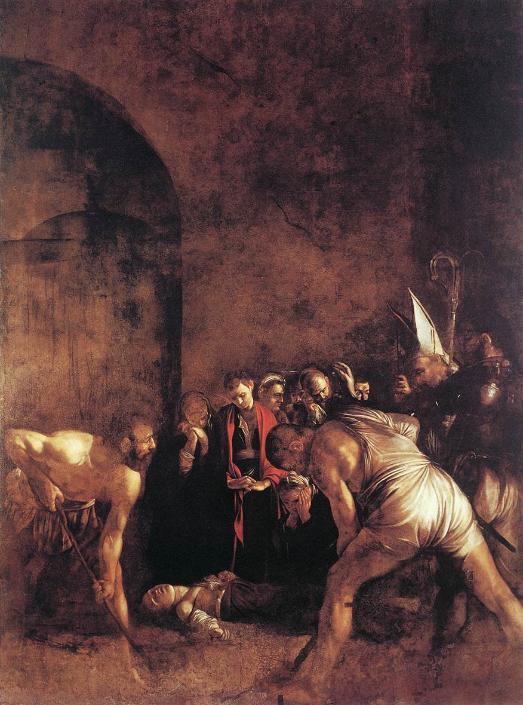
Nature
Anguran is the solemn and sombre god of death. He is responsible for collecting the souls of dead worshippers and escorting them to the underworld where Sharu judges them. Those worthy enough are admitted to the Halls, where they spend their eternity as they are deemed deserving. The unworthy souls are returned to live another mortal life; the truly bad are condemned to Pandour’s Hells for an eternity of torture and suffering.
Anguran’s servants (known variously as the “Angels of Death”, “Anguran’s Harvesters”, “The Reapers” or “The Guides”) are sent to collect the spirits of the dead from the spirit realm. His priests alert them to a newly departed soul, and try to ensure that the spirit is safe from evil influence until it is collected.
Depiction and Symbols
Anguran is generally depicted as deeply cowled and with his head bowed. This means that his face is rarely seen, and a popular superstition is that those looking into the cowl of statues of Anguran see their own dead face. The nature of Anguran’s aspect means that depicting him outside of places concerned with death is considered to be in bad taste.
Symbols associated with Anguran are those linked to mortuary rituals or mortality, such as spades, hourglasses and skulls.
Allies
Anguran is allied with Linmeth, the Goddess of Health and Healing. This seems strange to many, until they see what a natural progression it is!
Worshippers
Anguran is most often worshipped upon the death of a loved one, or when remembering the dead. Aside from his priests, few people find him a suitable area for regular worship, though there are some who believe that by showing Anguran worship in their lifetime will ensure his favour upon their death.
The priests of Anguran are a gloomy group who tend to be slightly anti-social, though much of this is thanks to the way that others tend to react to them. In general, they are dedicated to their charges (the dead), and treat them better than many in the population treat the living.
Blessed
Those Blessed by Anguran may be able to calm a restless ghost and/or guide it on its way to Anguran’s realm.
- Spirit Empathy for 10 points.
- Lay to Rest at skill level IQ+4 (as the Ritual Magic ritual); any summoner who attempts to summon the dead spirit must beat the Lay to Rest ritual roll in a Contest of Skills. Costs 5 points.
It is also said that Anguran himself collects the dead souls of those he blesses, and that the souls of the Blessed cannot be summoned back (including for a Resurrection).
Magic
Anguran may endow his priests with Power Investiture at a maximum level of (their Religious Rank–1). Upon reaching Religious Rank 1, Anguran enables his priests to learn the following spells in addition to the common priest rituals.
Note that the necromantic spells are purely to combat the abuse of the dead; any attempt to raise or control the dead for other reasons is likely to result in Anguran’s wrath (and withdrawal of the spells at the very least).
Spell | College | Page
Astral Block | Necromantic | M159
Aura | Knowledge | M101
Awaken | Healing | M90
Banish | Necromantic | M156
Body Reading | Healing | M88
Bravery | Mind Control | M134
Cleansing | Healing | M94
Control Zombie | Necromantic | M152
Death Vision | Necromantic | M149
Echoes of the Past | Knowledge | M107
Fear | Mind Control | M139
Gloom | Light and Darkness | M112
Glow | Light and Darkness | M112
Hide Emotion | Communication and Empathy | M45
History | Knowledge | M106
Images of the Past | Knowledge | M107
Insignificance | Communication and Empathy | M48
Night Vision | Light and Darkness | M111
Repel Spirits | Necromantic | M158
Resist Disease | Healing | M90
Retrogression | Communication and Empathy | M47
Scents of the Past | Knowledge | M107
Sense Emotion | Communication and Empathy | M45
Sense Life | Communication and Empathy | M45
Sense Spirit | Necromantic | M149
Steal Vitality | Necromantic | M150
Summon Spirit | Necromantic | M150
Suspended Animation | Healing | M94
Terror | Mind Control | M134
Turn Spirit | Necromantic | M151
Turn Zombie | Necromantic | M152
Ritual and Ceremony
As befits his area of influence, Anguran’s ceremonies and rituals are solemn and grave. Fast or excited movements, and displays of extreme emotion are discouraged. Most people find Anguran’s services very monotonous.
At funerals, sacrifices to Anguran are usually made for a dead person’s spirit. To please the spirit and attempt to make the passage to the afterlife more bearable, the sacrifice may be of anything that the person enjoyed in life. Typically at a funeral, a favoured pet or mount may be sacrificed so that they can accompany their master through the afterlife. In recent years, this practice has largely become ceremonial and the priest performs a symbolic sacrifice of the animal’s Life Energy (often with a Steal HT spell).
Disciplines of Faith
Priests of Anguran vow to respect the dead of any sapient race no matter what the person was like in life (it is not for them to judge the spirits). This makes them natural enemies of necromancers, against whom they vow to battle.
This tenet is worth –10 points.
Other Tenets and Suggestions
Duty. The church of Anguran will sometimes ask its priests to exorcise restless spirits, or to perform the Final Rest ceremony and spell for a ghost. Another duty sometimes handed out to priests of Anguran is the eradication of necromancers. As this duty is hazardous but occasional (6-), the value is -7.
Enemies. The major enemies of the church of Anguran are necromancers. This is a small group with formidable individuals, who only appear rarely (6-), for a final disadvantage of –10.
Social Regard (fear). Whatever the priest may actually be like personally, most people are uncomfortable around representatives of Anguran: 5 points/+1, to a maximum of +2.

BACHUE Goddess of Harvest

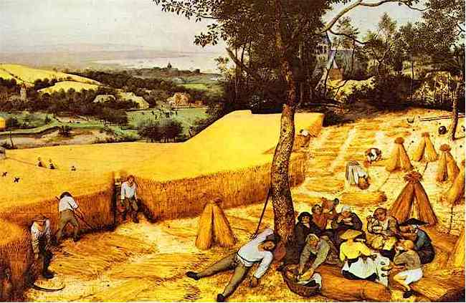
Nature
Bachue is a popular figure, especially in rural areas. Her influence on the harvest makes her worship almost essential for the success of farmers. In rural areas, those who show Bachue disrespect are considered to be the worst of criminals as they are endangering the livelihoods of the populace as well as committing blasphemy.
Though Bachue is a generous goddess, she is also known to have a vengeful streak. She is as likely to ruin the harvest of a village that fails to show her proper respect, as she is to boost the harvest of a favoured one. Of course, whatever she feels was missing in the devotions of her worshippers may have been something that her priests have no idea that she wanted.
Depiction and Symbols
Bachue is usually shown as a robustly attractive and healthy woman bearing sheaves of wheat and other such cereals. Occasionally, Bachue carries a basket of vegetables, and is always depicted with whatever cereal, fruit or vegetables are grown locally. Bachue is normally shown wearing local rural costume.
Symbols of the harvest are symbols of Bachue: scythes, wheat and crop-laden baskets.
Allies
Bachue is allied with Habren, the Goddess of Fertility. Although the two goddesses cover very similar areas, Habren is concerned with the planting of crops, whereas Bachue is concerned with their harvesting. Canny farmers worship both goddesses!
Worshippers
By far the largest group of worshippers of Bachue are rural farmers; almost every village has a temple or shrine to her.
The priests of Bachue are often skilled farmers themselves, and in rural areas are sought out to solve mundane, as well as religious, agricultural questions.
Blessed
Those Blessed by Bachue are unusually sensitive to the condition of plants and can magically improve a crop with their touch.
- Plant Empathy for 5 points.
- Fertility (as the Ritual Magic ritual) at skill level IQ+4, except that it only works on crops. Costs 5 points.
Magic
Bachue may endow her priests with Power Investiture at a maximum level of (their Religious Rank–1).
Upon reaching Religious Rank 1, Bachue may grant her priests the following spells, in addition to the common priest rituals.
Spell | College | Page
Heal Plant | Plant | M161
Identify Plant | Plant | M161
Insect Control | Animal | M30
Mature | Food | M78
Plant Growth | Plant | M162
Rain | Air | M195
Resist Cold | Fire | M74
Seek Plant | Plant | M161
Sense Life | Communication and Empathy | M45
Stone to Earth | Earth | M51
Ritual and Ceremony
A good deal of ritual associated with Bachue involves dancing and merrymaking. Bachue’s aspect is also associated with making wine and beer, and these are consumed in her honour during many rituals. This makes her larger ceremonies resemble parties, and her holy festivals are an excellent excuse for her followers to get drunk and indulge in rather wild behaviour. Much singing and occasional dancing accompany even smaller ceremonies, though it is not as free and wild as with larger festivals.
Most farmers are careful to set aside part of any harvest in a small ceremony to Bachue, thus ensuring her goodwill for the next.
Disciplines of Faith
Priests of Bachue vow to protect crops and the harvest. Being so fundamental to the success of a farming community, this tenet is worth only -5 points.
Other Tenets and Suggestions
Alcoholic. Celebrating Bachue’s influence over wine and beer-making can make some priests go a little overboard: -15 points.
Duty. The only duties a priest of Bachue may be called upon to perform are those associated with ridding a crop of pestilence and disease. Although often sometimes difficult, this duty is not dangerous and is worth no points.
Skills. Almost all priests of Bachue have the Farming skill at a minimum of 12.
Social Regard (respected). The harvest is a vital aspect of life in Saduria, and Bachue’s priests are shown respect in response to this. 5 points/+1, to a maximum +2.

chauro Goddess of the Home

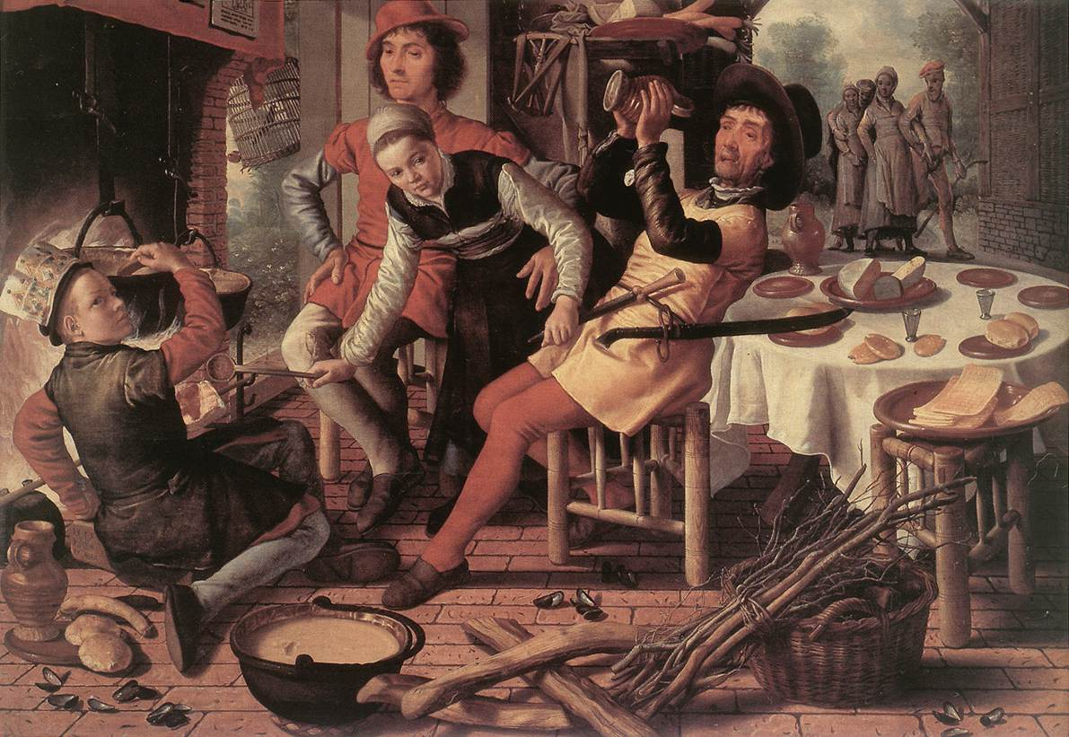
Nature
Chauro is the comforting and motherly goddess of the hearth and home. All domestic life within the home comes under her auspices, and her main concerns are the maintenance of domestic health and harmony, however this may be achieved.
Unusually amongst the Old Gods, Chauro is patron to a faerie race, the brownies (known as “Chauro’s Children”). These shy, furry little humanoids delight in performing acts of small kindness to deserving families, acts which include mending worn clothing and tidying away mess. As long as they are left a bowl of milk and small food treats at night, they will remain with a family. Anybody who attempts to observe or capture a brownie risks permanently driving them away. Those who show Chauro disrespect or attempt to harm the brownie will attract its spite, and the kind acts are replaced with petty acts of sabotage and destruction.
See the text box at the end of the Chauro section for a fuller description of brownies.
Depiction and Symbols
Chauro is usually shown as an attractively matronly woman wearing simple clothing. Sometimes, depictions show her with a broom or another piece of domestic paraphernalia. She may be seen with a brownie hiding about her person.
Worshippers
Everyone wants a happy home, and Chauro is an extremely popular goddess as a result. Most homes, especially in rural areas, have at least a small shrine to her, and a statuette of the goddess is the traditional gift to a couple moving into a new home.
The priests of Chauro act as domestic counsellors as well as spiritual advisors. They may be called upon to help for almost every problem, from marriage difficulties to cleaning worries.

Blessed
Those Blessed by Bachue are granted the personal attentions of a brownie. The brownie will hide itself about the Blessed person’s home or luggage, and perform useful little domestic tasks. Attempts to observe the brownie may drive it away for a time, but it will usually return so long as it is left in peace in the future. Repeated attempted to observe the brownie will drive it away for good. If this is the fault of the Blessed person they lose the points (as with an ally)
This useful (if trivial) Blessing is considered an Ally worth 10 points.
Magic
Chauro may endow her priests with Power Investiture at a maximum level of (their Religious Rank–1).
Upon reaching Religious Rank 1, Bachue may grant her priests the following spells, in addition to the common priest rituals.
Spell | College | Page
Clean | Making and Breaking | M116
Continual Light | Light and Darkness | M110
Converse | Sound | M173
Cook | Food | M78
Cool | Air | M195
Create Water | Water | M184
Dye | Making and Breaking | M116
Extinguish Fire | Fire | M72
Find Weakness | Making and Breaking | M116
Haircut | Body Control | M39
Heat | Fire | M74
Ignite Fire | Fire | M72
Know Recipe | Food | M78
Mature | Food | M78
Nightingale | Protection and Warning | M137
No-smell | Air | M24
Prepare Game | Food | M78
Preserve Food | Food | M79
Purify Food | Food | M78
Purify Water | Water | M184
Rejoin | Making and Breaking | M116
Relieve Sickness | Healing | M90
Repair | Making and Breaking | M118
Season | Food | M77
Soilproof | Making and Breaking | M116
Test Food | Food | M77
Truthsayer | Communication and Empathy | M45
Warm | Air | M195
Watchdog | Protection and Warning | M167
Ritual and Ceremony
As befits a domestic goddess, most of her ceremonies are concerned with trivial household tasks. Chauro’s priests are usually invited to conduct their rituals in the houses of followers, as few large temples exist.
Chauro asks that a small portion of the main family meal be dedicated to her each day, and that she is remembered when the family gathers.
Disciplines of Faith
Chauro imposes no Disciplines of faith on her priests, beyond those concerned with maintaining domestic harmony.
Other Tenets and Suggestions
Duty. Priests of Chauro are often called upon to sort out domestic problems, but this is not dangerous and is therefore worth no points.
Skills. As they are called upon to act as domestic counsellors, priests of Chauro find skills such as Diplomacy, Finance, Psychology, and Sociology useful. Housekeeping is almost essential.
Social Regard (respected). Everyone likes domestic harmony, and Chauro’s priests are held in high regard: 5 points/+1, to a maximum +3.

BROWNIE. Faerie, (spirit race). 233 Points
Brownies are a free-willed race of faeries that serve Chauro, the Old Gods Goddess of the Home. There physical form is small (usually less than a foot tall) and heavily furred, superficially resembling dark-furred chinchillas but with kindly humanoid faces and hands. Brownies are incredibly shy, and dislike being paid attention beyond small acts of kindness (such as being left bowls of milk). Any attempts to leave more extravagant gifts will upset the brownie who will likely leave.
In the home, brownies perform small domestic duties and protect the home and family, though they are not likely to physically attack anything beyond a particularly troublesome rodent. Far more rarely they may also attach themselves to homeless individuals, and may travel around with them secreted in their baggage. Those lucky houses and people who have attracted the attention of a brownie (there is never more than one per family or person) are considered blessed by Chauro.
__________________________________________________________________
ST 10 DX 12 IQ 10 HT 11
Size Modifier –4 (18” tall)
Advantages: Doesn’t Breathe [20], Doesn’t Eat or Drink [10], Doesn’t Sleep [20], DX+2 (figured in) [40], HT+1 (figured in) [10], Immune to Metabolic Hazards [30], Insubstantiality (Affect Substantial +100%) [160], Invisibility (Substantial only –10%, Usually On +5%) [38], Unaging [15]
Disadvantages: Code of honour; Care for and protect household but leave if offered a gift [-10], Dependency on mana (Common, constant) [-50], Dread, cold iron (common) [-20], Frightens animals [-10], Reduced move –2 [-10], Sense of duty to household [-5], Shyness, severe [-10], Vulnerability, cold iron x2 damage (occasional) [-20]
Quirks: Distractible [-1], Dull [-1], Humble [-1]
Skills: Housekeeping at IQ+8 [28]

ELENDIC God of Music
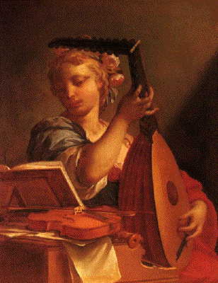
Nature
Elendic is a god much celebrated in times of festival and party, but revered only by a few bards and musicians for the majority of the time. His aspect of music is a luxury that is appreciated by most people, but needed by none.
Elendic’s influence covers all aspects of music, from solemn recitals to wild folk music. He is as happy with a village fiddler as with a dignified urban harpsichord player.
Depiction and Symbols
Depictions of Elendic depend on which music is popular in the area. He may be a jolly man with a flute or a stately harpist. All depictions show him with a musical instrument or two, and most have him shown apparently enjoying some unheard tune.
Any musical instrument is associated with Elendic and is used as a symbol of him.
Worshippers
Professional musicians call on Elendic to help them with performances, composers ask for his help in writing, and audiences thank him for both! In general, though, the population is more concerned with the land and their domestic problems to worship Elendic regularly.
Priests of Elendic are usually skilled musicians, and his temples ring with music and song.
Blessed
A person Blessed by Elendic will have a natural talent for music
- Musical Ability Talent: 5 points/level.
- Group performance (conducting).
- Musical composition.
- Musical influence.
- Musical instrument.
- Singing
- +1 Reaction bonus from anyone hearing or critiquing their work.

Magic
Elendic may endow his priests with Power Investiture at a maximum level of (their Religious Rank–1).
Upon reaching the Priesthood (Religious Rank 1), Elendic allows his priests to learn from the following spells in addition to the common priest rituals:
Spell | College | Page
Alter Voice | Body Control | M41
Awaken* | Healing | M90
Beast Soother* | Animal | M29
Bravery* | Mind Control | M134
Cadence* | Body Control | M39
Drunkenness* | Mind Control | M136
Enthral* | Mind Control | M139
Fascinate* | Mind Control | M135
Foolishness* | Mind Control | M134
Insignificance | Communication and Empathy | M48
Master* | Animal | M30
Memorize | Knowledge | M105
Musical Scribe | Sound | M174
Persuasion* | Communication and Empathy | M45
Presence | Communication and Empathy | M48
Recall | Knowledge | M106
Silver Tongue | Sound | M174
Sound | Sound | M171
Voices | Sound | M172
*These spells require the priest to sing or play a musical instrument for the duration of the spell. This takes the place of the usual spoken words of power but cannot be dispensed with, no matter how high the caster’s skill.
None of these spells can be cast at a higher skill than the priest’s Singing or relevant Musical Instrument skill (as relevant).
Ritual and Ceremony
As may be surmised from his aspect, Elendic’s rituals involve a good deal of music. Some of the ceremonies resemble concerts; only the presence of priests indicates that a religious ceremony is occurring.
Elendic is called upon before recitals and performances, and he gains Life Energy from people’s enjoyment of music dedicated to him.
Disciplines of Faith
Elendic requires that his priests promote and perform music. This is not generally a hardship, and is only worth -1 point.
Other Tenets and Suggestions
Skills. Any skill connected with music is appropriate for a priest of Elendic, but the skills Singing and Musical Instrument are particularly relevant, especially if the priest is learning the spells of Elendic’s clerical magic that require a song or musical instrument. Some priests may also learn the skill Connoisseur – music to appreciate better their god’s aspect.
Voice. If the priest’s instrument is his voice, then this advantage is a natural and obvious one: 10 points.

habren Goddess of Fertility

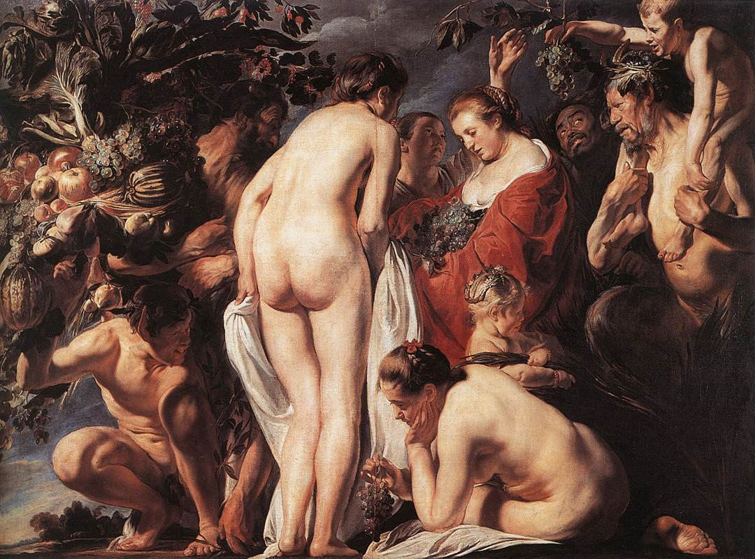
Nature
Habren’s influence deals with all aspects of fertility, from reproduction to financial deals. Her wide-ranging facets have earned her the nickname, “Goddess of Many Branches”.
Whatever enterprise she is overseeing, Habren looks to maximise the result. She loves to see plenty spring from little, and is always happy when something grows, whether it is agricultural crops, a human baby or a virus!
This lack of distinguishing between beneficial and detrimental fertility makes her as likely to be called upon to withdraw her fertile influence as to grant it.
Depiction and Symbols
Habren is generally shown wearing local costume appropriate to the side of her aspect being celebrated. In rural areas she may be shown wearing a dress of living plants, in banks carrying a coin-laden set of scales, and in the homes of newly-weds as a matron holding a baby.
Symbols of Habren include corn dollies, scales and branches.
Allies
Habren is allied with Bachue, the Goddess of Harvest. Habren is responsible for the crops growth, but Bachue then takes over when they are harvested. Most farmers will worship both goddesses, paying each more attention at the appropriate time.
Priests of Bachue and Habren often have lively but friendly discussions on why their goddess is the most important in the partnership.
Worshippers
Although farmers are the largest group of worshippers, merchants and investors also regularly seek Habren’s favour. Couples trying for children pray to Habren, as do couples not wanting children!
Habren may also be called upon to withdraw her fertile touch in times of epidemic, whether of insects, rats or disease. Prostitutes who have no wish to become pregnant during the course of their business also popularly worshipped Habren.
Blessed
Those Blessed by Habren either have the Business Acumen Talent or the Green Thumb talent. It is very rare to have both.
- Business Acumen Talent: 10 points per level
- Accounting.
- Administration.
- Economics.
- Finance.
- Gambling.
- Market Analysis.
- Merchant.
- Propaganda.
- +1 Reaction bonus per level from your business associates.
- Green Thumb Talent: 5 points per level.
- Biology.
- Farming.
- Gardening.
- Herb Lore.
- Naturalist.
- +1 Reaction bonus per level from gardeners, farmers and sentient plants.
Magic
Habren may endow her priests with Power Investiture at a maximum level of (their Religious Rank–1).
Upon reaching Religious Rank 1, Habren may grant her priests the following spells, in addition to the common priest rituals.
Spell | College | Page
Bless Plant | Plant | M161
Create Air | Air | M23
Create Earth | Earth | M51
Create Plant | Plant | M163
Create Water | Water | M184
Decay | Food | M77
Distil | Food | M46
Essential Earth | Earth | M53
Extinguish Fire | Fire | M72
Hair Growth | Body Control | M39
Heal Plant | Plant | M161
Identify Plant | Plant | M161
Insect Control | Animal | M30
Mature | Food | M78
Pestilence | Necromantic | M154
Plant Growth | Plant | M162
Pollen Cloud | Plant | M162
Rain | Air | M195
Rejuvenate Plant | Plant | M163
Remove Contagion | Healing | M90
Sense Life | Communication and Empathy | M45
Tangle Growth | Plant | M162
Ritual and Ceremony
Habren’s fertility aspect takes many forms, and so do the rituals and ceremonies of her priests. The essence of them all is the same, however, and concerns itself with blessing Habren for her fertile bounty. It is the detail that differs; one temple may concentrate on agriculture, another on investment, and yet another on gambling.
Usually, some token of the aspect’s particulars will be present in the ritual, whether it is crops, money or dice.
Disciplines of Faith
Habren’s priests must spread fertility, helping the infertile and judging the virtue of the case of anyone who wishes fertility to be suppressed for a time. These disciplines are neither difficult nor arduous and are worth -5 points.
Other Tenets and Suggestions
Duty. Occasionally, a priest of Habren may be called upon to make an area of land fertile. This will probably involve much digging, irrigation and fertilisation, and is an arduous task but not dangerous, and is worth no points.
Skills. Priests of Habren will normally have one or more of the skills; Economics, Finance, Gambling, Market Analysis, Merchant, Farming or Gardening at a minimum of 12. Most have more than one.
Social Regard (respected). Priests of the fertility goddess are respected by the populace, mainly in rural areas but everyone has some enterprise that they want to grow: 5 points/level, to a maximum of +1.

halfour God of Storms

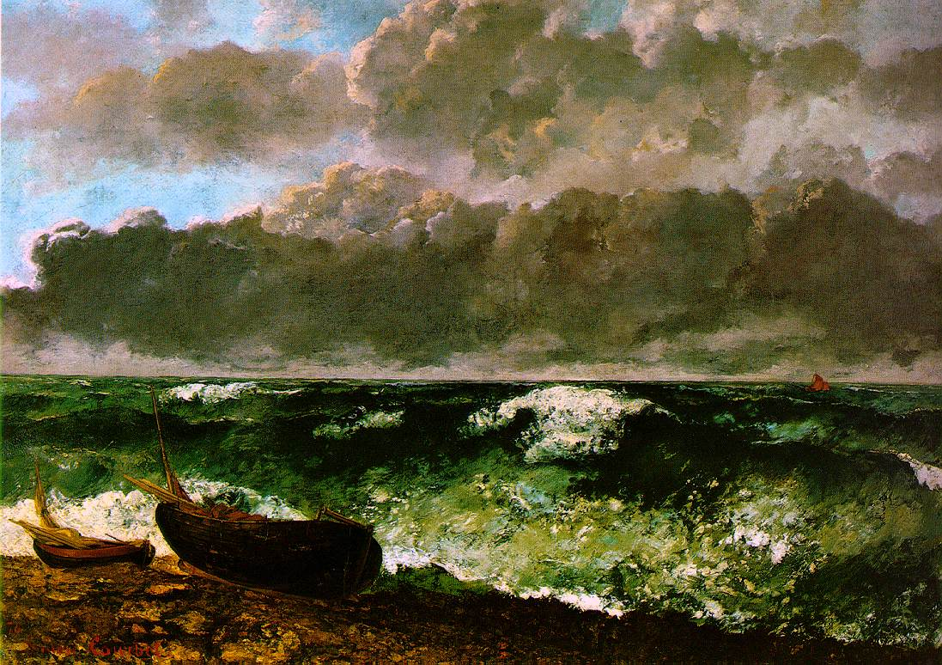
Nature
Halfour is the violent God of Storms and wild weather. Storms are manifestations of Halfour’s anger, and people pray to him to help calm his temper before the damage his storms cause is too great.
Halfour is also sometimes seen as a god of winds and weather, though this is an optimistic interpretation of his powers and not many people are convinced by it.
Depiction and Symbols
Halfour is usually shown as a strong man with wild hair and beard, with clothing blowing around him. He is generally depicted frowning, though some statues may have him smiling if they wish to appeal to his better nature.
Worshippers
Halfour is worshipped directly by people who are impressed by the sheer power he commands. When storms smash whole villages or wreck fleets, the populace is reminded of Halfour’s strength and his worship temporarily rises.
Mainly, however, Halfour attracts worship from those who wish to avoid his storms. This includes mostly sailors and farmers, but also hunters, travellers, shepherds and others who find themselves far from shelter a lot.
Blessed
Those Blessed by Halfour are able to predict storms and other weather phenomenon. They are greatly prized by shipping agents!
- Predict Weather (up to 7 days within 5 mile radius): 20 points.
Magic
Halfour may endow his priests with Power Investiture at a maximum level of (their Religious Rank–1).
Upon reaching Religious Rank 1, Halfour may grant his priests the following spells, in addition to the common priest rituals.
Spell | College | Page
Clouds | Air | M194
Create Air | Air | M23
Earth to Air | Air | M25
Predict Weather | Air | M193
Purify Air | Air | M23
Rain | Air | M195
Shape Air | Air | M24
Storm | Air-weather | M195
Wall of Wind | Air | M25
Wind | Air-weather | M195
Windstorm | Air | M25

Ritual and Ceremony
Halfour’s temples are all open to the elements. Many are built in places where the wind is fiercest, on plains, on mountains or high hills.
The rituals are as wild as the god, with much shouting and swirling movement. People used to the more genteel nature of ceremonies of the other Old Gods are often shocked at the elemental passions of Halfour’s rituals.
Disciplines of Faith
Halfour’s priests vow never to shelter from a storm, they also vow to actively seek to perform many of their ceremonial duties in wild. Many will deliberate cast clerical magic to summon storms on holy days (approximately once per month), which does not enamour them to their immediate neighbours.
This Discipline of Faith may be dangerous, and is certainly inconvenient, for a -10 points.
Other Tenets and Suggestions
Skills. Although only required by their god to not actively shelter from storms, many priests choose to live outside for most of the time. This requires Survival skill unless close to civilisation. Many priests also have Meteorology, though this is secondary if they also have the clerical spell, Predict Weather.
Social Stigma (wildman). In extreme cases, the wild and rough-looking priest living outdoors in the middle of nowhere may attract a social stigma in much the same way as barbarians and other “primitive” peoples.
Temperature Tolerance. If the priest chooses to stay out in all weathers, then being tolerant to the cold will be a great advantage: 2 levels maximum, at 1 point per level.

hashin God of Murder and Violent Death

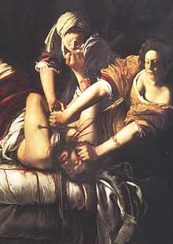
Nature
Hashin is regarded as the most malign of the Old Gods. His aspect of violent and sudden death is an uncomfortable one for most people, and they see him as evil. Most worshippers of Hashin are, or are certainly assumed to be, assassins or murderers.
It is said that Hashin has no sympathy or empathy with those mortals upon whom he casts his baleful influence. He is as happy with the violent death of a thug as with the murder of an innocent child. There are plenty who believe that Hashin ought to have been imprisoned behind the Great Seal and be grouped with the devils.
Those who accuse Hashin, however, overlook one thing: it is the mortals who are performing the murders and killings, and Hashin never actually encourages or commands a death. Rather, his unenviable task is to look after those mortals to whom the devils would otherwise undoubtedly be drawn. In essence, Hashin does not make murderers, but he does look after their souls.
Depiction and Symbols
Hashin is generally demonised, and his depictions show him with fangs, glowing eyes and drawn blades. In temples and areas where the artist was more charitable, Hashin is seen as cloaked figure with an impassive face.
Symbols of Hashin are daggers and anything poisonous.
Worshippers
Hashin attracts the cold-blooded killers, those frightened of the cold-blooded killers, and those who want to be cold-blooded killers. Openly proclaiming yourself a worshipper is likely to attract unwanted attention from the authorities, and most followers of Hashin remain secretive.
Many nobles have secret shrines to Hashin, not only if they are trying to have a rival murdered, but also in an attempt to protect themselves against being murdered. This last reason rarely works; Hashin does not protect his worshippers against each other any more than he cares for the other victims.
Priests remain secret through discretion as well fear of legal persecution, because many are skilled assassins as well as priests. Note that, because they keep their priesthood secret, priests of Hashin do not get the social status normally associated with their rank.
Blessed
Hashin Blesses followers with an unearthly ability to see in darkness.
- Night Vision: 1point/level, to maximum 9 levels.
Magic
Hashin may endow his priests with Power Investiture at a maximum level of (their Religious Rank–1).
Upon reaching Religious Rank 1, Hashin may grant his priests the following spells, in addition to the common priest rituals.
Spell | College | Page
Alter Visage | Body Control | M41
Boost Dexterity | Body Control | M37
Climbing | Body Control | M35
Dark Vision | Light And Darkness | M111
Darkness | Light and Darkness | M111
Dull Hearing | Mind Control | M133
Dull Sight | Mind Control | M133
Flash | Light and Darkness | M112
Hinder | Body Control | M36
Insignificance | Communication and Empathy | M48
Might | Body Control | M37
Pain | Body Control | M36
Poison Food | Food | M78
Spasm | Body Control | M35
Strike Blind | Body Control | M38
Strike Deaf | Body Control | M38
Strike Dumb | Body Control | M38
Strike Numb | Body Control | M40
Stun | Body Control | M37
Test Food | Food | M77

Ritual and Ceremony
As befits such a secretive god, Hashin’s rituals and temples are hidden from public gaze. In general, the populace will never know that a temple to Hashin exists in their town, but most towns have one, and some villages share one hidden away somewhere.
The ceremonies are full of dark overtones, with masked worshippers and plenty of bared knife blades, but no sacrifices or other killing goes on. Hashin may be god of murder but he will not tolerate human sacrifice on his behalf.
Often, an assassin will perform a dedication ceremony to Hashin before a mission. This is acceptable, and Hashin will often watch over the murderer.
Disciplines of Faith
Oddly for such a bloodthirsty church, Hashin does not demand much of his priests or worshippers. He certainly does not demand that they kill (although he would like the murdered person’s soul dedicated to him). Assassins come from all walks of life, from brutal thugs to elegant nobles, and no discipline of faith could cover them all.
Other Tenets and Suggestions
Bloodlust. It is possible that a love of killing would draw someone to become a priest of Hashin in the first place: -10 points.
Callous. If a priest of Hashin starts getting a conscience then he may be in the wrong job: –5 points.
Enemies. If the priest has been known to commit murder, then somebody, somewhere will hunt him.
Sadism. This is actually quite rare, for a sadistic assassin is not an efficient one. It might be found amongst acolytes and lower ranked priests, but they are expected to overcome it (buy it off) if they wish to progress: –15 points.
Secret Identity. Most priests of Hashin keep their profession secret for fear of persecution and arrest. The penalty for murder is death, and a religious court will not reduce the sentence simply because they recognise that Hashin is one of their own: -30, -40 if status is 3+.
Skills. Most priests of Hashin take at least some of the skills expected of an assassin. Not all priests are assassins, and not all assassins are priests of Hashin, but plenty are stealthy and skilled in the art of killing.
Social Regard (feared). Many people are frightened to show open hostility to the representatives of a god of murder, but that does not mean they like being around them. Note that this is incompatible with a priest keeping his profession a secret: 5 points/+1, maximum +3.
Social Stigma (criminal). Only if the priest has actually been accused of criminal behaviour will this be relevant. This is a –1 Reaction modifier (-2 in law-enforcement circles) for –5 points. Being a wanted criminal, of course, carries its own problems….
linmeth Goddess of Health and Healing

Nature
Linmeth is, naturally, a very popular goddess who even rival pantheons will usually respect. As the Goddess of Health and Healing, she has influence over all aspects of recover from ailments, including hygiene, diet and lifestyle.
Linmeth is not in competition with physicians, as she only heals for a price. There are plenty of charitable centres where the rich will pay to have the poor healed and made well, but usually Linmeth’s priests are choosy about who they heal with their magic. Casting a healing spell is seen as a great boon from the Goddess, who prefers to retain the Life Energy herself! If there was free healing then the temples would be overwhelmed and the Goddess exhausted of her Life Energy.
Linmeth’s priests preach a healthy lifestyle and diet, and very quickly become tiresome and irritating. Most are prepared to sit through a sermon, however, rather than submit to the physicians.
Depiction and Symbols
Linmeth is often shown as a motherly figure carrying a bowl of water and a cloth. She is sometimes seen surrounded by the sick.
Allies
Linmeth is allied with Anguran, the God of Death. This association surprises many, but Anguran’s duties to the souls of the dead mirror those of Linmeth to the living.
Worshippers
Those who are ill, or have someone who they know who is ill, worship Linmeth. In practice this means just about everyone, for the TL3/4 world of Saduria teems with illness and disease.
Priests of Linmeth are always skilled healers, having mundane skills as well as access to clerical magic. Many work in depressed areas, mainly treating disease and educating people about healthy living. Rich benefactors, often people who have benefited from Linmeth’s attentions in the past, usually finance these missions.
Linmeth’s priests always charge for their services, and generally charge more than an equivalent mundane healer. This price goes to buying expensive medicines and equipment, towards training physicians and assistants, and towards buying land and buildings for new hospitals. Occasionally, a trade may be made where the healed person can donate other goods or services. Often, such a person will work as an assistant in one of Linmeth’s hospitals.
Blessed
Linmeth may Bless her favourites with the power to heal. Take one of the following options.
- Healing (own and other sapient humanoid races only): 30 points.
- Faith Healing (works on any race): 36 points.
- Healing; Disease Only: 18 points.
- Healing; Injuries Only: 24 points.
- Healing; Own Race Only: 24 points.
See B(4th)59 for further details.
Alternatively, the Blessed person may find it easy to learn mundane healing skills.
- Healer talent: 10 points per level:
- Diagnosis
- Esoteric Medicine
- First Aid
- Pharmacy
- Physiology
- Psychology
- Surgery
- Veterinary
- Reaction bonus +1/level from past and present patients.
Magic
Linmeth may endow her priests with Power Investiture at a maximum level of (their Religious Rank–1).
Upon reaching Religious Rank 1, Linmeth enables her priests to learn all the spells of the Healing College, in addition to the common priest rituals.
Ritual and Ceremony
Linmeth’s quiet and gentle nature is reflected in her rituals. Movements are calm and measured and tone of voice and emotions level. Examination of Linmeth’s rituals shows obvious similarities between the ritual and the actions of a physician.
Ceremonies to Linmeth always include prayers for the ill, and a call for donations! Many hospitals in Saduria are run by Linmeth’s priests and double as temples. Patients are assured of competently skilled carers, but at the expense of both their wealth and having to sit through interminable sermons.
Disciplines of Faith
Priests of Linmeth vow to care for the ill, no matter who they are, as long as the price is paid. This often includes working in areas where disease or other hazards are present. In addition, the priest is expected to live healthily, to avoid alcohol and bad living, and to maintain high levels of personal hygiene.
This tenet is worth -15 points.
Other Tenets and Suggestions
Duty. Priests of Linmeth are occasionally sent to heal the sick in remote or dangerous areas. Villages plagued by epidemics, natural disasters and battlefields all attract the church’s missionaries. As this duty is hazardous but occasional (6-), the value is -7.
Skills. Healing skills are almost mandatory. A priest of Linmeth need not be a physician, but should be able to at least act as an assistant. Most are skilled physicians (using Esoteric Healing or Pharmacy-herbal), and many are also surgeons (Surgery) and/or herbalists (Herb Lore). Other skills such as First Aid, Diagnosis, and Physiology are also common.
Social Regard (respected). Being a priest of Linmeth means that you are treated with respect. After all, everyone required medical care at some point in their lives: 5 points/+1, up to a maximum of +2.
Healing
The full rules for Healing are found on B(4th)424.
In Saduria, there are four options open to the sick (five if you just wait to heal naturally):
- Magical healing.
- Professional Doctors/Surgeons.
- Barber Surgeons.
- Herbalists and other traditional healers.
Magical healing includes that from priests, mages and witches. It is reliable, fast and potent but not necessarily freely available.
Professional doctor and surgeons have been trained in the Sadurian universities, learning modern techniques and using good or better equipment (see equipment modifiers B(4th)345). Most surgeons are also doctors, though they do not have the Physician skill, and are trained to Diagnose as well as operate. Professional doctors and surgeons operate (pun intended) at TL4.
Barber Surgeons are the self-trained surgeons that are a carry-over from an earlier age. They are cheaper and more widely available than professional surgeons, may have Diagnosis but are rarely trained in Pharmacy, and usually have only basic equipment. Barber surgeons still use TL3 techniques, and many leave their patients in a worse condition than they started in.
Herbalists are the wise men and women who create healing potions and lotions in rural areas. They are very rarely Surgery trained, and limit their healing to administering their herb-based remedies.

nakki God of Water

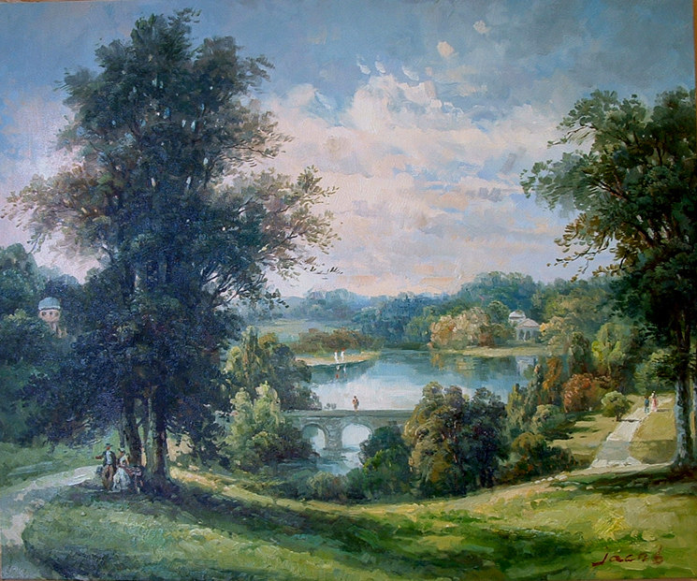
Nature
Nakki is the God of Water, specifically inland water and its inhabitants. His aspect includes rivers, lakes and ponds, but also underground water and wells.
Nakki‘s moods are changeable, and he will playfully spin a boat to face the opposite way, or even ground it on a sandbank if the crew have not made the proper devotions before setting off.
Depiction and Symbols
Nakki is sometimes known as “the Boatman”, and is usually shown as a young man with a punt pole and broad-brimmed hat. Although the hat is almost universal, the pole may be exchanged for a fishing rod, net or even a coracle.
Symbols connected with Nakki are freshwater fish and inland aquatic animals.
Worshippers
Nakki’s major worshipper base is composed of fishermen and boatmen. These are the people who are most likely to be using inland water regularly, and therefore the ones who seek Nakki’s blessing most often.
Priests of Nakki are charged with ensuring that wells and rivers are maintained, and they are most often called upon to help during droughts. Merchants using river traffic will usually request that a priest of Nakki bless their boats before setting out.
Blessed
Those Blessed by Nakki are able to divine secrets using fresh water.
- Divination-Crystal gazing (using pure, still, water): 10 points.
Magic
Nakki may endow his priests with Power Investiture at a maximum level of (their Religious Rank–1).
Upon reaching Religious Rank 1, Nakki may grant his priests the following spells, in addition to the common priest rituals.
Spell | College | Page
Amphibian Control | Animal | M30
Body of Water | Water | M185
Breathe Air | Water | M26
Breathe Water | Air | M189
Create Spring | Water | M190
Create Water | Water | M184
Crustacean Control | Animal | M30
Current | Weather –Water | M194
Dehydrate | Water | M188
Destroy Water | Water | M185
Essential Water | Water | M189
Fish Control | Animal | M30
Mammal Control (aquatic only) | Animal | M30
Melt Ice | Water | M186
Purify Water | Water | M35
Repel Amphibian | Animal | M31
Repel Crustacean | Animal | M31
Repel Fish | Animal | M31
Repel Mammal (aquatic only) | Animal | M31
Resist Water | Water | M186
Seek Water | Water | M184
Shape Water | Water | M185
Swim | Movement | M147
Umbrella | Water | M185
Walk on Water | Water | M186
Walk Through Water | Water | M188
Water Vision | Water | M187
Waves | Weather – Water | M194

Ritual and Ceremony
Ceremonies to Nakki inevitably involve plenty of fresh water; most temples have pools or large bowls full of purified water. Many of the more devoted congregations conduct the entire ceremony in lakes or rivers, though this is usually limited through the practicality of temperature and safety; the congregations’ spiritual well-being being secondary to the danger of being swept away or attacked by water-dwelling beasts.
Rituals of blessing include much splashing of fresh water on the item or person to be blessed. It is obvious to onlookers whether or not someone emerging from a temple of Nakki has just been blessed!
Disciplines of Faith
Priests of Nakki are expected to remain free from worldly confusion. To this effect, they must spend many hours per day in deep contemplation and meditation, preferably by a body of tranquil water.
This tenet is worth –10 points.
Other Tenets and Suggestions
Autohypnosis. This skill gives the priest +2 to a specific mental task, including Ritual Magic rolls.
Eidetic Memory. One advantage of a regime of quiet contemplation and meditation is the ability to focus the mind to almost mystical levels. Priests of Nakki may substitute a Meditation roll for the usual IQ roll for learning: 5 or 10 points.
Intolerance. Priests of Nakki like calm and their own company. They can sometimes be rather intolerant of those who are noisy and boisterous: –5 points.
Less Sleep. A focussed and calm mind often allows less sleep: 2 points/level to a maximum of 4 levels.
Loner. One drawback of being so self-focussed is that it becomes more difficult to deal with other people: –5 points.
Longevity. It may be the calm minds, or it may be the drinking of pure water, but priests of Nakki seem to age extremely well: 2 points.
Meditation. This skill is very important to priests of Nakki, as they are expected to meditate for much of the day.
Skills. Many (but by no means all) priests of Nakki have the skill of Swimming. Other common skills are Boating (various craft) and Fishing.

pandour God of Retribution
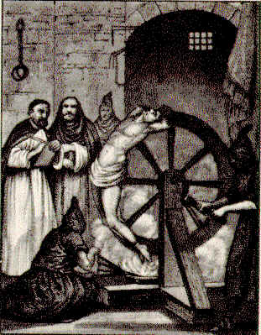
Nature
Pandour is a vengeful and intolerant god who advocates harshly punishing all those guilty of sin. The son of Sharu, God of Justice, Pandour sits on his father’s right hand and lists the sins of a dead soul, his sister, Peletri, sits on their father’s left hand and lists the soul’s good acts.
Pandour is also in charge of the Hells, where the souls of evil people are cast for eternal torture and suffering.
The Sadurian populace know Pandour as a fierce and unforgiving god, whose servants are frequently engaged in rooting out evil. Often, these hunts involve the persecution of people suspected of just being sympathetic to the cause of whatever Pandour views as evil.
Depiction and Symbols
Pandour is often portrayed as a stern man in a hooded cloak, usually carrying a sword and set of scales (to weigh up the sins of the accused).
Swords, scales and an accusingly pointed finger are symbols of Pandour.
Allies
Pandour is allied to Sharu, God of Justice and his father.
Worshippers
A worshipper of Pandour may be anything from a genuine advocate of deserved punishment to a rabid bigot. Sadly, the god attracts those who take pleasure in the persecution of the weak and helpless, and much of Pandour’s bad reputation stems from this association.
The better of Pandour’s followers believe that punishment of sin is the best way to discourage it, and argue that it is the best way to stop a misguided person from falling into the clutches of the devils.
Pandour’s priests organise hunts for sinners, reserving most of their energy for demon and devil-worshippers, witches and blasphemers (including anyone committing religious crimes against the Old Gods). They will also hunt out anyone who has committed major secular crimes. In their spare time, they are suspicious of worshippers of other pantheons, foreigners and sorcerers (even where sorcery is legal). These hunters are variously known as Pandour’s Riders, Black Riders, or the Bleak Judges.
Priests and worshippers of Pandour may be called upon to act as magistrates, but are more usually given a role as prosecuting legal counsel, especially in religious trials.
Blessed
Pandour Blesses his faithful with the power to find sorcery or associated evil. Most will have one power only, but the most favoured may have several. Those so Blessed are often called upon to serve Pandour’s Riders: Cost 10 points per power.
- Detect Sorcery
- Detect Sorcerers.
- Detect Undead.
- Detect Witchcraft
- Detect Witches.
Magic
Pandour may endow his priests with Power Investiture at a maximum level of (their Religious Rank–1). Upon reaching Religious Rank 1, Pandour enables his priests to learn the following spells in addition to the common priest rituals.
Spell | College | Page
Aura | Knowledge | M101
Borrow Language | Communication and Empathy | M46
Bravery | Mind Control | M134
Compel Truth | Communication and Empathy | M47
Detect Magic | Knowledge | M101
Gift of Letters | Communication and Empathy | M46
Gift of Tongues | Communication and Empathy | M46
Know True Shape | Knowledge | M106
Mystic Mark | Making and Breaking | M119
Pain | Body Control | M36
Pathfinder | Knowledge | M105
Resist Pain | Body Control | M38
Seek Magic | Knowledge | M102
Seeker | Knowledge | M105
Sense Emotion | Communication and Empathy | M45
Sense Foes | Communication and Empathy | M44
Sense Life | Communication and Empathy | M45
Strengthen Will | Mind Control | M136
Trace | Knowledge | M106
Truthsayer | Communication and Empathy | M45
Turn Zombie | Necromantic | M152
Weaken Will | Mind Control | M136
Ritual and Ceremony
Ceremonies to Pandour involve much calling upon sinners to renounce their wicked ways. If a sinner is truly wishing to repent, Pandour’s priests have rituals that they can perform to inform both Pandour and Sharu of this fact. Much of the time Pandour’s priests spend in ritual concerns this dealing with repentant sinners. A huge number appear begging for repentance whenever one of Pandour’s Riders appears in town….
A darker version of this ritual is performed during the execution of an unrepentant sinner.
Disciplines of Faith
Priests of Pandour vow to drive out sin by whichever means they can manage. Some prefer to preach about the pain of Pandour’s Hells, while others take a more physical and direct approach.
This tenet is worth -10 points.
Other Tenets and Suggestions
Bully. Sad to say, many priests of Pandour have this limitation: -10 points.
Duty. Priests of Pandour are quite commonly called upon to help drive out some evil wrongdoer. This duty is fairly often (9-), and hazardous the value is -10.
Fanaticism. Not all priests of Pandour are fanatical, but the church does tend to attract more than its fair share: -15 points.
Legal Enforcement Powers. Pandour’s priests have the Emperor’s permission to both arrest and execute criminals: 15 points.
Skills. Weapon skills are useful for Pandour’s Riders, Riding is also good if the priest is to travel any distance. Detect Lie is an extremely useful skill for interrogation. Intimidation is a skill that seems to be part of a Pandour priest’s arsenal almost by default!
Social Regard (feared). Being a priest of Pandour often makes people nervous around you. The more your image emphasises who you are, the greater the reaction: 5 points/+1, up to a maximum +3.

peletri Goddess of Mercy

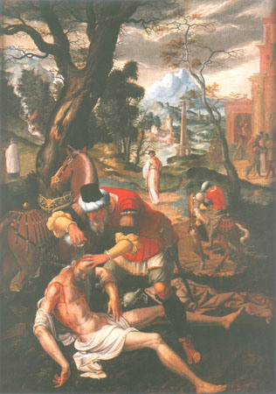
Nature
Peletri is the much-loved Goddess of Mercy. She is the daughter of Sharu, God of Justice, and sits on his left hand to plead for the souls of the dead. Her brother, Pandour, sits on their father’s right and lists the soul’s evil deeds. The two siblings are therefore in opposition, but they are not considered enemies.
Peletri is a gentle goddess with unlimited sympathy and the ability to see the best in everyone. Most people believe that they deserve Peletri’s blessing, but may not agree that others do. As Peletri will plead mercy for a multiple murderer as much as for a child who has stolen sweets, she is often seen as unrealistically naïve.
Depiction and Symbols
Peletri is shown as a serenely smiling young woman with welcoming open arms.
Worshippers
Whilst popular, especially with the guilty, Peletri is also seen as out of place in a cynical and sinful world. Her worshippers are seen at once as kind hearted and charitable, yet also naïve and an easy mark. Luckily for most priests of Peletri, the populace in general are intolerant of those trying to take advantage of the gentle goddess’s better nature.
Priests of Peletri are commonly found mounting expeditions to take mercy to the wicked. Most are received with genuine pleasure, or turned away by bemused and amused villains, but some priests fall foul of the worst of them.
Blessed
Those Blessed by Peletri can bring spiritual relief to those with troubled souls.
- Peaceful Sleep (as the Mind Control spell – willing subjects only): 16 points.

Magic
Peletri may endow her priests with Power Investiture at a maximum level of (their Religious Rank–1).
Upon reaching the Priesthood (Religious Rank 1), Peletri allows her priests to learn from the following spells in addition to the common priest rituals:
Spell | College | Page
Clean | Making and Breaking | M116
Create Food | Food | M79
Create Water | Water | M184
Dream Projection | Communication and Empathy | M46
Dream Sending | Communication and Empathy | M45
Dream Viewing | Communication and Empathy | M45
Essential Food | Food | M79
Find Direction | Knowledge | M101
Gift of Tongues | Communication and Empathy | M46
Great Voice | Sound | M173
Healing Slumber | Healing | M94
Light | Light and Darkness | M110
Persuasion | Communication and Empathy | M45
Purify Water | Water | M184
Quick March | Movement | M144
Rejoin | Making and Breaking | M116
Relieve Addiction | Healing | M92
Relieve Madness | Healing | M92
Relieve Paralysis | Healing | M93
Relieve Sickness | Healing | M90
Restore Memory | Healing | M92
Retrogression | Communication and Empathy | M47
Sense Danger | Protection and Warning | M166
Sense Emotion | Communication and Empathy | M45
Sense Foes | Communication and Empathy | M44
Sense Life | Communication and Empathy | M45
Share Vitality | Healing | M90
Watchdog | Protection and Warning | M167
Water to Wine | Food | M79

Ritual and Ceremony
Peletri’s priests are happy to alter their rituals to suit their congregation. Those who are desperate for forgiveness will request long and elaborate ceremonies, those for whom forgiveness is not a priority prefer a few token gestures and a short phrase or two.
Disciplines of Faith
Peletri teaches that all sentient beings have good in them, and that this good outweighs the bad. Priests are taught to always allow people (and this includes non-human sentients) to repent, right up until death (when Peletri takes over).
Additionally, all genuine requests for aid must be answered to the best of the priest’s ability, even if this puts the priest at risk.
This tenet is essentially a combined Pacifism (self defence) and Charitable, for a –30 point Disadvantage.
Other Tenets and Suggestions
Claim to Hospitality. The church of Peletri is popular enough that most towns and villages have at least one family willing to house and feed its priests*: 10 points.
*Note that, although the priest saves having pay for board and lodging, the money saved is usually given away to the needy!
Duty. Peletri is demanding of her priests, calling on them to take mercy wherever it is most needed. Quite often, this is highly dangerous, not least for the terrain and land they may need to traverse.
This duty is dangerous and happens quite often (12-), and so is worth –15.
Pitiable. Sometimes, people can’t help feel sorry for priests of Peletri: 5 points
Skills. Any social and communication skills are appropriate for priests of Peletri. Languages are also useful.
Selfless. This is almost universal for priests of Peletri: -5 points.
Social Regard (venerated). Most priests of Peletri are highly thought of, but treated almost as naïve children: 5 points/+1 to a +4 maximum.

samas God of Fire and the Sun

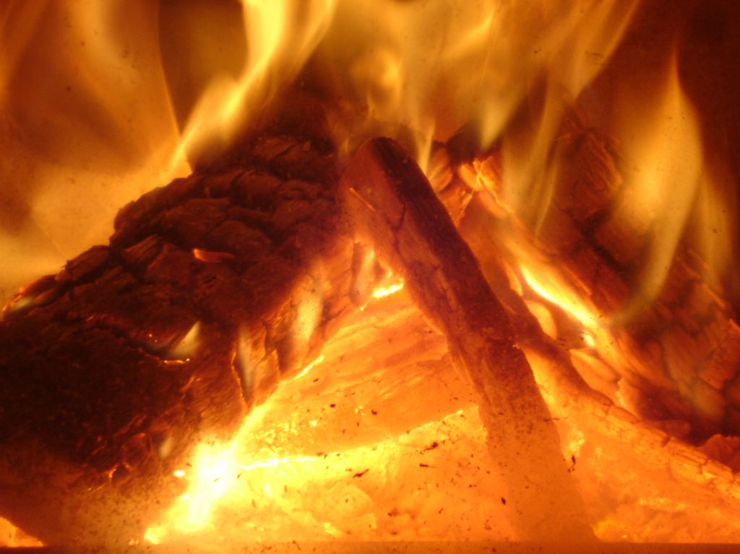
Nature
Samas’s influence covers both sun and earthly fire. He is a god with a disposition to match his aspect, and is known for being both unpredictable and demanding. When his worshippers fail to show the proper devotions, Samas will often deliberately weaken the power of the sun as a warning. Occasionally he will allow Tanith (the Moon Goddess) to hide the sun completely.
Samas is one of the oldest of the Old Gods; some say he was originally part of the Nature God pantheon, though his priests deny this vehemently. Whatever is the case, it is certain that many Elemental spirits serve Samas, though not as many as serve the Nature Gods.
Depiction and Symbols
Samas is shown as a powerfully built man clad in little more than a loincloth. Usually he will be shown with flames erupting from his upturned palms.
The most common symbol associated with Samas is the sun itself.
Worshippers
Everyone who depends directly on fire or the sun, including farmers, smiths and so forth, venerates Samas. Often, people pray to him to protect them from fire, notably warehousemen and merchants with stock in warehouses, sailors and those working with large open fires.
Priests of Samas have a reputation as pyromaniacs, but this is a little unfair; they may worship and revere fire, but most are aware of its danger. In many urban areas, temples to Samas are surrounded by empty space thanks to the mistrust of those building their houses. Nobody deliberately builds their house up against a building full of flame and pyromaniacs!
Blessed
Samas Blesses his favourites with ability to see secrets in flames.
- Divination (pyromancy): 10 points.
Magic
Samas may endow his priests with Power Investiture at a maximum level of (their Religious Rank–1).
Upon reaching Religious Rank 1, Samas may grant his priests spells from the Fire College, in addition to the common priest rituals.
Ritual and Ceremony
Samas’s rituals are always accompanied by fire. The size of the fire depends on the importance of the ceremony in question, from an oil-filled bowl for a small personal ceremony to a bonfire for a major event. When the sun aspect is being emphasised, priests either go naked (in summer!) to celebrate its heat, or (in winter) build enormous bonfires to help rekindle the weakened sun.
Samas’s ceremonies appear quite primal in nature, which is further evidence for those who believe Samas to originally be a Nature God.
Disciplines of Faith
Priests of Samas are charged to keep the temple fires fuelled (when they are present), and to perform rituals for the sun every morning and evening.
This is a relatively easy tenet, worth –5.
Other Tenets and Suggestions
Pyromania. Anyone obsessed by fire is going to be accused of pyromania, but many of Samas’s priests really are: –5 points.
Temperature Tolerance. Most priests of Samas quickly get used to high temperatures: 1 point/level, to a maximum of 2 levels.

sharu God of Justice

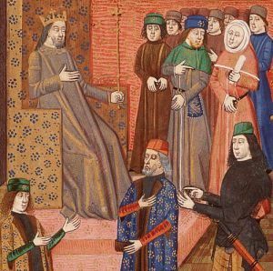
Nature
Sharu is the judge of the dead. Sharu’s son, Pandour, and daughter, Peletri intercede for and against those spirits presented to him for judgement. Sharu’s decision allows the soul to pass on to the Halls, or be condemned to Pandour’s Hells.
Sharu’s aspect of emotionless judgement is unattractive to many, though he is still worshipped in a vain attempt to curry favour for when the worshipper dies.
Depiction and Symbols
Sharu is shown as an older man with eyes closed (showing his impartiality) and carrying a huge book in which he records his judgements.
Worshippers
Worshippers of Sharu tend to be judges and magistrates, or those for whom the law is important in some way. Despite his relatively limited worshipper base, Sharu is still powerful as he receives plenty of fervent worship on behalf of newly departed souls.
Priests of Sharu are in demand as judges, but usually limit themselves to sitting in judgement on religious cases. They have a reputation for being utterly unbribeable and impartial.
Blessed
Sharu Blesses his favourites with the ability to sort truth from lies.
- Truthsayer (as the Communication and Empathy spell): 10 points.
Magic
Unusually for gods of the Old Gods pantheon, Sharu does not offer clerical magic to his priests. He prefers his representatives to make their way with their skills, and does not really have the Life Energy to spare in granting magical powers.
Ritual and Ceremony
Ceremonies of Sharu are solemn and highly ritualised. His priests are encouraged to stick to ages-old rituals, and the ceremonies are therefore the same as they were centuries ago.
A notable ritual happens before every trial in Saduria. Although priests of the New Gods have begun to exchange the ritual for one of their own, the ritual dedicating the procedures to Sharu is an old and established one.
Disciplines of Faith
Sharu’s priests are expected to live their lives to exacting and unchanging rituals. Almost every aspect of their lives is governed by tried and tested ceremony.
This tenet is worth –5 points.
Other Tenets and Suggestions
Honesty. One drawback of serving a god of justice is that you see the law as inviolate, no matter who has made it: -10 points.
Indomitable. By sticking to the tried and tested rituals, a priest may train himself to ignore emotional influences: 15 points
No Sense of Humour. The law is serious, and sometimes the rigors of a ritualised life leech out all sense of fun: –10 points.
Skills. Law is an obvious and almost essential choice. Bureaucracy is also useful, as are Languages and Detect Lies.
Social Regard (respected). Priests of Sharu are respected for their wisdom and impartiality: 5 points/+1, maximum +2.

sigu God of Livestock

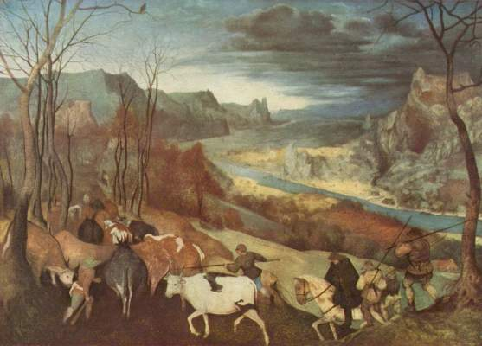
Nature
Sigu is the solid, caring god who has influence over domesticated livestock. Like many of the beasts that make up his aspect, Sigu may occasionally appear slow-witted, though this is only due to his careful and unhurried consideration of matters.
Sigu cares deeply for his herds or flocks, and treats each animal as his children. Despite this love, Sigu understands that most livestock will be slaughtered and only asks that the animal’s soul be dedicated to him in the process. Natural predators are also tolerated, although Sigu may be called upon to help dissuade persistent and particularly destructive culprits.
Depiction and Symbols
Sigu is usually depicted as a solidly built man carrying the young of whichever livestock is most prevalent in the area. Some, more unusual, images of Sigu show him with the body of a man but the head of a species of livestock.
Symbols associated with rearing livestock, and symbolic images of livestock are commonly used to denote Sigu.
Worshippers
Unsurprisingly, Sigu’s main worshipper base comprises shepherds and livestock farmers. He is mainly a rural god, though slaughterhouses and even butchers may also contain worshippers. Some urban dwellers may also remember Sigu, notably those keeping fowl in back yards.
Priests of Sigu are often called upon to oversee the important times in the livestock calendar especially lambing and calving. They may also be called upon to intercede with Sigu to prevent or cure disease and parasites.
Blessed
Those Blessed by Sigu have an uncanny ability to work with animals.
- Animal Friend Talent: 5 points per level.
- Animal Handling.
- Falconry.
- Packing.
- Riding.
- Teamster.
- Veterinary.
- +1 Reaction from all animals.

Magic
Sigu may endow his priests with Power Investiture at a maximum level of (their Religious Rank–1).
Upon reaching the Priesthood (Religious Rank 1), Sigu allows his priests to learn from the following spells in addition to the common priest rituals:
Spell | College | Page
Beast Link | Animal | M30
Beast Possession | Animal | M32
Beast Soother | Animal | M29
Beast Speech | Animal | M31
Beast Summoning | Animal | M30
Bird Control | Animal | M30
Create Water | Water | M184
Mammal Control | Animal | M30
Master | Animal | M30
Resist Pain | Body Control | M38
Rider | Animal | M31
Watchdog | Protection and Warning | M167

Ritual and Ceremony
Sigu’s ceremonies are linked to livestock. There are ceremonies for every major stage of the livestock farming calendar, and Sigu’s priests are often asked to perform rituals on behalf of farmers.
Disciplines of Faith
Sigu’s priests are expected to protect any and all livestock from unnecessary suffering, and to promote their benefits wherever possible.
This is worth –15 points.
Other Tenets and Suggestions
Animal Empathy. Having a feeling for animals is an obvious benefit for priests of Sigu: 5 points.
Skills. Animal skills are most common for priests of Sigu, as well as Farming. Some ranged weapon skill may also be useful to help protect livestock from predators.
Social Regard (respected). Priests of Sigu are well respected members of their community: 5 points/+1, maximum +2.

skoal God of the Sea

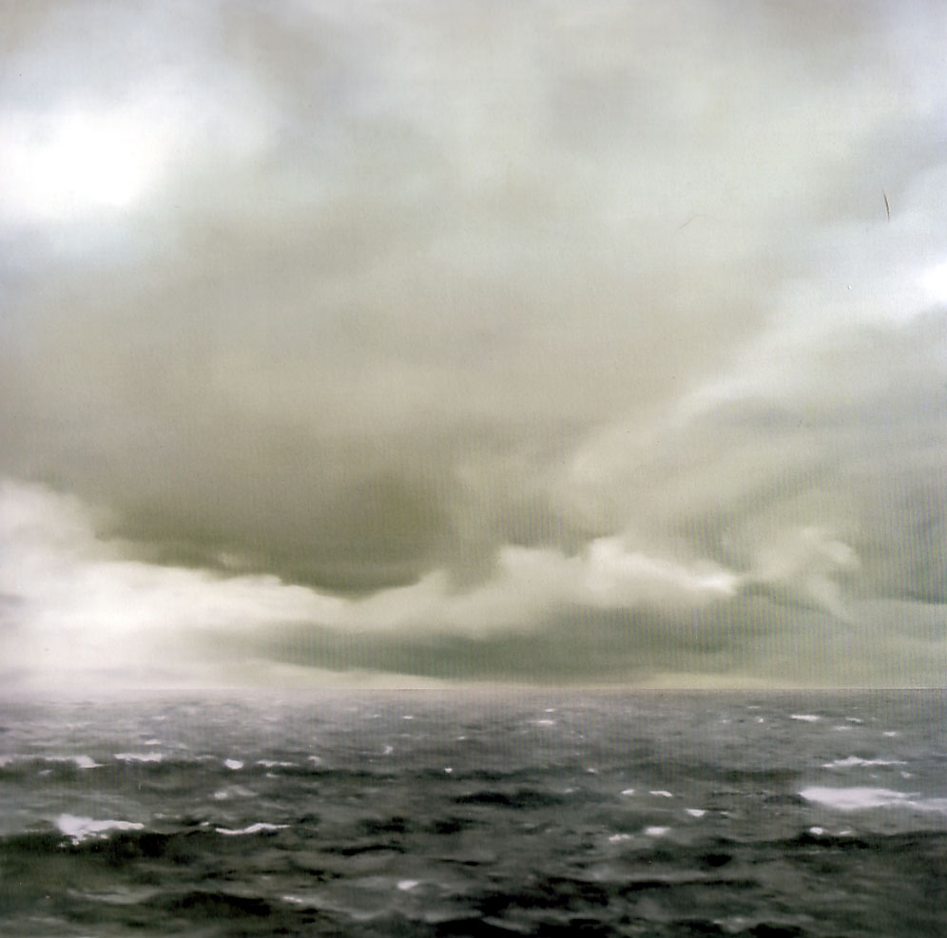
Nature
Skoal is the wild and unpredictable God of the Sea. Nakki, God of Water, has influence over inland and fresh water, but the seas and oceans are Skoal. Where the two meet (estuaries, large saltwater lakes and so on) either or both may claim influence.
Skoal is the patron of many lesser spirits, and all manner of grotesque and beautiful spirit creatures may be encountered in the sea. One reason for this is the lack of sentient life within the seas, leaving far more room for creatures of spirit to exist. Some, but by no means all of these creatures are friendly towards humans. The worst of them delight in creating hazardous sea conditions and drowning mortals, some will even venture ashore to specifically prey upon humans.
Depiction and Symbols
Skoal is generally depicted as a hoary old man with seaweed-entangled hair and beard. He is traditionally shown carrying a huge conch shell with which he both creates the waves and summons his servants.
Seashells of all descriptions are associated with Skoal.
Worshippers
Skoal is worshipped mainly by those who depend on the sea. Sailors, merchants with shipping and fishermen all pray to Skoal for their safety. Skoal may or may not heed these warnings, but will generally allow the prayers of the especially devout to sway his actions.
Priests of Skoal are often found aboard ships (where captains appreciate the protection they can offer), but are just as likely to be found living on the shore, close to the sea. Some are loners, living in crude huts by lonely beaches, others prefer the bustle of a port.
Blessed
Those Blessed by Skoal gain the ability to safely enter the undersea world.
- Amphibious: 10 points.
- Doesn’t Breathe (Gills): 10 points.
Magic
Skoal may endow his priests with Power Investiture at a maximum level of (their Religious Rank–1).
Upon reaching Religious Rank 1, Skoal may grant his priests spells from the following list, in addition to the common priest rituals.
Spell | College | Page
Breathe Air | Water | M26
Create Water | Water | M184
Current | Weather – Water | M194
Destroy Water | Water | M185
Find Direction | Knowledge | M101
Fish Control | Animal | M30
Fog | Water | M193
Mollusc Control | Animal | M30
Preserve Food | Food | M79
Purify Food | Food | M78
Resist Water | Water | M186
Seek Water | Water | M184
Shape Water | Water | M185
Swim | Movement | M147
Tide | Weather – Water | M194
Walk on Water | Water | M186
Walk Through Water | Water | M188
Water Vision | Water | M187
Waves | Weather – Water | M194
Whirlpool | Water | M187
Ritual and Ceremony
Ceremonies to Skoal are commonly to request protection from the sea and Skoal’s more hostile creatures. His priests are therefore in demand before most sea voyages, and are also a regular and important part of fishing communities.
Disciplines of Faith
Skoal does not impose any disciplines on his priests beyond maintaining as much contact as possible with the sea.
Other Tenets and Suggestions
Chummy/Loner. This represents two ends of a scale; some priests like the hustle and bustle of a crowded port, others live as hermits. –5 or –10/ -5
Skills. The skills of Boating, Crewman, and Swim are very relevant to priests of Skoal. Survival (beaches and islands) may also be useful. Priests spending along time on board ships might also take Meteorology.
Social Regard (respected). Priests of Skoal garner respect from those dealing with the sea: 5 points/+1, maximum +2.

tanith Goddess of Women and the Moon

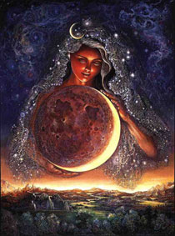
Nature
Tanith is the distant and ambiguous Goddess of the Moon. She is sometimes revered as a beacon of light in night’s otherwise ungodly darkness, but her influence is as changeable as the moon’s phases and she is often assumed to be a dark goddess.
Tanith is primarily seen as a moon and night goddess, but also represents women, dreams, insanity, and a high level of spiritual purity.
An unusual sub-cult of Tanith is dedicated to Yselle, goddess of feminine ideals. Yselle is a Personification demigoddess promoting female principles, but a major part of her worshipper base comprises men who feel that they have more in common with women than with their own sex.
Depiction and Symbols
Tanith is seen as a cloaked and serene woman, with attractive but distant features. In some areas, especially where Tanith is mistrusted, she is seen with a cold and slightly menacing facial expression.
The moon is an obvious and common symbol of Tanith, but anything connected with the night is also used.
Worshippers
The vast majority of worshippers of Tanith are women. Her temples act as refugee centres for women who are escaping the restrictive binds of male-centred family and society, and they will only admit men inside in extreme circumstances (and then only those men true to Tanith).
All priestesses of Tanith are women, and the head of the church is referred to as the Matriarch (as opposed to Patriarch). Priestesses of Tanith are expected to remain virgins, those who join the church too late to meet this tenet are restricted to Religious Rank 1. Most who break this vow whilst already ordained have their rank withdrawn, and Tanith withdraws all her powers. In cases where a priestess loses her virginity involuntarily, the Matriarch may be persuaded to restore it through Divine Intervention.
Blessed
Those Blessed by Tanith may view a person’s dreams in a mirror or similar surface.
Tanith only ever Blesses females.
- Dream Viewing (as the spell, M45): 8 points.

Magic
Tanith may endow her priestesses with Power Investiture at a maximum level of (their Religious Rank–1).
Upon reaching the Priesthood (Religious Rank 1), Tanith allows her priestesses to learn from the following spells in addition to the common priest rituals. Note that there is no religious restriction on who these spells may be used upon, but the nature of the church means that priestesses will prefer to use beneficial spells on worshippers and women, needing a good reason to use them on men from other faiths:
Spell | College | Page
Darkness | Light and Darkness | M111
Divination (Oneiromancy) | Knowledge | M108
Dream Projection | Communication and Empathy | M46
Dream Sending | Communication and Empathy | M45
Dream Viewing | Communication and Empathy | M45
Fear | Mind Control | M139
Foolishness | Mind Control | M134
Forgetfulness | Mind Control | M135
Gloom | Light and Darkness | M112
Glow | Light and Darkness | M112
Healing Slumber | Healing | M94
Hide Emotion | Communication and Empathy | M45
Madness | Mind Control | M136
Mass Sleep | Mind Control | M137
Night Vision | Light and Darkness | M111
Nightmare | Mind Control | M140
Peaceful Sleep | Mind Control | M138
Permanent Madness | Mind Control | M139
Relieve Madness | Healing | M92
Remove Reflection | Light and Darkness | M113
Remove Shadow | Light and Darkness | M110
Sense Emotion | Communication and Empathy | M45
Shape Light | Light and Darkness | M111
Sleep | Mind Control | M135

Ritual and Ceremony
Tanith’s ceremonies are carried out at night. Major phases of the moon are celebrated by a corresponding major ceremony, and most rituals involve invoking the power of the moon.
No men (apart from lay worshippers) are allowed to witness the full ceremonies of Tanith and this inevitably leads to speculation over what occurs. The most popular theories are naked rites and human sacrifice.
Disciplines of Faith
Tanith expects her priestesses to live as virgins. She prefers that they limit their association with men to a minimum but stops short of banning contact. Male friends are allowed, as is association with male worshippers, but deliberately seeking out male companionship is frowned upon. Given the nature of most Tanith priestesses, this is not a difficult tenet to follow.
This is worth –15 points.
Other Tenets and Suggestions
Lecherousness and Sex Appeal. Obviously, these are not really suitable for priestesses of Tanith (unless the priestess is homosexual).
Less Sleep. Priestesses of Tanith worship at night, and often get by with very little sleep: 2 points/level to a maximum of 4 levels.
Lunacy. Sometimes, priestesses of Tanith are attracted to the church to try to answer questions about themselves. Lunacy might be one of them: -10 points.
Night Vision. Working at night means that many priestesses of Tanith get used to the darkness: 1 point/level to a maximum of 9 levels.
Phobia (Androphobia). Many women join Tanith’s church to legitimately avoid contact with men. This phobia represents a fear that men may try to attack or dominate you: -20.
Reputation. Men (and many women) tend to react badly to priestesses of Tanith, seeing them as man-hating witches. This is a –1 to –3 bad Reputation affecting almost everyone. –5 per –1 Reaction.
Social Regard (feared/respected). Priestesses of Tanith are equally respected by women, and feared and mistrusted by men: 5 points/+1, maximum +2.
Will (only versus male suggestions). There is little hope of a man persuading a priestess of Tanith to do anything she does not want to do: 3 points/level.

tathbeth Goddess of Spirits and Witchcraft

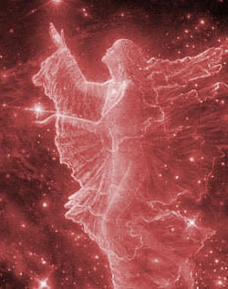
Nature
Tathbeth has two distinct aspects, spirits and witchcraft, but most people confuse the two and see no difference. Any spirits are covered under Tathbeth’s influence, but her priests mainly concentrate on the minor spirits not otherwise worshipped. By providing a channel for them to communicate, Tathbeth keeps a measure of control over the lesser and otherwise unregarded spirits.
Witchcraft is very much based on the coercion of spirits, but also covers much “folk” knowledge and medicine. Though witches and priests do not generally get along, priests seeing witches as meddling in powers that should be left alone, and witches seeing priests as narrow-minded and over-conservative, Tathbeth allows a church for those witches who wish to be represented.
Tathbeth is a secretive and intolerant goddess, ironically reserving the worst of her intolerance for those who do not accept her aspect.
Depiction and Symbols
Tathbeth is depicted as either an attractive woman wearing local costume with a hooded cloak, or as a wizened old crone. In either case, the definitive feature of Tathbeth’s depiction is an ornate cloak clasp with an eye design. The iris of the eye has a five-pointed star within in. Legends say that Tathbeth sees all from the amulet eyes in her statues.
Worshippers
Tathbeth appeals to anyone for whom communication with the spirits is of concern. Many mediums and diviners seek out the teachings of Tathbeth, in many cases to better understand their own gift. Witches are usually reluctant to seek organised religions, being fundamentally individual by nature, but some are so keen to further their knowledge (and power) that they choose to associate with the goddess.
Priests and priestesses of Tathbeth are not necessarily either mediums or witches, but most are. Tathbeth’s worship, by the nature of her worshippers, is fragmented and has a large number of both sub-cults, especially worshipping powerful Lesser Spirits, and differences of emphasis. Often, the congregation of one priest will actually be antagonistic towards another, simply due to a difference of opinion or interpretation.
Blessed
Tathbeth allows her Blessed favourites to contact the spirits.
- Medium: 10 points.

Magic
Tanith may endow her priests with Power Investiture at a maximum level of (their Religious Rank–1).
Upon reaching the Priesthood (Religious Rank 1), Tathbeth will allow her priests to learn the following necromantic Spirit spells. Note that, just because the spells are necromantic, most of the spirits contacted are not from dead mortals but are Divine spirits or even Lesser Deities:
Spell | College | Page
Affect Spirits | Necromantic | M151
Astral Block | Necromantic | M159
Banish | Necromantic | M156
Bind Spirit (by type) | Necromantic | M158
Command Spirit (by type) | Necromantic | M153
Entrap Spirit | Necromantic | M157
Materialise | Necromantic | M150
Repel Spirits | Necromantic | M158
Solidify | Necromantic | M151
Summon Spirit | Necromantic | M150
Turn Spirit | Necromantic | M151

Ritual and Ceremony
Tathbeth’s ceremonies are full of symbolism and spiritual contact. Often, the spirits are invited to join the ceremony, sometimes benefiting from the Life Energy generated.
Ceremonies are conducted in places of importance to the spirits, and this may mean a long-deserted settlement or forest glade. Weather permitting, priests of Tathbeth prefer to conduct their ceremonies naked and with few mundane trappings (thus being closer to the spirits they call on).
Disciplines of Faith
Tathbeth expects her priests to serve the spirits. By having her priests regularly contact them, Tathbeth learns much about the current hierarchy of Divine spirits, and especially which spirits are powerful enough to become Lesser Deities. Tathbeth is then able to recruit these spirits before the other gods become aware of them.
This discipline extends to seeking out newly discovered or reported areas of spirit activity, and attempting to communicate with the spirits there.
Having to investigate all spirit activity is worth –10 points.
Other Tenets and Suggestions
Ally and Ally Group. Some priests of Tathbeth are particularly friendly with the spirits, so much so that they will aid their mortal friend: variable.
Animal Empathy. If the priest has a particular talent with Animal spirits, they may also have a spiritual understanding of mortal beasts: 5 points.
Autohypnosis. This skill gives the priest +2 to a specific mental task, including Ritual Magic rolls.
Channelling. Different from mediums in that the spirit takes over the channeller’s body sufficiently to speak through it: 10 points.
Compartmentalised Mind. This might represent the result of a friendly spirit lodging somewhere in the priest’s mind: 50 points/level.
Epilepsy. Commonly thought to be a sign of being touched by the spirits, in the priest’s case it might be just that: -30 points.
Ritual Adept and Aptitude. Useful to all priests, these are extremely useful for witches as well: 10 points per level / 1 points per level.
See Invisible (spirits). This variation allows a priest to see spirits normally invisible to mortals. It is very useful to Tathbeth’s priests.
Skills. Exorcism is a handy skill for anyone dealing with spirits. Occultism may provide a little background knowledge about certain spirits.
Social Regard (feared). Priests of Tathbeth are treated warily, as most people are nervous of anyone spending so much time in contact with spirits: 5 points/+1, maximum +2.
Spirit Empathy. Although a good deal of Tathbeth’s magic involves forcing spirits to do her priests’ bidding, a few priests prefer to persuade rather than to dominate: 10 points.
Spirit Advisor. A variation on the Ally advantage, the spirit advisor only provides knowledge: variable.
Weirdness Magnet. This is really a way to represent the priest being a magnet for spiritual activity. They might well find themselves being shunned by those affected by this disadvantage: -15 points.

viktor God of War

Nature
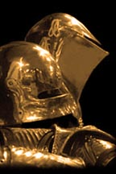
Viktor is a god whose popularity waxes and wanes according to the current political and military situation. Just like soldiers in general, priests of Viktor are seen as brave warriors and national heroes when conflict is widespread, but are then aggressive troublemakers when peace is announced.
Viktor glories in battle and war, seeing combat as the ultimate test of spiritual strength and mortal character. Viktor’s influence combines personal bravery and skill at arms with tactical manoeuvring and strategic thinking.
Depiction and Symbols
Appropriately enough for a warrior’s god, Viktor is always shown in armour and wielding either a sword or axe. Normally, this depiction shows armour in a style current for the age of the statue, and many such images are dateable by comparing armour styles.
Symbols of Viktor are weapons of any style, but mainly axes.
Worshippers
Viktor is a warrior’s god and the vast majority of his worshippers are soldiers. Both mercenaries and Imperial troops follow Viktor, for he does not care for or against who his followers fight.
Priests of Viktor are usually rather more skilled in combat than most other priests, but are not necessarily warriors. Because of the nature of his worshippers, however, most priests are able to take care of themselves on a battlefield as it is here that most of their ceremonies will take place!
Blessed
Those Blessed by Viktor have a divine talent with a single weapon. This cannot be used a prerequisite for further cinematic advantages unless the referee decides that such cinematic abilities are acceptable in his campaign.
- Weapon Master (pick one weapon): 20 points.

Magic
Viktor is less concerned with magic than many of his fellow gods.
Viktor may endow his priests with Power Investiture at a maximum level of (their Religious Rank–2).
Upon reaching the Priesthood (Religious Rank 1), Viktor will allow his priests to learn from the following spells in addition to the usual priest rituals:
Spell | College | Page
Accuracy | Enchantment | M65
Boost Dexterity | Body Control | M37
Enchant | Enchantment | M56
Fortify | Enchantment | M66
Lighten | Enchantment | M67
Power | Enchantment | M57
Puissance | Enchantment | M65
Resist Pain | Body Control | M38
Share Vitality | Healing | M90
Vigor | Body Control | M37

Ritual and Ceremony
Viktor’s priests are used to performing their ceremonies on battlefields, both before and after the battle, and occasionally even during! The ceremonies are necessarily robust and direct, with little discrete movement or ritual.
One important ritual that Viktor’s priests learn is the one they perform over the newly slain. This ritual calls the attention of Anguran to the dead soul, and helps to reduce the chance that the dead spirit will come under the influence of the devils.
Disciplines of Faith
Viktor’s priests are not expected to live their lives to any strict discipline of faith. They have a hard enough life following the armies and living in barracks.
Other Tenets and Suggestions
Combat Reflexes. Though not usually soldiers themselves, priests of Viktor frequently find themselves in combat situations: 15 points.
Skills. Any weapon skills are useful for a priest of Viktor. First Aid, Strategy, and Tactics are also appropriate.
Social Regard (feared). Priests of Viktor inspire fear from those around them, in much the same way as any warrior: 5 points/+1, maximum +2.

THE NEW GODS

Nature of the New Gods
When the New Gods decided that mortals were losing sight of the reason that they were created for (i.e. to worship the gods), they split from the Human Gods (later known as the Old Gods) and formed their own pantheon.
The New Gods are Personification spirits who represent philosophical ideals rather than earthly values. By removing worldly distraction from their aspects, the New Gods effectively distilled the worship of mortals and so receive Life Energy out of all proportion to the number of their worshippers.
Worshippers of the New Gods are few in number but powerful in influence. Because the Sadurian Emperor is a fervent devotee, the Sadurian nobility follow his example in the hope that it will improve their political standing. The ordinary people find the New Gods distant and rather impractical, and many worshippers turn back to the Old Gods in times of real emergency.

Death and Funeral Arrangements
The New Gods teach that, in time, the spirit of a dead mortal may be returned to the world to live another life. The amount of original soul’s essence that is reincarnated depends on the state of the remains of the body. For this reason, followers of the New Gods try to ensure that the body being buried looks as much as it did in life as possible. Burial and entombment are the only way to dispose of the dead person’s remains, the richest have their remains interred in mausoleums.
Servants of Kalisis, the Goddess of Death and Fear collect the dead spirit. It is then escorted to the goddess’s realm where they are treated according to their mortal deeds. Especially worthy souls are allowed to become Ascended spirits, others may become Divine spirits or simply serve the gods while they await rebirth. Those who were especially wicked may be punished by being made revenants searching for a way to redeem themselves.
Friends and relatives of the deceased will generally concern themselves with ensuring that the body is properly prepared and presented. Occasionally, the dead person may have lost a body part. If this is the case, wooden replicas will often be made and placed the coffin. It is believed that this token will allow the soul to carry most of their essence through to their next life.

Magic and the New Gods
The New Gods teach that only the gods should wield magic, for only they have the wisdom to use it wisely. Priests are allowed to use Ritual Magic (Divine), but no other form of magic is tolerated.

Priests of the New Gods

Requirements
The New Gods require that their priests possess a pure spiritual faith. The most devout of them cloister themselves away in monasteries to study theology and associated matters. These monasteries may also act as lodging for travelling priests of the New Gods.
Requirement | Acolyte | Priest | Bishop | Cardinal | Lord High Theologian
Claim to Hospitality | 5 points | 5 points | 5 points | 5 points | 5 points
Clerical Investment | 5 points | 5 points | 5 points | 5 points | 5 points
Discipline of Faith* | -10 pts. | -10 pts. | -10 pts. | -10 pts. | -10 pts.
Legal Immunity | 5 pt. | 10 pt.** | 10 pt.** | 15 pt.** | 20 pt.**
Religious Rank  (at 5 points per level) | Level 0 | Level 1 | Level 2 | Level 3 | Level 4
Religious Ritual† | 12- | 14- | 16- | 18- | 20-
Reputation | Var. | Var. | Var. | Var. | Var.
Social Regard (respect): max 2 levels | 5 pts/lvl | 5 pts/lvl | 5 pts/lvl | 5 pts/lvl | 5 pts/lvl
Status | Level 0 | Level 1 | Level 3 | Level 5 | Level 7
Theology† | 12- | 14- | 16- | 18- | 20-
True Faith | 15 pts. | 15 pts. | 15 pts. | 15 pts. | 15 pts.
* Disciplines of Faith for priests of the New Gods take one of two forms:
- Monasticism. At least 75% of the priest’s time need be spent shut away from the world in religious study.
- Asceticism. May not have status beyond that granted by Religious Rank, or Wealth above average. Priests are expected to renounce most earthly pleasures, including excess of any kind.
** Includes “diplomatic pouch”.
†These skill levels are usually taken with a specialism in the priest’s preferred god, although this is not necessary.
Each god (church) has only one Cardinal, who is the direct representative and favourite of that god.
There is only one Lord High Theologian. He (and it is invariably a he in the current age) is the mortal representative of the New Gods, and is expected to both interpret and enforce the wishes of the gods. Many people believe that the Lord High Theologian is actually more politically powerful than is the Emperor himself.

belhella God of Wisdom

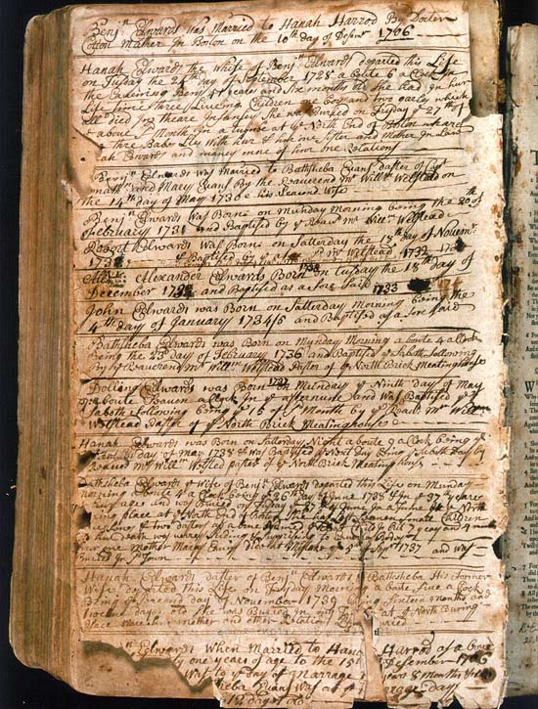
Nature
Belhella is the stern and dedicated “All Seeing God” His all-encompassing knowledge allows Belhella to make sound judgements on all aspects of mortal life, and he thus may try to influence anything he feels will benefit from his wisdom. Belhella is a god who disapproves of frivolity or trivial behaviour. His world is ordered and logical, with little room for the more foolish aspects of human behaviour.
Depiction and Symbols
Belhella is usually depicted as a stern-faced older man carrying a book or scroll. Books and associated paraphernalia are associated with Belhella, and are often used symbolically to represent him.
Allies
All of the New Gods are considered allied to Lihan, the leader of the pantheon.
Worshippers
Sages and researchers follow Belhella’s teaching, which suits their single-minded pursuit of knowledge. The church’s emphasis on structure and rejection of trivial distraction means that Belhella has many more monasteries in his name than other gods. These closeted centres of learning are popular places for academics to visit, although the monks are generally extremely choosy about whom they share their wisdom and libraries.
Blessed
Those Blessed by Belhella have uncanny ability to learn.
- Sage Talent (new talent): 10 points/level.
- Administration.
- Area Knowledge (any number).
- Expert Skill (any number of themes).
- Hidden Lore (must specialise).
- History (must specialise).
- Linguistics.
- Research.
- Teaching.
- Writing.
- Reaction bonus; +1/level from academics.
Ritual and Ceremony
Belhella’s ceremonies are long and solemn. Any form of raised emotion or frivolity is ruthlessly discouraged, and the rituals are deliberately repetitive and monotonous. In this way, there are no distractions or worldly interferences.
Other Tenets and Suggestions
Hidebound. A lifetime of studying ancient texts and established doctrines makes it difficult to come up with original ideas: -5 points.
No Sense of Humour. Belhella discourages humour, and so his church tends to attract those for whom humour is unimportant: -10 points.
Skills. Any academic skills are suitable for priests of Belhella, but the skills Expert Skill, Hidden Lore, History and Research are especially appropriate.

brionelle Goddess of Love

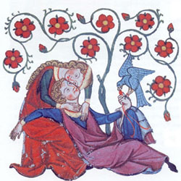
Nature
Brionelle represents the concept of philosophical love, as opposed to a physical, worldly, love. Her aspect of chaste love appeals to romantics and poets, and she is often called upon as a muse for the new trend of romantic bards.
Depiction and Symbols
Brionelle is shown as a beautiful but chaste noblewoman, usually depicted with a slightly wistful expression as if thinking of some unattainable love.
Roses and lilies are often used as symbols of Brionelle.
Allies
All of the New Gods are considered allied to Lihan, the leader of the pantheon.
Worshippers
The nobility sees Brionelle as a natural patron for the ideal of chivalry, a noble concept that is losing ground on the battlefield but gaining popularity at court. Poets and bards alike use Brionelle unashamedly in their works, often allegorically.
Priests of Brionelle are known to be available as counsellors for the broken-hearted, though their solutions are usually simply to pray to the goddess rather than anything practical. In general, those who seek their advice are looking for love in the wrong places; quite often they are in love with people who are already married, promised to another, or of such a different social class that their union is impossible.
Blessed
Those Blessed by Brionelle are so concerned with loving their fellow beings that nothing about person in question can upset them.
- Unfazeable: 15 points.
Ritual and Ceremony
Brionelle’s ceremonies are light and pleasant, with music and much recital of verse. A good deal is made of the love of mortals for Brionelle and of Brionelle for mortals. The cynical find such ceremonies unbearably naïve.
Rituals to Brionelle are often included in love poems, being almost prayers that the poem will strike the right romantic note with the intended audience. A side effect of this inclusion is that some of the better love poems so dedicated can actually act to deter or repel devils and demons, who find such pure and spiritual love repellent.
Other Tenets and Suggestions
Charisma. Often, a love of people will show through and they will react to you accordingly: 5 points/level.
Empathy. It is easier to find and receive love if you can read people’s intentions: 5 or 15 points.
Fearlessness. With a sense that all creatures deserve love, priests of Brionelle are less disturbed by other’s actions or appearances: 2 points/level.
Skills. Any communication skills are good for priests who wish to spread Brionelle’s vision of universal love. The skill of Enthrallment is particularly useful for priests with bardic abilities, and this should be accompanied by Public Speaking. The skill of Poetry (M/A) is also very appropriate for priests of Brionelle.

kalisis Goddess of Death, Fear and the Night

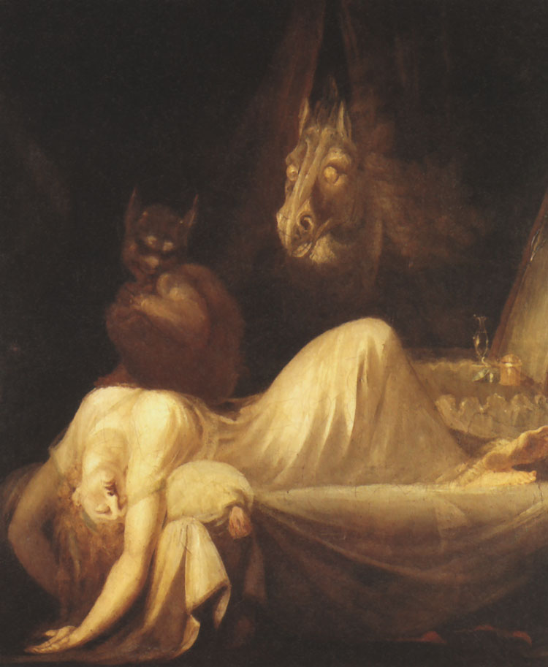
Nature
Kalisis is the closest that the New Gods have to an “evil” god. This is not, however, an accurate description of Kalisis, and the goddess is as devoted to the well being of her followers as any other.
Kalisis’s aspect of fear and the night covers all that man is scared of. By representing these fears, Kalisis intends that mortals better understand them, and so become less apprehensive of them. For no good reason other than man’s own fears, Kalisis is also often seen as a female’s goddess, usually representing women who have independent minds and lives.
As Goddess of Death, Kalisis is responsible for the collection of the souls of the dead. They are then judged by her, and their fate depends on this judgement; the particularly worthy may become Ascended spirits or Divine spirits. Most are allocated to become servants of Kalisis until they are reincarnated. Those whose mortal life was especially wicked may become revenants, doomed to wander the mortal realm as ghosts until they find a way to redeem themselves.
Depiction and Symbols
Kalisis is usually seen as a beautiful woman wearing dark velvet clothing in a high noble style.
Any of the usual emblems of death or the night are used to symbolise Kalisis.
Allies
All of the New Gods are considered allied to Lihan, the leader of the pantheon.
Worshippers
Kalisis attracts worshippers of two main types. The first group are those who wish to confront and understand their fears, or wish to remember the dead. These seek Kalisis’s blessing in their pursuits and hope to overcome fear or improve the deceased’s fate through her worship.
The second group are those who delight in fear and death, and wish to use Kalisis as a means to further their own selfish ends. Needless to say, priests of Kalisis are less inclined to either publicise or encourage this second group.
Blessed
Those Blessed by Kalisis are peculiarly immune to fear.
- Fearlessness: 2 points/level.
Ritual and Ceremony
Ceremonies celebrating Kalisis involve candles and dim lamps. The ceremonies take place in gloomy surroundings and represent Kalisis being a light in the darkness.
Other Tenets and Suggestions
Skills. Priests of Kalisis will have skills that reflect their emphasis. Many of those who use the night to their own advantage will have thievery skills and some may even have assassin skills. Priests who wish to understand and overcome fears will possibly have Psychology skill.

lihan God of Strength and Masculinity

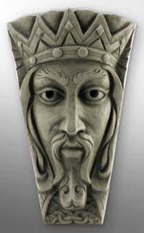
Nature
Lihan is the leader of the New Gods, and covers many related aspects. His influence of Strength does cover physical strength, but it mainly embodies mental power, and is also taken as representing spiritual strength.
His Masculinity aspect is a controversial one for the female priests who prefer not to concentrate on this part of his worship. It is not the masculinity itself that disturbs them, but more the fact that the masculinity is so closely interwoven with both strength and leadership that it infers that females are lacking them.
Depiction and Symbols
Lihan is normally shown as a dignified nobleman of mature years.
Allies
All of the New Gods are considered allied to Lihan, the leader of the pantheon.
Worshippers
All the other gods in the pantheon acknowledge his leadership, and so everyone who follows the New Gods indirectly worships Lihan and usually remembers him in their ceremonies.
In addition to this indirect worship, many who seek positions of power and leadership in the mortal world directly worship Lihan. Lihan’s priests are often seen as models of competent leadership, whether or not this is actually the case. Both military and political leaders are careful to pray to Lihan, and (possibly more important) to be seen to worship him.
In his aspect of strength and masculinity, Lihan is followed by many who are either grateful for those traits, or are lacking in them and wish for his blessing in improving either or both.
Blessed
Those Blessed by Lihan have immense strength of will.
- Indomitable: 15 points.
Ritual and Ceremony
Lihan’s priests are unofficially the elite within the New Gods pantheon. This aggrandisement carries over into Lihan’s ceremonies, and they are generally regarded as the most imposing with the pantheon.
Lihan’s rituals are long established and the oldest within the New Gods, and strict adherence to them is a major part of Lihan’s priest’s lives.
Other Tenets and Suggestions
Skills. Law and Leadership are obvious choices for priests of Lihan.
Will. Most priests train themselves to resist external influences: 5 points/+1.

persera Goddess of Charity
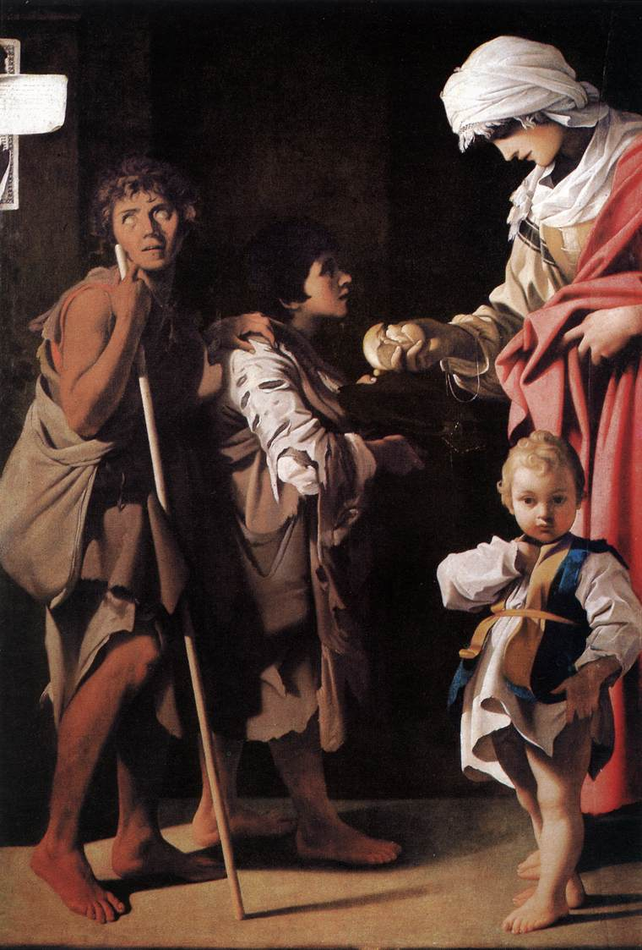
Nature
Persera represents a generosity of spirit, as well as simple financial charity. She is known as the “Gentle Goddess”, and is well loved; it is Persera that many New Gods worshippers turn to in times of crisis, hoping that she may intercede on their behalf.
Not as naïve as Peletri, in many ways Persera’s counterpart in the Old God’s pantheon, Persera is hard headedly practical in her application of charity. Whilst her overwhelming aim is to bring relief to those in need, she is also concerned with raising the funds to do so.
Depiction and Symbols
Persera is usually depicted as an attractive, motherly, woman holding out her hands in welcome.
The most common symbol of Persera is a pair of outstretched palms.
Allies
All of the New Gods are considered allied to Lihan, the leader of the pantheon.
Worshippers
Persera’s worshippers are often engaged in some charitable operation, whether intent on improving the life of the poor, setting up educational establishments or distributing food to the hungry. Most towns have one or more shelters where the desperate can lodge and find food temporarily. Those who want to stay longer than a few days will find themselves pressed into the service of the goddess in return.
Priests of Persera usually busy themselves with running the vast numbers of charity undertakings in progress from the temple, or with raising the money required to finance them
Blessed
Those Blessed by Persera have the ability to persuade people.
- Voice: 10 points.
Ritual and Ceremony
One perceived drawback of receiving the charity of Persera’s priests is that the receivers are expected to participate in long and tedious ceremonies. For most people this is an unavoidable, if temporary, shortcoming.
Rituals to Persera are full of appeals to her generous nature and references to the shortcomings of mortals.
Other Tenets and Suggestions
Charitable. This is almost a requirement for priests of Persera: -15 points.
Skills. Skills such as Housekeeping and First Aid are useful for mundane tasks undertaken by Persera’s priests. More useful, perhaps, are business skills such as Administration and Finance, as priests are expected more to coordinate charitable missions than actually physically participate in them.

tantric God of Elementalism

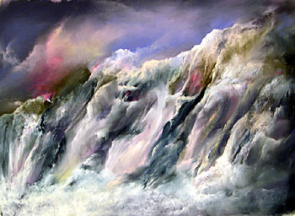
Nature
Tantric is a wild god, more elemental than god. He represents primal forces and natural power, and is an unusually unrestrained member of the New Gods pantheon.
As unfathomable as the sea, and as changeable as the wind, Tantric is worshipped mainly by those who wish to request his help in avoiding the worst of either weather or sea conditions.
Depiction and Symbols
Tantric is often shown only in a symbolic manner. The most popular form for depicting Tantric is as a dragon. This, though Tantric’s priests may deny it, is due to a racial memory of dragons as being elementals in this form.
Allies
All of the New Gods are considered allied to Lihan, the leader of the pantheon.
Worshippers
Tantric’s worshippers attempt to tame the elements by their devotions. Although inimical to the concepts of the New Gods (where self-restraint is a key tenet), Tantric also attracts worship from those of an elemental nature.
Priests of Tantric are a little outside the norm for the New Gods, and are often found living as hermits in isolated places where they try to grapple with the opposing aspects of Elementalism and self-restraint. In many cases, the priests choose to concentrate their spiritual energy by denying their physical well-being. Fasting and even self-flagellation are common, but some go to extremes even beyond this.
Blessed
Those Blessed by Tantric seem immune to the elements.
- Temperature Tolerance: 1 point/level to a maximum of 2 levels each way.
Ritual and Ceremony
Tantric’s ceremonies are a little more forceful than most within the pantheon, but are nowhere near as wild as Tantric’s elemental nature might suggest.
Other Tenets and Suggestions
Skills. Priests who decide upon becoming hermits will probably find it necessary to learn Survival (of a terrain based on where they intend to live). Meditation is also common for loners, as it helps concentrate on the weighty matter of reconciling Tantric’s nature with New Gods’ tenets.

THE NATURE GODS

Nature of the Nature Gods
The Nature Gods were the first to create life forms, and thus the first to gain worship. Their creations were those things that humans would later call “natural”, that is, they are not sentient. Animals, plants, bodies of water and the weather are all the result of the Nature God’s initial creativity, and they are also responsible for beastmen and several other animal hybrids.
By permanently tying themselves to their creations, the Nature Gods are able to draw Life Energy directly from the world without formal worship from sentients. The amount of this energy, however, is low compared to that of the gods who have large numbers of sentient worshippers, and is dependent on the well-being of the natural world. Sentient worshippers exist, but are few, and the Nature Gods rely on them to protect and promote nature rather than to recruit new worshippers.
The Nature Gods are a unified body, which promotes balance; worshipping one god to the exclusion of others is unbalancing and thus discouraged. Within the pantheon, all gods are considered equal.

Death and Funeral Arrangements
The mortal body of the followers of the Nature Gods holds the spirit until the body is destroyed. This means that animals slain by predators or injury should be eaten, either by their killer or by scavengers, and that the bodies of human worshippers need to be burnt or left for scavengers to eat.
It is this reliance on the body’s destruction that explains why predation and natural scavengers are part of the Nature Gods’ grand scheme.
Depiction and Symbols
With a small human following, Nature Gods rarely require depiction, though they may appear to their priests in visions and dreams. Where some symbolic representation is required, it tends to contain a great deal of natural design.
Worshippers
The Nature Gods attract people for whom isolation and living wild is preferable to living with other people. Most have at least a trace of madness, and some are completely insane.
Blessed
The Nature Gods Bless their favourites with the ability to take on beast form and/or the ability to speak with plants and/or animals.
- Speak with Animals: 25 points.
- Speak with Plants: 15 points.
- Shapeshifting (Alternate Form): variable cost (must be a natural animal).

Priests of the Nature Gods

Requirements
With little real interest in attracting human worship, the Nature Gods see their priests more as caretakers of the natural world than conduits of Life Energy. Because of this, formal requirements are very few. Most priests learn appropriate outdoor skills, but this is because their lifestyle will require them rather than any hierarchical prerequisites.

Requirement | Acolyte | Druid | High Druid | Grand Druid | Arch Druid
Clerical Investment | 5 points | 5 points | 5 points | 5 points | 5 points
Discipline of Faith* | -10 pts. | -10 pts. | -10 pts. | -10 pts. | -10 pts.
Religious Rank  (at 5 points per level) | Level 0 | Level 1 | Level 2 | Level 3 | Level 4
Religious Ritual | 12- | 14- | 16- | 18- | 20-
Social Regard (feared): maximum 2 levels | 5pts/lvl | 5pts/lvl | 5pts/lvl | 5pts/lvl | 5pts/lvl
Status ** | Level 0 | Level 1 | Level 2 | Level 4 | Level 6
Theology | 12- | 14- | 16- | 18- | 20-
* Disciplines of Faith for priests of the Nature Gods:
- To protect the natural world from ‘unnecessary’ destruction. Necessary destruction might include killing for food or materials, or cutting plants for minimal shelter.
- To promote the spread (or recovery) of wild animals and plants. This may be as simple as planting seedlings, or as extreme as waging war against organised human settlements.
** The social status for priests of the Nature Gods is only at the levels given when in isolated rural areas. In any sort of urban settlement the Nature Gods are not taken seriously enough to gain this level of status, and all levels are reduced by one. The cost of the social status is therefore reduced by 25%.
Druids are not gregarious or organised by nature, and the formal hierarchy is somewhat more relaxed than with other religions. A Druid might go for years at a time without seeing his High Druid, and a High Druid might only meet a Grand Druid during his investment ceremony.
There are only ever nine Grand Druids, and only one Arch Druid. These high ranking priests act as the druidic council, known as the Circle, to appoint new High Druids and interpret religious doctrine. Even this council does not meet often, usually gathering only for the Summer and Winter Solstices, when new High Druids are invested and religious matters discussed.
Note that priests of the Nature Gods gain a lower social status than do those of the New and Old Gods, and are not given legal immunity. This is partly to do with the lack of organised worship in Saduria, and partly to do with the suspicion that many feel for the elemental nature of the Nature Gods.
Clerical Magic
The Nature Gods cannot afford the Life Energy to grant their priests’ Clerical magic. Instead, most druids learn Ritual Magic - Divine. As well as the rituals from the Path of the Gods, priests of the Nature Gods are also able to learn from the Path of Nature.
Ritual and Ceremony
The Nature Gods are far less concerned for formal ritual than the more “civilised” New or Old Gods. Ceremonies are primal in nature, involving much chanting, dance and burning of herbs and fragrant wood. Breathing in hallucinogenic smoke grants the priests’ visions and insights, and may aid their ritual magic.
Unusually amongst the human gods, the Nature Gods occasionally encourage human sacrifice. This is justified as part of the cycle of nature and is only performed in extremis, usually when the killing of a person will benefit a greater number. Most commonly such sacrifices are made for blessing crops or creating a Sacred Space.
Other Tenets and Suggestions
Any skill or power that allows the priest to survive in the wild is useful.
Animal Empathy: This could represent a spiritual understanding of the creatures of the Nature Gods.
Animal Friend: Particularly suited to the type of druid who calls upon Animal spirits.
Fit: An outdoor life requires a healthy physique.
Outdoorsman: Especially useful if the druid lives rough.
Skills: Survival and Naturalist are two of the more obvious skills, but Herb Lore, Tracking, and Animal Training are also common druidic skills.
Social Regard (fear): Druids are wild and unpredictable. Even followers of the Nature Gods treat them with fearful respect: 5 points/+1, to a maximum of +2.
Social disadvantages are common in druids, they do not need or particularly respect other people and it shows!

RITUAL MAGIC – The Path of the Nature
Gods have no access to regular spells, the Life Energy required to cast them would be too much for the Nature Gods to support. As an alternative, they can call upon the servitor spirits of their gods to provide magical effects.
Note that the Path of Nature is separate from the Path of the Gods, and mastery of one Priests of the Nature confers no benefits to learning the other.
All the following Rituals are taken from GURPS Spirits, pages 100 and 101, with modifications for 4th edition and for context.
Endure Elements Defaults to Path of Nature
This brief (10 minute) ritual temporarily grants the subject the equivalent of a level of Temperature Tolerance (B(4th)93) per point by which the roll is made (minimum 2 levels). A sufficiently powerful ritual can make the subject effectively immune to the effects of heat and cold. Druids use this to do things like walk barefoot on hot coals without injury.
Predict Weather Defaults to Path of Nature
A brief (10 minute) ritual gives the caster a general idea of the weather for the next 1d days. This does not include supernatural effects that alter the weather.
Seek Beast Defaults to Path of Nature
A 10 minute ritual gives the caster a vision of the nearest specified animal or group of animals and indicates direction and distance.
Gentle Beast Defaults to Path of Nature-1
This 10-minute ritual improves an animal’s reaction roll toward the caster by the amount by which the ritual roll is made (minimum +1). The caster can affect multiple animals with the usual Multiple Target penalty.
Fertility Defaults to Path of Nature-3
This ritual helps ensure growth and reproduction, for crops or animals (including people). For crops, the magician performs a one-hour ritual and rolls; if successful, the affected plants grow quickly and well, untroubled by pests and disease. Overall yield is increased by 5% for every point by which the caster succeeded, to a maximum of +100% (a true bumper crop).
For animals, he ritual prepares a charm that is placed on or near a female subject. The next time it is possible for the subject to conceive, she does. The ritual does not circumvent contraception nor any medical conditions that make it impossible for the subject to conceive.
This ritual usually entails a sacrifice; for animals the sacrifice is of a new-born of the same species, for plants the sacrifice is of a large (SM 0+) creature, often a human ritually chosen (which adds +1 to the roll)! Without a sacrifice, the roll is at –1.
Hunter’s Blessing Defaults to Path of Nature-3
This ritual assists a group of people in hunting one species of animal, selected at the time the ritual is cast. The individual animal cannot be specified; the hunters must take their opportunities as they appear. However, the animal is considered the ‘target’ of the ritual; for example, Multiple Target penalties apply if the hunters plan on bringing down more than one animal. (This is rarely necessary and most casters limit the ceremony to a single prey animal).
The caster performs the hour-long ritual with the hunters present. If the ritual is successful, the hunters gain a bonus for the blessing’s duration on all skill rolls directly related to the pursuit of the specific animal species. The bonus is a base +2, with a further +1 for every 2 full points the ritual roll was made by. This is usually adds to Tracking and Weapon skills, and often Stealth and Camouflage when the hunters are setting up an ambush; the relevance of other skill rolls to the hunt is left to the GM’s judgement.
Mist Defaults to Path of Nature-3
The caster performs a 10-minute ritual, summoning a thick fog that fills the affected area. The magician can enlarge the area with the usual modifiers. The fog blocks vision as does the Fog spell (M40).
Summon Beast Defaults to Path of Nature-3
Summon Beast works like the Beast Summoning spell on M23, except it requires a 10-minute ritual. To call many animals, the caster must take a Multiple Target penalty for the desired number of animals.
Command Beast Defaults to Path of Nature-4
This 10-minute ritual allows the caster to control the actions of a single animal. The ritual empowers a charm (usually a collar or leg band) and allows the caster to fasten it onto the animal. The animal obeys the caster’s verbal commands for the duration of the ritual as long as it wears the charm. The druid can affect multiple targets with the normal modifiers.
Hasten Mount Defaults to Path of Nature-5
By performing this ritual for 10 minutes, the druid lends a single riding animal unusual fleetness. The mount gets +1 Move for every 3 full points by which the ritual roll succeeds (minimum +1 Move).
Weatherworking Defaults to Path of Nature-5
This one-hour ritual changes the weather to suit the caster’s desires. The ritual affects an area, but does not use the area modifiers. Instead, a successful ritual affects a radius of one-half mile. Every –1 to skill increases the radius by another half mile. For every point by which the ritual roll succeeds, add +1 to the chance of the desired weather. The GM should determine the chance on 3d of the desired weather occurring naturally. Some guidelines: likely weather for the season and region (e.g. rain on the coast in the spring) occurs on 10 or less, rarer weather (e.g. drizzle in the desert) on 5 or less, and extraordinary weather (e.g. an inland hurricane, snow on the equator) only on a 3. The effects of the ritual occur within 12 hours; if the caster wants them to happen sooner, he is at –1 for each hour he wants to subtract from the total; when reduced to one hour, each minute subtracted increases the penalty by –1. Having the weather change occur one minute after the ritual is complete puts him at –70!
If the GM allows*, this ritual can also improve the chances of other environmental phenomena, like earthquakes or even volcanic eruptions, but these events are usually very unlikely. The GM can require a certain degree of success (anywhere from 5 to 20 points or more) before there is any chance of an event happening (depending on local conditions). Additional points of success then increase the chance normally.
* Just for information, I don’t allow this for druids as I feel such phenomena are outside their remit.
Thunderbolt Defaults to Path of Nature-7
One of the most physically spectacular rituals, Thunderbolt causes a bolt of lightning from the sky to strike a target designated by the druid. The ritual has two parts. The first is the hour-long preparation of a small charm that serves to “draw” the lightning down. This charm must be placed on or near the target of the strike (although it can be done without his knowledge or permission). The second part of the ritual takes only 10 minutes. If the caster is successful and the target fails to resist, a lightning bolt strikes the target, doing 1d damage for every points the ritual roll succeeded by (minimum 1d). The bolt cannot be dodged, since the charm “draws” it to the target. The lightning bolt destroys the charms if the ritual is successful. If the caster fails the second ritual roll, a similar lightning bolt strikes both him and the client (i.e. whoever asked for the ritual to be performed in the first place). The bolt does 1d damage for every point the magician missed the ritual roll by (minimum 1d).

APSU Goddess of Water and the Sea

Nature
Apsu is the shadowy and cruel goddess of water in all its forms. Her realm is a dangerous one as Apsu delights in taking mortal souls by drowning, frequently resorting to subterfuge and trickery to attract mortals. Those who take heed of the Nature Gods are careful to make sacrifice to appease Apsu before crossing large bodies of water.
Druids who have had visions of Apsu have variously reported her appearing as a divine nymph maiden, a wizened weed-strewn hag, and a magnificent black horse.
Servitor Spirits
Apsu’s servitor spirits protect her bodies of water, but also act to lure mortals into the water to drown them. From such drownings both Apsu and her spirits gain Life Energy.
Most of Apsu’s servitor spirits are Spirits of Place. The most common forms taken by the spirit are animals connected to that piece of water, such as beavers otters and so on, although the form of a wild horse is popular for spirits who enjoy trickery. The spirit encourages humans to ride it, but then plunges into the water and swims out, throwing its rider into the water to drown.
BARCHAT God of the Sun

Nature
If the Nature Gods have a leader then Barchat would be him. Even the other gods of the pantheon accept that his aspect is essential for the well-being of the world’s life-forms. He is a dominant figure whose power declines in the winter, and nature declines along with him. Druids are careful to maintain worship to Barchat during the long winters, and may offer elaborate and substantial sacrifice if the winter is particularly long and harsh.
Those who claim to have seen Barchat report his appearance as a great bull-headed man, often breathing fire.
Servitor Spirits
Barchat’s servitor spirits are fire elementals. A few Spirits of Place associated with volcanoes and other lava pits also serve Barchat, but these are few and far between (though they may be very powerful).

BYEL God of the Wilderness

Nature
Byel is the god of travellers in the wilderness. He is a caring and compassionate god who will help those lost and alone in the vast wild lands that are his domain. Although the wilderness theoretically includes forests, other gods (Chernog and Druantia) have a more specific influence on these features and Byel tends to concentrate more on open scrubland and heathland.
Lost travellers, exhausted and half-dead, have reported being led to safety by the cloaked and windswept figure of Byel, often accompanied by wolves.
Servitor Spirits
Most commonly, Byel’s servitor spirits are lesser Animal Spirits, especially those of wolves and other plains creatures. Many followers of the Nature Gods claim to have seen such supernatural animals acting as guides when travelling in harsh conditions.
CHERNOG God of the Forest

Nature
The deepest, darkest, forests are terrifying places full of mortal danger. Chernog is as dark and forbidding as his aspect. He delights in playing evil tricks on travellers in his realm, misleading them or forcing them to walk into marsh or other hidden dangers. When Chernog is in a particularly malicious mood, even prayers and sacrifice will not persuade him to leave a worshipper alone.
Chernog may appear in dreams as a twisted black tree spirit, set with glowing red eyes and a cackling fanged mouth.
Servitor Spirits
The spirits that serve Chernog are as malevolent as their master. Boggarts (malicious and cruel forest faeries similar to goblins) and spriggans (like boggarts, but more tricksters than killers) are the most common of Chernog’s servitor spirits, but many dark Spirits of Place lurk within the deep forests.

DAMONA Goddess of Farming

Nature
Damona is something of a rogue amongst the Nature Gods. Whereas the majority of the pantheon discourages agriculture because of the land clearance involved with crops, Damona both supports and encourages such farming. Many believe Damona to be a latecomer to the Nature Gods, a Divine Spirit grown to god status as humans discovered agriculture and looked for associated gods to worship.
Damona blesses and protects the crops of her worshippers as long as the planting and harvest are accompanied by suitable ceremony to her. In particular, she demands that the blood of a young woman is scattered at the planting, and a young man is sacrificed at the harvest. Often, these victims are treated like royalty for the year preceding their sacrifice, and in many cases they are promised that their souls will rise to become Divine Spirits as reward for their service.
Those priests who have seen Damona in visions claim that she appeared as a beautiful and robust woman wearing the clothing of a local farmer’s wife and carrying a sickle.
Servitor Spirits
Damona is served by the Spirits of Place associated with the crops and farms she oversees.
DRUANTIA Goddess of Woodland

Nature
Where Chernog is the God of the Forest, Druantia is the gentler Goddess of woodland. Though not really a true opposite to Chernog, Druantia does provide a balance to Chernog’s malevolence and ensures that the natural harmony is maintained. Druantia oversees lightly wooded areas and the outskirts of forests.
Priests who have had visions of Druantia speak of a beautiful white doe with intelligent eyes.
Servitor Spirits
Spirits of Place and several lesser Animal Spirits associated with woodland serve Druantia. In particular, dryads and naiads act to protect glades sacred to the goddess.

FLIDAIS Goddess of Animals and the Hunt

Nature
Flidais is a goddess with two seemingly opposed aspects, animals and hunting. The dual nature makes more sense when the balance required by the Nature Gods is taken into account, as without predation (and hunting is seen as predation) the prey animals would quickly run out of food. This hunting, however, is only tolerated when it is for food or other necessary materials. Hunting for sport only is calculated to make Flidais very angry.
Flidais has been seen in visions as a tall, handsome woman with flaming red hair, dressed as a chieftain from ancient times. She usually appears in visions riding a chariot and accompanied by hunting hounds and huntsmen. Hunters, lost and delirious from hunger or disease, have reported seeing Flidais sweeping by on hunts of her own. Rumour has it that she will send avatars (powerful spirits completely under her control) to hunt down those who deliberately and persistently offend her.
Servitor Spirits
Flidais has a wide variety of lesser Animal Spirits that serve her. In addition, the greater, totem, Animal Spirits look to Flidais. These Animal Spirits represent the entire species and are powerful deities in their own right, but still serve the goddess. It is to appease and show respect to these spirits that Flidais encourages hunters to make offerings to the spirit of their intended prey before they go to kill it.
KEELUT God of Predators

Nature
Keelut is the god of all things dark and dangerous. If it preys on man (or his animals), then Keelut represents it. Natural predators are certainly part of Keelut’s aspect, but he is more associated with the unnatural and unpredictable behaviour of rabid and insane creatures. The howling, bloodthirsty race of beastmen is a classic example of Keelut’s domain.
Those unfortunate to have seen Keelut in visions say that he appeared as a matted, snarling, black hound with glowing red eyes.
Servitor Spirits
Spirits serving Keelut are the malicious and malevolent spirits that delight in bloodshed and madness.

RAMMAN God of Storms and Thunder

Nature
Ramman is the god of wild and stormy weather. Under his influence, the patterns of weather swirl and flow through the world, maintaining and distributing plant life. When the rains fail, or the storms ravage woodlands and fell trees, it is said that Ramman is either angry or diverted.
Druids who have seen Ramman in their visions reported that he appeared as a heavily bearded, wild-haired man of late middle-age.
Servitor Spirits
Ramman is typically served by Air Elementals.

THE AAGARHIK GODS

Nature of the Aagarhik Gods
The Aagarhik gods are brutal and primitive and are not generally a popular choice of worship for human societies. They are mostly found worshipped by orcs and their kin, but small communities of isolated humans have turned to the Aagarhik gods almost in desperation.
It is difficult to see the attraction of such unsophisticated deities, but their simplicity is their appeal. When you live in a society where “might makes right”, you’re your choice of gods will often reflect your own views.
Human worship of the Aagarhik gods is seen as depraved and uncivilised. Worshippers and priests gain no status for their ranking with in the pantheon, and are likely to be the target of persecution at worst, and missionaries of more acceptable religions at best.

Death and Funeral Arrangements
Followers of the Aagarhik gods believe that the spirits of the dead remain on earth to watch over their former companions. In time, these spirits will fade away unless given worship and recognition by the living. Failure to respect the ancestors, therefore, invites their wrath and is a thing not taken lightly. This works both ways; a wicked or otherwise evil person will not be mentioned after he is dead in order that his spirit might fade away more quickly.
Dead bodies may house the dead spirit for a time after death. By consuming the body, followers can imbibe a little of the dead person’s soul into themselves, gaining a little of their skills, wisdom and insights. This is done with great ceremony, as the ceremony ensures that the spirit is both appeased and bound to the body as it is eaten. Such ritual consumption is generally only undertaken for those who were great in life; few want to imbibe the wisdom of those equal or inferior to themselves.
Another side of this cannibalism is an attempt to show dominance over the dead spirit. Using a different set of rituals; by eating the body, and thus the spirit residing within it, the eater is capturing the spirit of the dead and adding it to his own. This might be done to show contempt for an enemy and is frequently seen during raids.
A third form of cannibalism is simply eating the dead for food. Human worshippers thankfully rarely practice this, though it is not uncommon amongst orcs.
The belief that the dead inhabit their dead bodies leads to careful disposal of the dead to avoid the spirits flying free and having no place to return to, thus seeking to inhabit the bodies of the living. The bodies are never completely destroyed if at all possible, and drying or mummifying the head is a standard way to preserve part of the body for the spirit to inhabit until the spirit finally fades away.

Priests of the Aagarhik Gods

Requirements
The Aagarhik gods accept only those who pass their tests to be their priests. In practice this means various trials of endurance and bravery, usually suggested by a vision or dream to the would-be priest. In game terms, the character must make a roll against HT (1-3) or Will (4-6) before buying the next level of Religious Rank, thus abstracting having passed such a test. Of course, GMs and players might like to come up with their own trials and play them out. Failure of this test means that the candidate must perform some act of contrition to the gods (usually a ritual humiliation) and wait until he is more enlightened before trying again (earned some more XP).
Requirement | Novice | Priest | High Priest
Clerical Investment | 5 points | 5 points | 5 points
Religious Rank  (at 1 point per level)* | Level 0 | Level 1 | Level 2
Status (2 points/level)* | Level 0 | Level 2 | Level 5
Disciplines of Faith | Var. | Var. | Var.
Legal Immunity | 5 pt.** | 10 pt.** | 15 pt.**
Religious Ritual† | 12- | 14- | 16-
Reputation | Var. | Var. | Var.
Theology† | 12- | 14- | 16-
* Recognised only amongst worshippers of the Aagarhik gods. In practice this is unlikely to occur very often, and hence can be bought the reduced costs.
** This only counts within a community of Aagarhik worshippers and so can be bought at 2 points/level (making it cost 2/4/6 points respectively).
† These skill levels are usually taken with a specialism in the priest’s preferred god, although this is not necessary.
Most priests operate within a small community or tribe (in the case of orcs). High priests out-rank many chieftains and are extremely powerful within the region over which they hold sway.

Evua God of Fire and the Sun
Nature
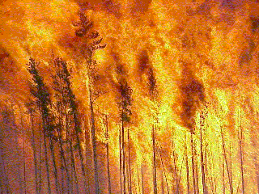
Evua is a god of heat and fire. He is as strong and unyielding as the sun, and as fickle as flame, yet also a life-giver. Anything connected to either fire or the sun itself are part of Evua’s area of influence, including volcanic lava, lightning, and magical fire.
By denying heat, Evua can cause death over a wide area, and his priests are careful to maintain his worship in the coldest times, hoping to regain his favours and thus stave off the End of World. So far, this has been successful, though the lands to the north have been out of favour with Evua for many eons, and are this permanently covered in snow and ice. Similarly, Evua dislikes his worshippers from scaling high places, for he sees them as an attempt to reach the sun itself. To discourage such behaviour, Evua shuns the highest peaks and leaves them covered in snow and icy winds.
Depiction and Symbols
Evua’s symbols are usually depictions of flame or the sun. In particular, the tribal or family fires are seen as representative of Evua and are revered almost as shrines in their own right.
Allies
Evua has no allies.
Worshippers
Worshippers of Evua fall into two camps: one camp comprises those who tend the domestic fires and prepare food at them, the other comprises the warriors who seek to emulate Evua’s firey nature in wild battle.
The first group of worshippers is much revered for their skills in starting and tending fire, and some skilled individuals are even able to use the fire to forge soft metals. Priests use the flames to see visions and to contact the spirits (entering a trance for ritual magic use), and are almost always called upon to bless any newly built fire.
The second group comprises beserkers who seek to be as strong and as unstoppable as the flames of their god. Priests are warrior-priests who are as skilled in arms as in their holy duties.
Blessed
Those Blessed by Evua seem immune to the elements.
- Temperature Tolerance: 1 point/level to a maximum of 2 levels each way.
Ritual and Ceremony
The essential element of all Evua’s ceremonies is, of course, a fire. Whether calling upon the sun or blessing a new campfire (which will be tended until the tribe moves on), rituals involve much burning of scented wood, herbs or leaves, and occasionally of sacrificial victims.

Guruhi God of Violence and Pain
Nature
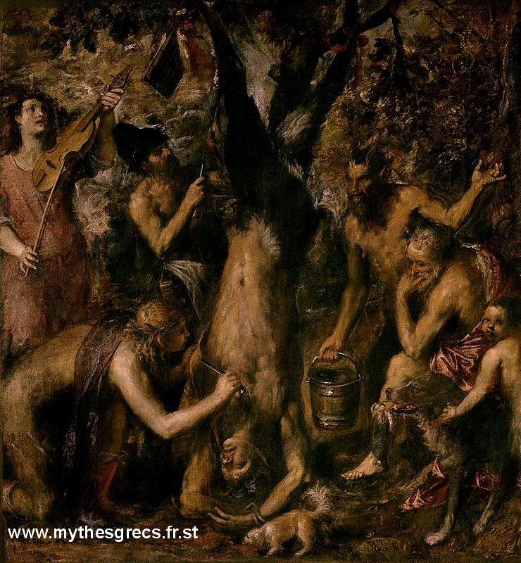
Guruhi is often seen as the most brutal god in a brutal pantheon. His aspect covers violent behaviour and inflicting pain, and he is a popular god with sadistic worshippers who see him as justification for their own habits.
In a large part, this is true. Guruhi revels in the suffering his worshippers cause in his name, yet he is also more than a simple god of sadism.
Guruhi stands by his followers and allows them to overcome and deal with the pain they are suffering. In this way, he is also a god of mercy, for he will harden the will of his faithful and allow them to withstand torture.
Unusually for a god, Guruhi is served and worshipped by goblins, a faerie race who personify sadism.
Depiction and Symbols
Guruhi is synonymous with anything that causes physical pain: barbs, knives and scorpions are common symbols associated with him.
Allies
Guruhi has no allies.
Worshippers
Bullies, sadists and even masochists all fall into Guruhi’s sphere of worship. In particular, he is served by the faerie race of goblins, and is their deity.
Priests of Guruhi are shunned even by other Aagarhik god worshippers, for most feel uncomfortable about his aspect. Captives taken by raids are threatened with being handed over to the Guruhi priests if they do not co-operate (though often their life is forfeit in any case). A priest of Guruhi is as much a torturer as he is a holy man.
Blessed
Those Blessed by Guruhi are able to withstand pain.
- High Pain Threshold: 10 points.
Ritual and Ceremony
Rituals and ceremonies dedicated to Guruhi are not places for the squeamish, and even the screams have been known to send those in the area running. The exact details of such events are left to the imagination.

kake-guia God of Death and the Dead
Nature
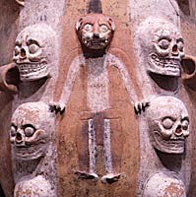
Kake-guia is the Aagarhik god of the dead, though not the afterlife. The Aagarhik gods do not offer their followers and afterlife, the spirits of the dead are left to wander until they finally fade away.
What Kake-guia does do, however, is protect the living from the ravages of the dead spirits that would otherwise haunt them constantly. He teaches the priests to properly prepare the bodies of the dead to bind the spirits of those the tribe wish to remember; this usually involves the partial mummification of the skull which is stored in a scared place.
A differerent means of disposing of the dead is cannibalism. This is done for one of two reasons; either to deliberately share in the spirit of the person being eaten, or to capture the spirit of a dead enemy. Either way, the body is ritually prepared by the priests who bind the spirit into it. Eating the body then involves eating the bound spirit, which will either support or serve the eater’s own spirit (according to which reason the body was eaten).
This belief that the dead wander free makes followers of the Aagarhik gods justifiably terrified of the possibility of undead, and plenty of taboos exist directly related to the prevention of raising or antagonising undead spirits.
The spirits of those the tribe do not wish to remember, often evil people or those who died in disgrace, are not mentioned after their death and they become taboo. In this way, the spirits do not gain the remembrance they need to survive and will fade away much more quickly. Breaking such a taboo is likely to be severely punished, especially if the spirit somehow manages to return and cause mischief.
Depiction and Symbols
Kake-guia is usually represented by images of skulls. His priests are instantly recognisable by the skull painted on their face in white clay and the mummified body parts they carry with their bound spirits in them.
Allies
Kake-guia is allied with Sakarabru, god of the Healing, Judgement and the Night.
Worshippers
Kake-guia is a popular god for superstitious worshippers. In particular he is worshipped to pacify and to remember the dead after raids and battles, when many hostile newly dead souls might otherwise be out to haunt their killers.
Kake-guia is also called upon by the families of the newly dead, either to help bind the spirit or so that the spirit will quickly fade.
Blessed
Those Blessed by Kake-guia are favoured by the spirits.
- Spirit Empathy: 10 points.
Ritual and Ceremony
Ceremonies to Kake-guia usually involve offerings to the spirits as well as to the god. If a particular request is being made of a spirit, the offerings and sacrifices will be in proportion to the request. Often, what the spirit enjoyed in life will be offered to the spirit in the hope that such preferences carry over.

Mararwana God of the Sea
Nature
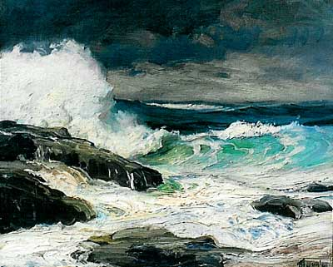
The sea is a mysterious place to most Aagarhik worshippers. Orcs, in particular, have little idea of what lies beyond the shore itself for they have only very basic knowledge of navigation and hardly ever travel by water. To the Aagarhik pantheon, therefore, the sea is the thing that surrounds the world and it is over the sea that the gods live.
Marerwana is the go-between, sending messengers and prayers to the gods and carrying power back to the mortal worshippers. The sea is Mararwana’s own essence and he is therefore one of the few gods that can actually be touched, even though he cannot feel the worshipper’s touch in return.
Depiction and Symbols
Mararwana is normally depicted as a huge wave, often stylised as a triangle. Shells and pieces of sea-creature are also representative of him, and his priests often walk around festooned with fish bones and seal-skulls.
Allies
Mararwana has no allies.
Worshippers
Mararwana is remembered with every prayer to another god, for he is the one who carries such prayers. Although some worship him in his own right, by far the most worship he receives is by proxy.
Blessed
Those Blessed by Marawana can see and interpret omens.
- Oracle: 15 points.
Ritual and Ceremony
Ceremonies to Marawana invoke him as the messenger of the gods.

nyamia Chief god of the Pantheon,
God of the Hunt
Nature
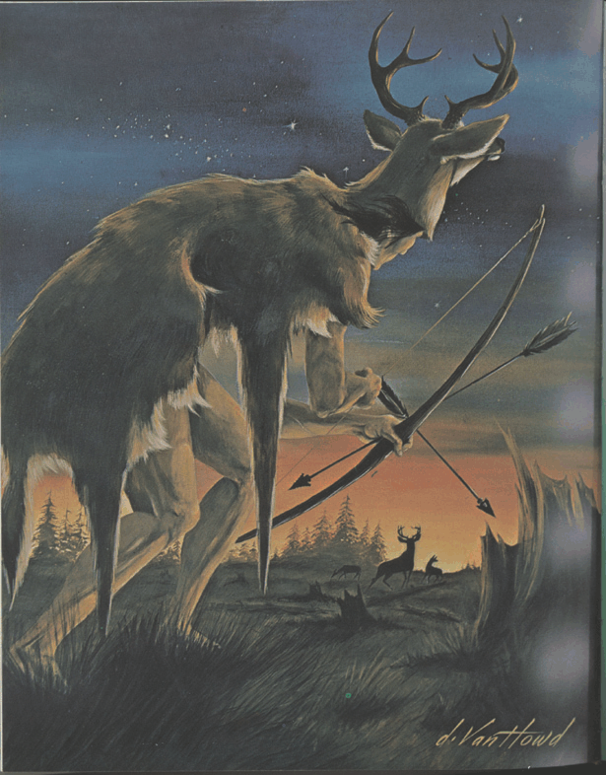
Nyamia is the chief huntsman and therefore the leader of the Aagarhik pantheon.
In people where a good hunt can mean the success or death of the tribe, the chief hunter is a valued position and one that frequently also means being the chieftain. Thus, Nyamia is the chieftain of the gods.
Nyamia is one of the oldest of the Aagarhik gods. From the time mortals started to hunt and call upon spirits to guide them, Nyamia had found his worshippers. He lets his people hunt and kill to survive, and is not fussy about what they kill. Nyamia is a god from earliest times, when the nicities of civilisation where unknown, and the shaping of creatures into predator and prey had not yet happened. Nyamia, therefore, sees anyone and anything as fair game for the hunt.
Depiction and Symbols
In general, Nyamia is shown bearing the form of the creature the hunters are looking for. In more general application he is depicted with the antlers of a stag or the horns of a bull.
Allies
Nyamia has no allies. His position as chief was settled through conflict, not negotiation.
Worshippers
Unsurprisingly, Nyamia is revered by both hunters and by leaders. Although his twin role is occasionally combined, more usually he is worshipped either as a god of leadership and chieftains, or as a god of hunting. Modern orcish society rarely sees the leader go hunting and so the hunters are separate from the leadership.
The whole tribe will make devotion to Nyamia before a hunt or in times of shortages, and he is remembered whenever the tribe catch prey or have a successful raid.
Blessed
Those Blessed by Nyamia are either particularly skilled at predicting animal habits or are natural leaders. Very rarely, a lucky individual will have both.
- Animal Empathy: 5 points.
- Charisma: 5 points per level.
Ritual and Ceremony
Ceremonies to Nyamia are long and involve much dance and song. When invoking Nyamia’s blessing for a hunt, the tribe will act out the important stages, with one playing the part of the animal. When emphasising the leadership aspect of Nyamia, much ritualised bowing and kow-towing is performed both towards the priest and to the tribal leader.

Sakarabru God of Healing, Judgement
and the Night
Nature
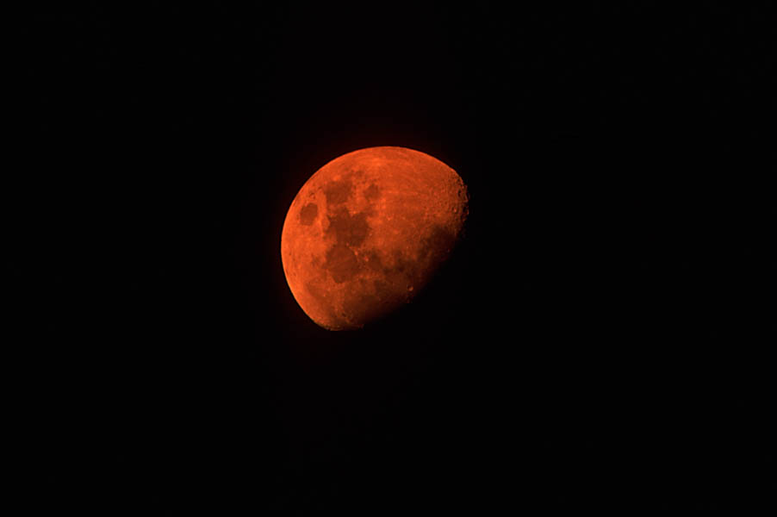
Sakarabru is the god of such apparently diverse aspects as healing, judgement and the night. These three aspects do, in fact link together, though their connections are not obvious to anyone not living the life of an Aagarhik follower.
Healing, to the followers of the Aagarhik gods, is a very random process. Some people may survive and recover from horrific injury, and yet others might die from apparently minor wounds. This indicates that the process has a lot to do with how the injured person is being judged by Sakarabru, and consequently what Sakarabru decides should happen. Much of Sakarabru’s judgement is apparently done at night, for the majority of injured people tend to recover or die during their sleep. Thus, the three aspects are neatly tied together.
Depiction and Symbols
Sakarabru is most often depicted using a moon symbol, whether full or crescent. In some ceremonies, the fullness of the moon being depicted indicates whether or not the worshippers are trying to call Sakarabru’s attention for good or to ask him to do evil. A thin crescent moon usually shows that the ceremony is trying to curse an enemy, often in the form of non-healing or infected wounds.
Allies
Sakarabru is allied with Kake-guia, god of Death and the Dead.
Worshippers
Sakarabru’s followers may be asking for his favours the next time they need to heal wounds, or they may be asking protection from the night and all its terrors.
Priests of Sakarabru may be skilled first aiders (TL0) but any medical knowledge beyond this is unknown to orcs, and is rare even amongst human worshippers of the Aagarhik gods. In any case, priests are not healers and are not expected to act as such. The tribal shaman (witch) will likely know some healing magic (ritual magic Path of Healing), and will probably fulfil this function when it is absolutely necessary.
Blessed
Those Blessed by Sakarabru can shrug off injury with remarkable ease.
- Very Rapid Healing: 15 points.
Ritual and Ceremony
Despite being a god of the night, ceremonies to Sakarabru very rarely happen at night. Instead, they are held in darkened places such as caves or thick groves. Chance plays a part in such ceremonies, emphasising the judgement of the god. A circle of worshippers may throw a rock in the air and stand stationary until it lands, chancing that it will not land on them, or a group will dance over a poisonous snake while it hisses and tries to strike.
One favourite punishment for religious crimes is for a criminal to be tied out overnight to see if the god will spare the accused, and thus prove his guilt or innocence.

