House Rules
Or, “These rules are going to be used because I say so”.

Strike Rank and Weapons
As written, longer weapons give a lower (faster) Strike Rank (SR). This works nicely when two opponents are meeting each other, but not so much in a melee.
Therefore, the following rules apply:
- Instead of the weapon’s Strike Rank as written on p.25, the weapon’s Enc is used instead. This translates directly, so an Enc 2 Battle Axe has a SR of 2. The published SR is not used.

- All spears have a –1 modifier to effective SR to simulate the speed at which they can be jabbed forward.

- When closing with the opponent for melee, the fighter with the shorter weapon must add 4 to his SR for the first round only. Once the first blows have been traded, the Strike Ranks are unmodified.

- Where an opponent uses a weapon with a published Strike Rank (pSR) two or more greater than that being used by the opponent, the fighter with the lowest DEX is at –10% to attack to simulate the difficulty of fighting inside or outside the weapon’s optimum reach. If one opponent cannot move, or is somehow slowed or otherwise unable to move freely (such as being Befuddled or Bound), the other fighter(s) automatically count as having the higher DEX for this purpose.

Example: Aganon the Agile (DEX 15) is fighting Scotos the Slow (DEX 10). Aganon uses a shortsword (pSR 3) while Scotos uses a two-handed long spear (pSR 0).

Aganon rushes forward but Scotos has a longer weapon so Aganon’s SR is increased by 4 for the first round, meaning Scotos jabs at him as he closes to shortsword range. After Aganon’s attack he no longer has the 4-point addition to SR and consequently goes first with his nimble blade (shortsword SR =1, two-handed long spear SR =2). The shortsword is 3 pSRs higher than the spear, and Aganon has the higher DEX. Scotos is at –10% attack whilst he tries to manoeuver the long spear in the cramped melee.

Later, Aganon is hit by a Binding spell, and loses the advantage of higher DEX. Scotos grins as he backs off to hold Aganon at longer range. Aganon now suffer the –10% attack penalty as he tries to dart in (slowly) past the spear’s point.
Aiming
Combatants have the chance to aim if they choose to delay their blow slightly in order to line up the shot. This is not a guarantee of hitting the specified location, but improves the chance of hitting roughly in the area aimed at.
- To aim, a combatant must declare they are going to do so at the beginning of the round, before any Strike Ranks are counted off.

- The aiming takes time so 3 Strike Ranks are added to the character’s SR. If this takes them beyond 12, they make the attack in the next round.

- If the character is successfully struck (i.e. not parried or blocked), or hit with any spell that affects them (overcoming POW where relevant), before their attack, the effect of the aim is lost and any successful hit rolls location randomly as usual. The attack still happens at the higher strike rank (ie. normal SR +3).

- On the new Strike Rank, the attack is rolled as normal.

- A successful attack means rolling for location, but the character may roll two d20 for hit location and must take the one closer to the location aimed for, even if this is a “worse” hit than the discarded d20 result.

Example: Aganon the Agile is still fighting Scotos the Slow but is having difficulty against his opponent’s plate armour, and so decides to try a jab to Scotos’s leather-armoured right arm.

Aganon declares his intention and adds the 3 Strike Ranks to his normal SR. Scotos attacks before Aganon’s new SR but Aganon manages to block the spear with his shield and then darts in to jab at Scotos’s right arm.

Aganon hits, and Scotos fails to defend against the attack. Aganon then rolls 2 d20, coming up with 09 and 16. The Right Arm is location 13-15, so the 16 is the closer roll. Aganon’s thrust for the arm misses its intended target as Scotos turns and inadvertently exposes his left arm to the blade.

Even if Aganon had decided that the 09 (the Abdomen) was a better hit, he could not have taken that result because the 16 was the closest to his intended target.
Appearance Statistic (APP)
Where CHA (Charisma) represents a character’s leadership qualities, APP (Appearance) is simply a measure of the appeal of their physical appearance.
In most cases this is only relevant to another member of the same species, but exceptional scores (less than 5 and higher than 16) will be noticeable even to members of other species, if only acknowledging the character to be a particularly ugly or attractive specimen of an alien race.

Using APP
Use APP rather than CHA in situations where the character needs to make an instant impression without being able to interact, or in situations where looks count more than personality. It is also used to seduce NPCs for <ahem> short-term “relationships”, or as part of a coercion attempt. Needless to say, the NPC will need to be predisposed to being seduced by that character for the attempt to have any chance of success (although the GM might rule that a Critical Success always succeeds!).
The best way to use APP is simply as a roll to score 5xAPP, but a character may choose to substitute an APP roll for a CHA roll to impress members of the opposite sex (own race only) by using a combination of seduction and dazzling looks. Should the target of such a roll realise that they are being smarmed in this way (usually an INTx5 roll), they will not be bedazzled at all and may instead view the character as shallow and insincere.

Seduction
The more formal art (skill) of Seduction is known by a rare few men and women (often disciples of Uleria – goddess of Love). If known, this can be substituted for the APPx5% roll; although taking more time and skill, no negative comeback results from a failed roll (although possibly from a Fumble) and positive results will be more fulfilling for those involved.
It may be used simply to distract a target although the Uleria cult frowns on those using its skills for nefarious purposes.
Seduction is a new miscellaneous skill. Just for those who are unsure, the skill of Seduction should not be confused with activities within the sexual act itself (although it is overtly sexual in nature and may raise eyebrows if attempted in formal company):
Seduction Base 05-25 30-50 55-75 80-100
10% 400 800 1600 EXP

01-04 05-08 09-12 13-16 17-20 Each +4
INT -10% -05% +05% +10% +05%
POW -10% -05% +05% +10% +05%
CHA -05% +05% +05%
APP -10% -05% +05% +10% +05%

Raising APP
APP cannot be raised under normal circumstances, but a character desperate to make an impression can gain temporary bonuses to APP rolls using suitable adornments.
Bonuses to APP can come from expensive jewellery, makeup, hairstyles and clothing. For game purposes, it takes 200L worth of makeup, hairstyling or clothing, and 1000L of jewellery to grant a +5% bonus to APP rolls, to a maximum of +20% (i.e. +5% per category). More money spent on looking good will not give further bonuses, but may make the character more memorable and noticeable. These adornments are certainly not limited to female characters, by the way. The men of the ancient peoples that Glorantha is evidently inspired by were just as vain as their womenfolk, if not more so.
Adornments tend to be one-offs, useful for particular occasions rather than working continually for the long term. Assume that any combination of adornments used for more than a day loses +5% of the total bonus per day after the first. Obviously, any form of combat or other physical activity will temporarily lessen the effects of APP and completely negate the bonuses added by adornment until the character has had a chance to rearrange themselves (and probably change clothes and pay for their hair to be restyled again).

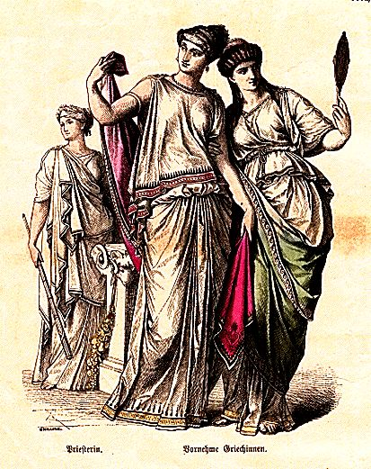
Defense and Encumbrance
As written, Defense is a slightly peculiar skill in that it can allow a heavily loaded but strong character to dodge as athletically as a naked gymnast.
Now I do like the idea of the Defense skill because I have a fondness for lightly-armoured characters being able to dodge rather than having to layer on the bronze to stand a chance of competing in a melee. As it is, Defense is not as reliable a defence as armour so it is not a true replacement, but it does give players the chance to play light and nimble characters with a fair chance of surviving their first combat.
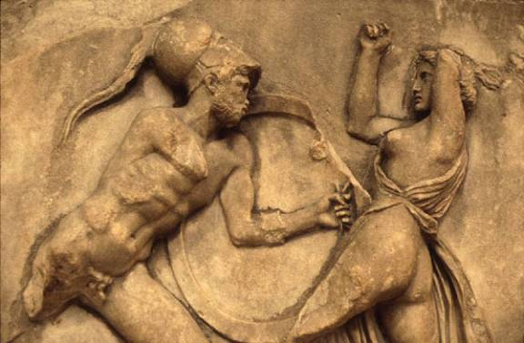

My Houserule is:
A character loses 5% Defense per point of ENC over half maximum ENC.
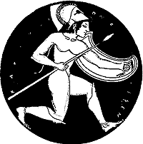
This does not affect any other ENC-related penalties, just the Defense.
Hopefully, this rule should reduce the possibility of plate-clad 17 STR Storm Bull beserkers floating like butterflies in the face of their frustrated opponents. In my opinion the heavy armour and attack and damage bonuses are big enough advantages for high-STR characters.
Size Statistic (SIZ): Height and Weight
The SIZ statistic as published is a single number representing both height and weight. This is fine for most NPCs and is a quick way to generate characters, but it lacks something of the personalisation that generating separate height and weight allows.
As suggested by the optional rule in the back of the rulebook, therefore, height and weight may be rolled separately. Note the word 'may'. A player who wants his or her character to be perfectly in proportion may decide (before rolling) that the character will use one SIZ roll as both height and weight. For those who want a little more variety, however, my houseruled SIZ works like this:
- Roll SIZ as normal (note that I prefer 2d6+6 for human SIZ). This first roll represents Height.
- Take two differently coloured d6 and designate one as 'plus' and the other as 'minus'. Roll them both and apply the result to the SIZ (Height) roll. This will give a number of SIZ+/-5. That number is the Weight.
Unfortunately, the SIZ table given in the rulebook results in very overweight human characters. Whether this is due to the table trying to give a 'one size fits all races' result or whether the average weights are excessive thanks to using C20th US data I have no idea, but when a SIZ 16 character is 175-180cm (5' 9" to 5' 11") and weighs in at 110-130kg (17st 4lb to 20st 7lb), something is wrong.

Well, possibly...

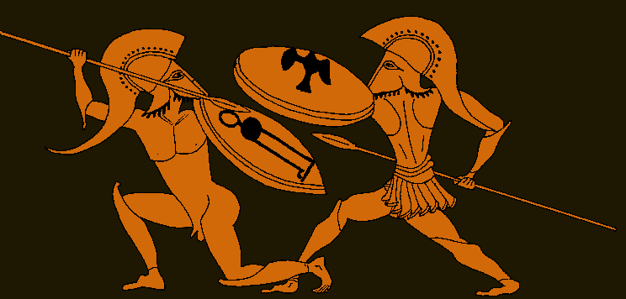

SIZ Rolled Height (cm) Height (imp.) Weight (kg) Weight (imp.)
3* 80-120 2ft 7in - 3ft 11in 17-39 2st 9lb - 6st 2lb
4* 90-125 2ft 11in - 4ft 1in 22-42 3st 6lb - 6st 9lb
5* 100-130 3ft 3in - 4ft 3in 27-46 4st 3lb - 7st 3lb
6* 110-135 3ft 7in - 4ft 5in 33-49 5st 3lb - 7st 10lb
7* 125-140 4ft 1in - 4ft 7in 42-53 6st 9lb - 8st 5lb
8 135-150 4ft 5in - 4ft 11in 49-60 7st 10lb - 9st 6lb
9 145-155 4ft 9in - 5ft 1in 57-65 9st 0lb - 10st 3lb
10 150-160 4ft 11in - 5ft 3in 61-69 9st 8lb - 10st 12lb
11 155-165 5ft 1in - 5ft 5in 65-73 10st 3lb - 11st 7lb
12 160-170 5ft 3in - 5ft 7in 69-78 10st 12lb - 12st 4lb
13 165-175 5ft 5in - 5ft 9in 73-83 11st 7lb - 13st 1lb
14 170-180 5ft 7in - 5ft 11in 78-87 12st 4lb - 13st 10lb
15 175-185 5ft 9in - 6ft 1in 83-92 13st 1lb - 14st 7lb
16 180-190 5ft 11in - 6ft 3in 87-97 13st 10lb - 15st 4lb
17 185-195 6ft 1in - 6ft 5in 92-103 14st 7lb - 16st 3lb
18 190-200 6ft 3in - 6ft 7in 97-108 15st 4lb - 17st 0lb
19* 195-205 6ft 5in - 6ft 8in 103-113 16st 3lb - 17st 11lb
20* 200-210 6ft 7in - 6ft 11in 108-119 17st 0lb - 18st 10lb
21* 205-215 6ft 8in - 7ft 1in 113-125 17st 11lb - 19st 10lb
22* 210-220 6ft 11in - 7ft 3in 119-131 18st 10lb - 20st 9lb
23* 215-225 7ft 1in - 7ft 5in 125-134 19st 10lb - 21st 1lb

*Humans cannot be this height on 2d6+6, but the entry is there to determine weight.

A few notes on the table:
- Height has been increased by one 'step' from the rulebook. Bearing in mind the Gloranthan world represents a pseudo-Classical age, the average heights are perhaps slightly shorter than C21st European/US.
- The weights are based on the high end of World Health Organisation BMI recommendations for the appropriate height of a 20-year-old male. I feel that this is fine to represent a fit young adventurer.
- I have not made any differentiation between male and female characters. I suggest that players wishing to realistically portray the normal average size difference between men and women use the lower end of the height range for female characters.

Example: Kate is generating her character, Tasmit, and chooses to have a random height and weight. Rolling 2d6+6 Kate gets 16. Tasmit is taller than most at 180-190cm (Kate decides that Tasmit is 183cm, or 6' tall). To determine weight, Kate rolls a red (+) and green (-) die. Red comes up 2 and green as 4. +2 and -4 come out to -2, so Tasmit's Weight is 16-2, or 14. This makes her 78-87kg (Kate goes for about 80kg, or 12st 9lb). Tasmit is a very tall but slightly slender woman.

Height and Weight for Derived Statistics
SIZ affects various derived statistics. As detailed in the back of the rulebook, here are the appropriate statistics and which SIZ they use:

Height Weight
Strike Rank Damage Bonus
Defense
Parry
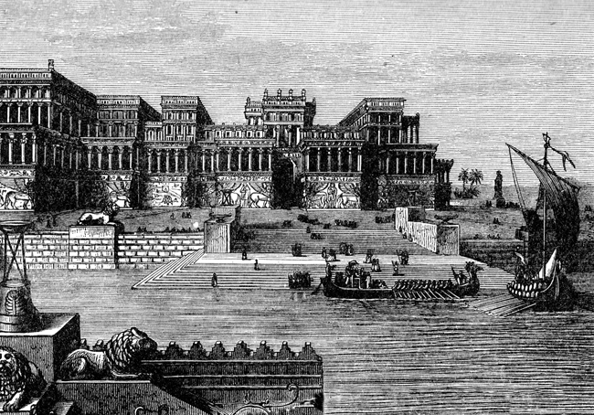
Stealth Stealth (take an average of Height and Weight)

