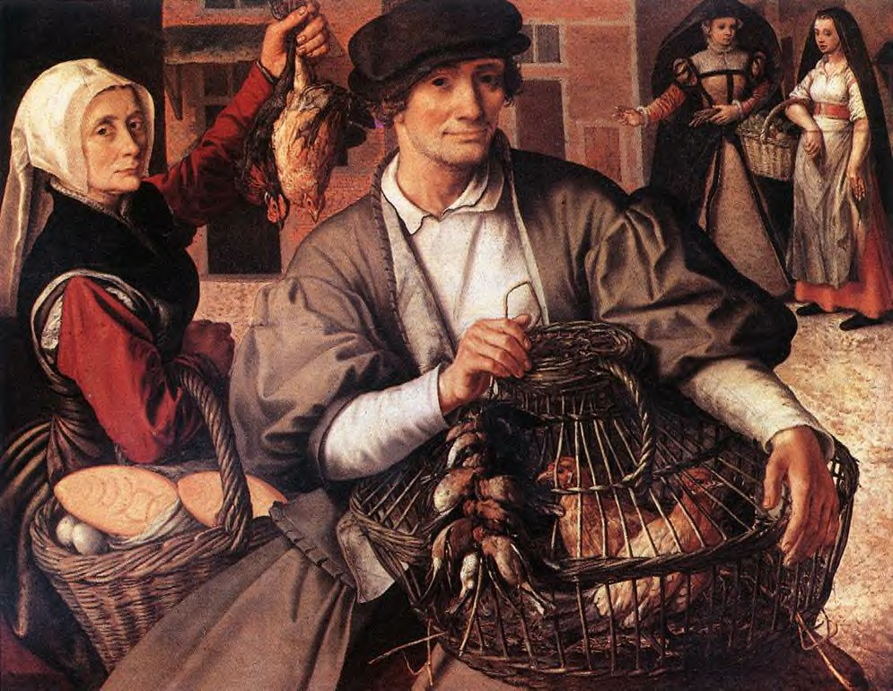
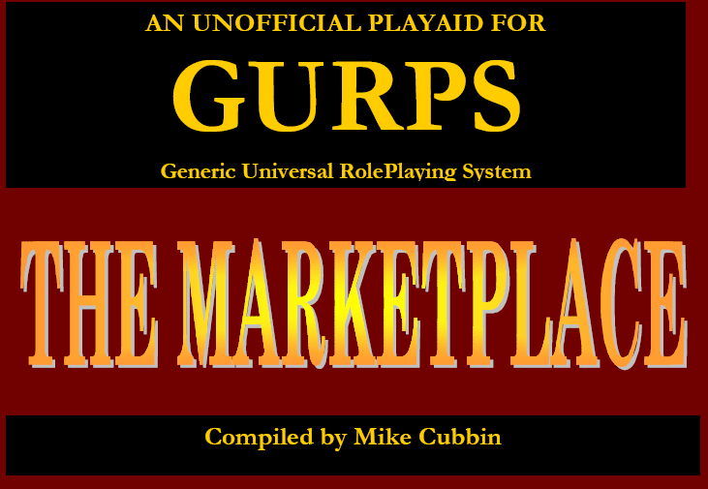

A complete guide to buying and selling goods and services in GURPS Saduria.

GURPS Saduria

By Mike Cubbin
Last edited 26th July 2007

www.Saduria.co.uk

Mike Cubbin has been playing RPGs since 1979, starting with the 2nd ed. AD&D and quickly moving to Runequest 2ed. A lifetime wasted buying and playing RPGs has led to the development of GURPS Saduria.

Mike is married with two young children. He lives in the UK and works full time to pay for his hobby.

He has no intentions of growing up.

