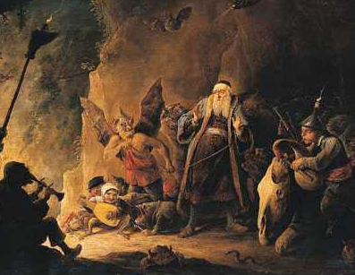
Contents
Devils, Demons and the Ancient Ones

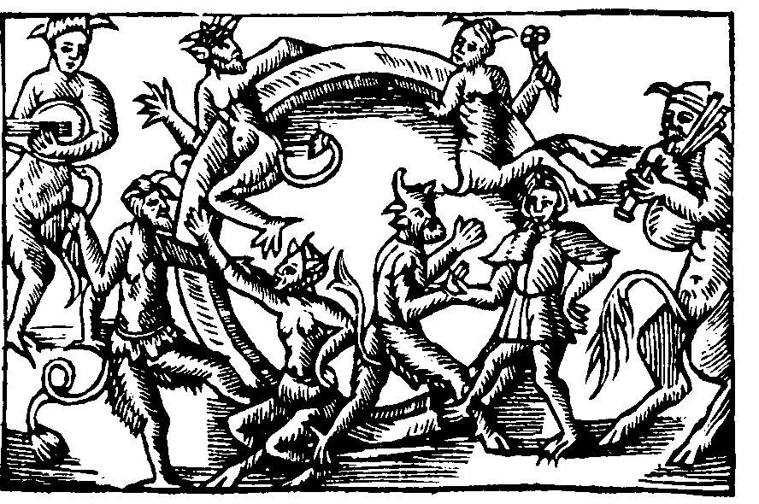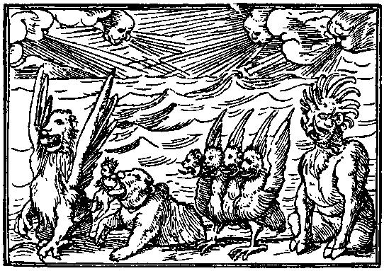
Page | Topic
2 | General Information
2 | THE DEVILS
3 | The Devils (list)
4 | Devil worshippers
4 | Blessed Advantage
4 | Priests
5 | DEMONS
5 | Priests
6 | THE ANCIENT ONES
6 | Priests

Devils, Demons and the Ancient Ones

General Information
The Devils, demons and Ancient Ones are spirits grouped only by the fact that misguided mortal will occasionally give them worship. Aside from them being spirits the three types of entity have nothing in common.
It is not recommended that PCs be allowed to worship such beings. Not only are their usual worshippers given little but madness and pain, but the secular authorities are also more than likely to treat such blasphemers with the full might of the law. Death is often the most merciful punishment handed down.
The DEVILs

The Devils are gods of evil aspect. During the God Age, just after the mortal races were created, the Devils sought to siphon Life Energy (Fatigue) from the mortals by methods that were ultimately destructive to the mortals. The other gods fought against this and the Devils were eventually imprisoned behind the Great Seal or Ward. This sub-dimensional prison holds the Devils and prevents them from sending their power to the world. Unfortunately, mortals still manage to both contact and send Life Energy to the Devils through forbidden rituals and sacrifice. Whilst this is not enough to allow the Devils to challenge the other gods directly, and certainly not enough to break out of their prison, it provides the Devils with the Fatigue they require to continue existing.
The Devils are happy to accept Life Energy from mortals by methods that most of the other gods would hesitate at encouraging. Suffering and physical sacrifice are rich sources of Fatigue, but will ultimately destroy the mortal races.
The Devils are not a pantheon. They see little reason to co-operate with each other except on a short-term basis, and even then they will usually be looking to betray their temporary ally. Unlike the gods, the Devils have no set of rules by which they limit their hostility towards each other, and the followers of one Devil are just as likely to be working against another Devil as they are to be fighting worshippers of the gods.
Devils can communicate with their servitor spirits, twisted and evil spirits who act as their masters’ envoys and ambassadors. These evil spirits seek out those desperate mortals who might be willing to serve the Devils, appearing with promises and demonstrations of the power they can offer.

The Devils

The Devils are not so rigidly defined in their spheres of influence as are the gods for they are willing to steal worshippers from one another without a thought. This lack of specialisation will eventually lead to the sidelining and extinction of individual Devils, but the Devils are too selfish and short-sighted in their views to worry about this.

The following table lists areas that the Devils prefer to concentrate on, but these aspects should not be taken as limiting what they will promise to attract worship.
Name | Title | Major aspects
Anak | The jailer | Technophobia, confinement.
Ashtaroth | The deceitful lover | Sexual immorality, destruction of loving relationships.
Apollyon | The liar | Deceit and treachery.
Beelzeboul | The violator | Destruction of hope and dreams.
Behemoth | The great beast | Mass mindless destruction.
Belial | The worthless one | Worthlessness and corruption.
Dragon-Man | The devourer | Materialism and greed.
Ijim | The satyr | Self-seeking pleasure.
Lamia | The succubus | Prostitution for power.
Lilith | The vampire queen | Vampires, power-seeking.
Mammon | The avaricious one | Miserliness and acquisitiveness.
Mephisto | The dark prince | Temporal power.
Mne Seraphim | The dark twins | Cruelty and desperation.
Molech | Eater of children | Destruction of innocence.
Rhadamanthus | The executioner | Extreme punishment of any “sin”.
Rintrah | The vengeful one | Resentment and jealousy.
Salamandrine | The fiery wrath | Uncontrolled anger or grudge.
Shadow | The promiser | Promises over substance. A desperate belief for the want of anything better.
Sihon | The impeder | Destruction of all religion and spirituality.
Spectre | Nightmare bringer | Terror and necromancy.
Tiriel | The selfish man | Isolation and selfishness.
Zazel | The dark genius | Forbidden knowledge.

Devil Worshippers

Worship of the Devils is illegal throughout the Empire, and is considered both a capital and religious crime. Yet still some people are drawn to the Devils, mainly thanks to the extravagant promises they offer. Only when it is too late are the promises revealed as lies. It should be noted that Devil worshippers are most often those for whom life has offered little; whether through the death of a loved one, a great misfortune, or constantly thwarted ambition. Depending on the Devil being worshipped, worshippers are seeking anything from power to revenge, or even simple oblivion.

Blessed advantage

A strong lure for followers of the Devils is the Blessed advantage, which can be relatively potent. Any or all of the following may be taken by one so blessed, but all have the Pact modifier (follow the orders of the blessing Devil). The level of advantage taken is entirely up to the character, but the more points the advantage is worth, the more they are at the beck and call of the Devil.
- Ally. This is usually an evil spirit, typically disguised as a companion.
- Innate attack. An unusual power, but some worshippers choose to be able to breathe fire or shoot lightning from their hands.
- Status. Social status will be achieved through the misfortunes of others.
- Wealth. A very common request.

Priests

With such limited congregations, priests of Devils lack a formal hierarchical structure within which they can progress. With that in mind, any sort of ranking system is worthless and Devil worshippers cannot buy Religious Rank for their religion. They are still obliged, however, to purchase Clerical Investment.

Devils do not have the power to offer magic, though most will gladly offer it as an incitement. Instead, priests can learn Ritual Magic - Devils, and all the Paths are open to them, including a version of the Path of the Gods which is fundamentally the same as that path, but applicable only to the Devils’ own ritual magic tradition. This path is known as the Path of the Devils.

Note that the Devils offer the use of ritual magic in order that their priests further the cause of the Devils. Uses of the magic involving suffering and pain are encouraged, with continued beneficial uses liable to result in the powers being withdrawn.

DEMONS

Demons are a spirit race that have no need or desire for worship, yet attract it anyway. What makes an individual worship such beings is unclear, for they seemingly offer very little except mind-blasting terror and destruction, frequently to the very people who are calling on them. They are predators, sucking mana from anything they can, and are consequently deadly foes to most other spirits as well as to mortals.

Demons as a race have no set shape. As spirits they can be viewed as amorphous dark shapes, twisting and curling in on themselves and projecting an aura of evil. When manifesting they pull ideas from things they have seen but possibly not understood, to form horrific amalgams of creatures and objects.

Demons are a very magical race, and frequently have a powerful armoury of innate spells. This makes them even more dependent than ever on mana, and they are attracted to any concentrations of magical energy. Most priests are aware of this and take measures to prevent such demons from taking advantage of magical energy on the Mortal Plane, but sorcerers seem blithely ignorant of the dangers or are perhaps less worried by demonic influence.

Demons seem able to flit freely from spirit realm to spirit realm, and will often lurk in a realm in disguise, preying on its inhabitants.

Priests

Priests of demons are known as demonologists (and are often confused with sorcerers who deal with demons), and do not attract congregations beyond a dozen or so equally insane followers. Apart from Clerical Investment, a demonologist requires only that he is insane enough believe worshipping demons is a good idea.

Very rarely, a demon might teach a mortal the ritual magic required to summon and deal with demons (Path of the Spirit, but only dealing with demons), and the magician will often then write the methodology down. Copies of such scribblings are found by others of a similar mindset (usually long after the writer has gone permanently insane or died horribly) and so the knowledge of contacting demons is passed along.

The Ancient Ones

If demons are malicious and predatory beings, then the Ancient Ones can be viewed somewhat simplistically as “super-demons”.

Another spirit race, the Ancient Ones are ultraterrestrial spirits of immense power. In times before mortals were created, the Ancient Ones preyed on the gods themselves and only the Life Energy supplied to the gods by mortal worship has allowed the gods to keep the Ancient Ones at bay.

The Ancient Ones are uninterested in mortals or the World except as a source of Life Energy. They would happily and unthinkingly drain the World of its energy and leave it a lifeless husk incapable of sustaining either mortals or spirits, before drifting on to find another meal.

It is believed that mortals cannot communicate with the Ancient Ones, and their very existence is known only to a knowledgeable few, but that does not mean that a misguided or insane magician will not find a way to call one of these monstrosities. The consequences of such a summoning would be severe, with the Ancient One using such a communication channel to enter the Mortal Plane and begin draining its inhabitants. The likely result would be vast areas of lifeless wasteland (a No-Mana area where no plants will grow), with thousands of mortals and spirits drained to husks or left soulless. How to get rid of an Ancient One in such circumstances is another problem, but it would almost certainly require the attentions of the gods themselves.

Priests

Mortals insane enough to want to worship the Ancient Ones are thankfully rare, and those who are able to persuade others to do likewise are unheard of.

Unless someone manages to create a following, any Clerical Investment is meaningless.

“Priests” of the Ancient Ones are highly unlikely to discover any tangible benefits from their devotion, but there is an outside chance that ancient religious texts will hold ritual magic rituals or spells to contact the Ancient Ones. Naturally, all right-minded people will destroy such texts, but there are always some misguided souls who prefer to study them in order to attempt to find the secrets of dismissing the Ancient Ones….

